**BASIC PROCESSES IN VISUAL PERCEPTION**

**Size constancy**

Depth perception is a problem because

* we have differences between left and right eye

But mainly because:

* The retina records a 2D image, instead we have to build a 3D space

We use disparity: differences of the two images projected on the two eyes

* Monocular: can be use even with a picture
* Ocularmotor

We have to combine all the different cues, there is one perception only

The system is able to compute depth. The distance between me and the object, one of the problems is that the size projection of the retina depends on the distance. Far away takes a little part of the retina, small on the image

We can not use retina size because the retina size is wrong

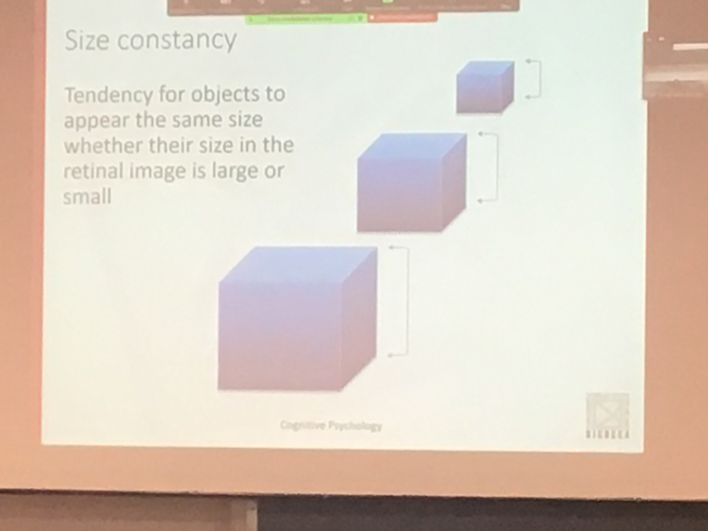

Same object at different distances

The perception has to keep the size of the object constant

Size constancy doesn't work all the time

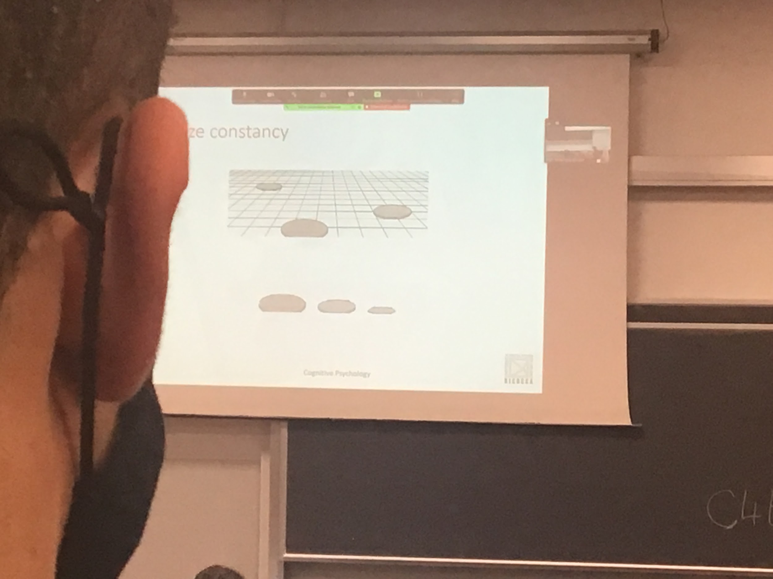

Projection on the retina of the same object can be very different

In psychology, want to try to understand what is the algorithm used by the brain to compute colour constancy

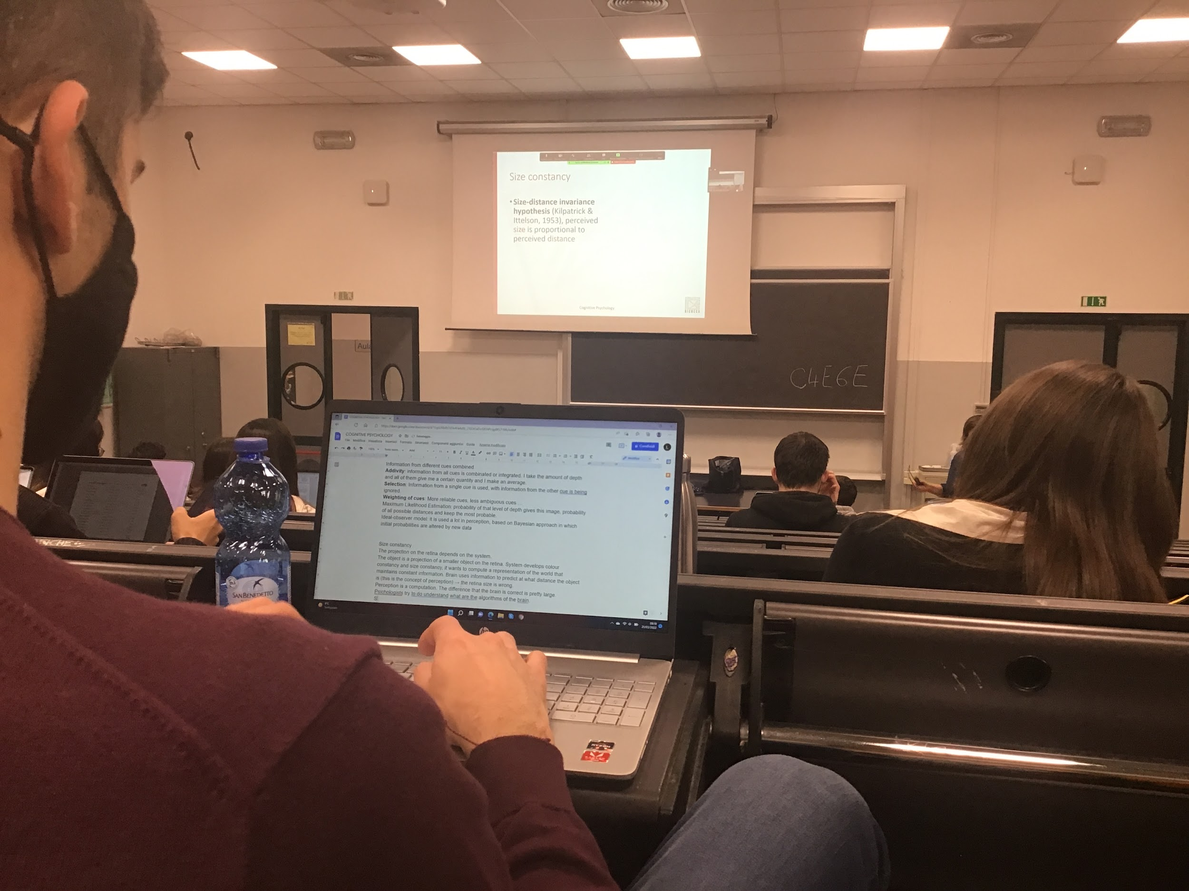

One of the strongest thesis *size distance invariance hypothesis*:

The size I perceive is proportional to the distance that I perceive

**Size** and **distance** seems to be **strongly connected**

First the system compute distance than correct the retina size multiples by the distance

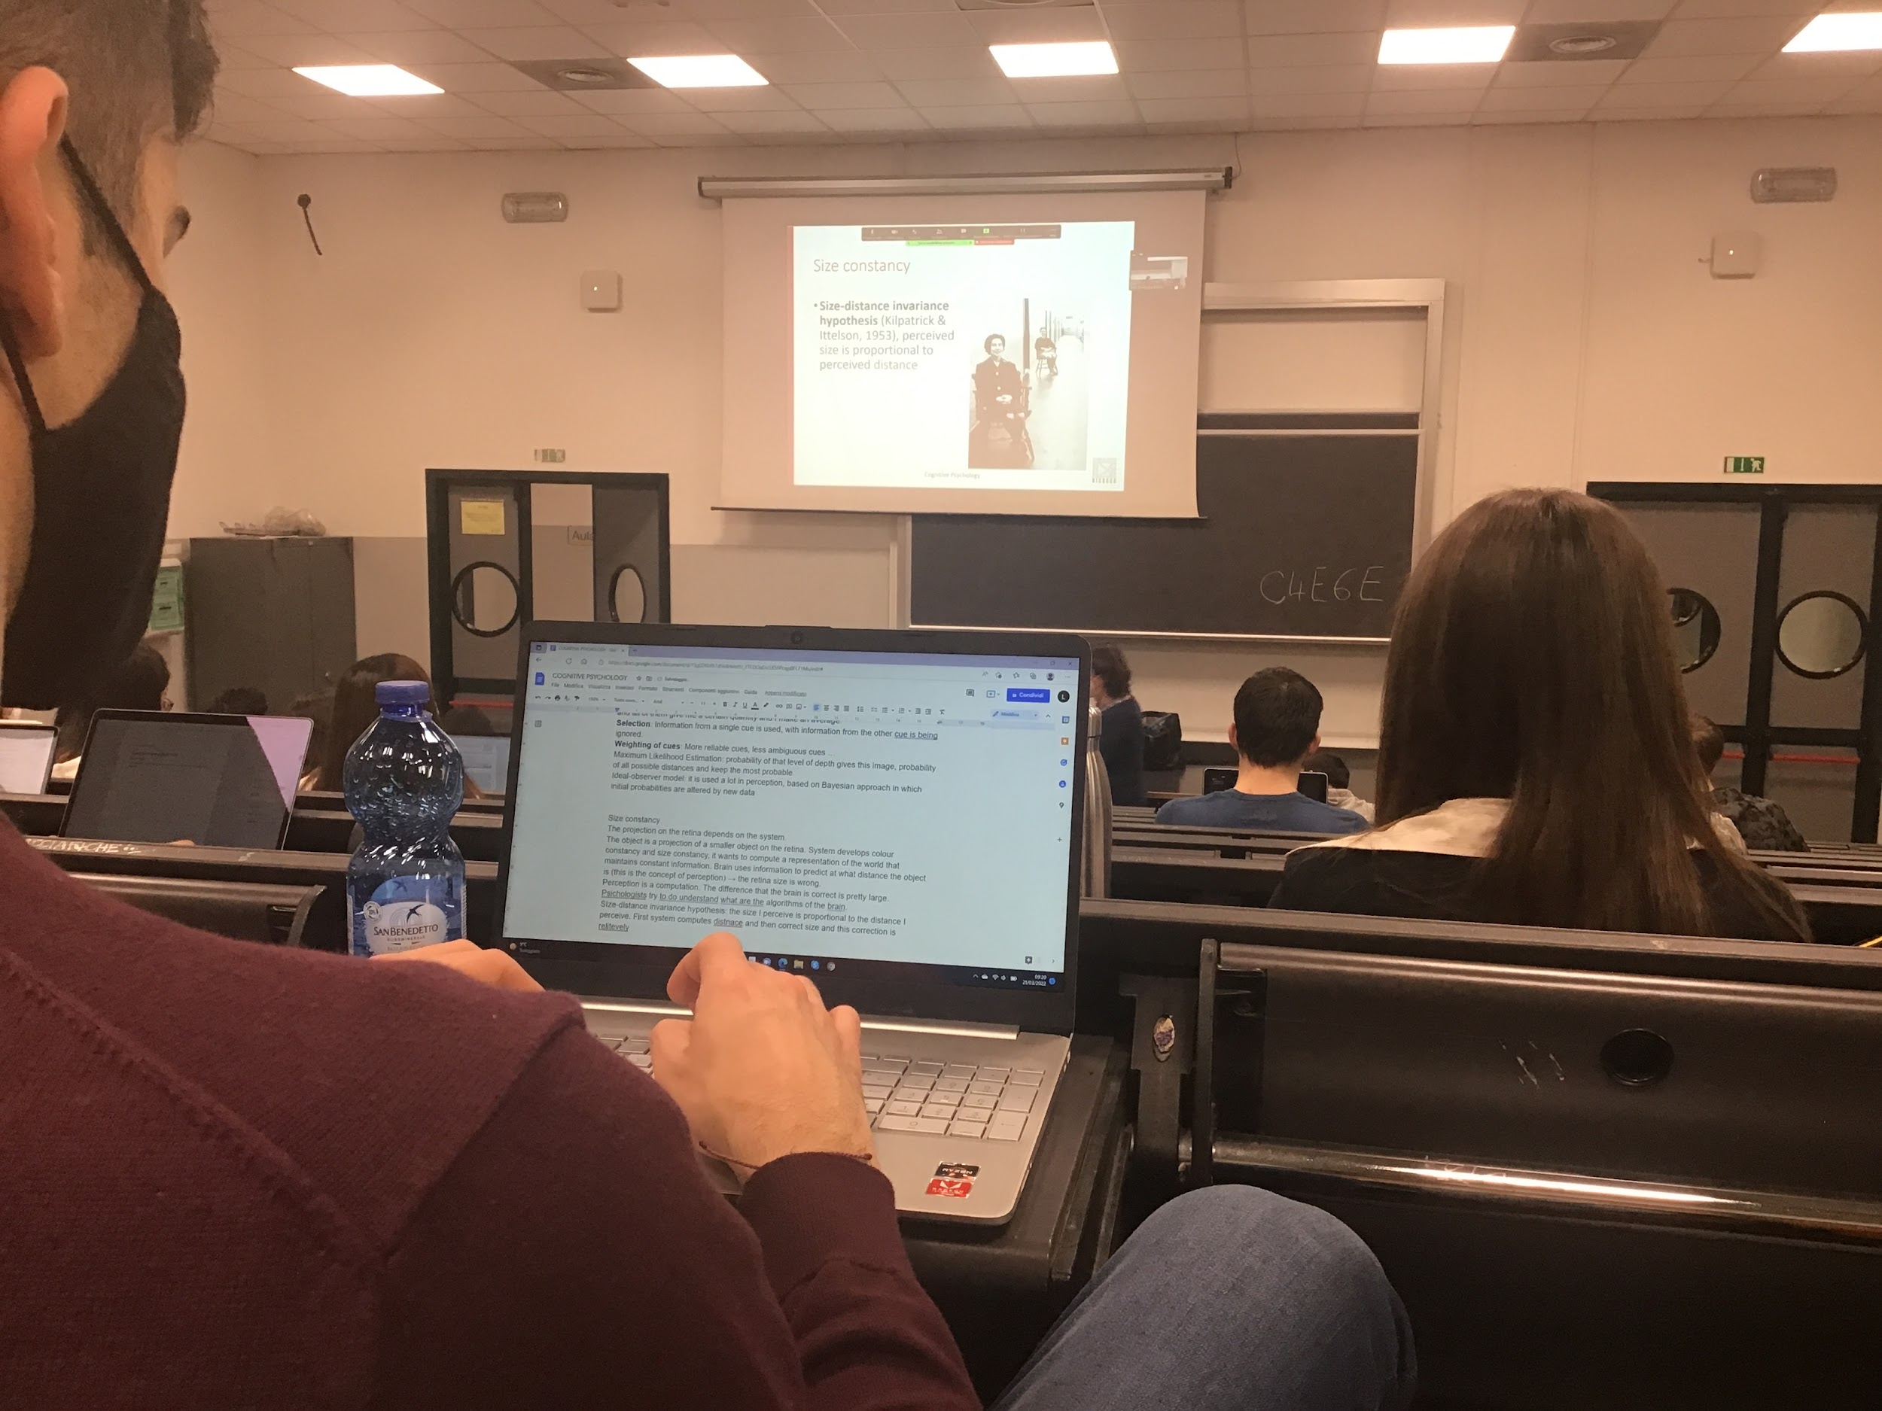

Two women sitting on two chairs on the corridor

My perception is that the two women have the same high

Our brain look at that picture, compute 3D automatically

Linear perspective

+completare con foto

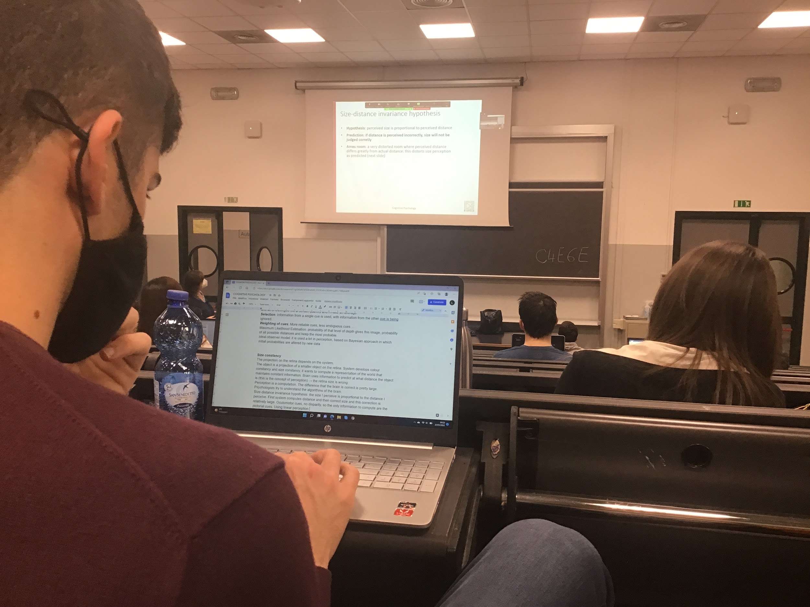

If you correctly perceive depth you correctly adjust size

Incorrect depth perception → incorrect adjust size

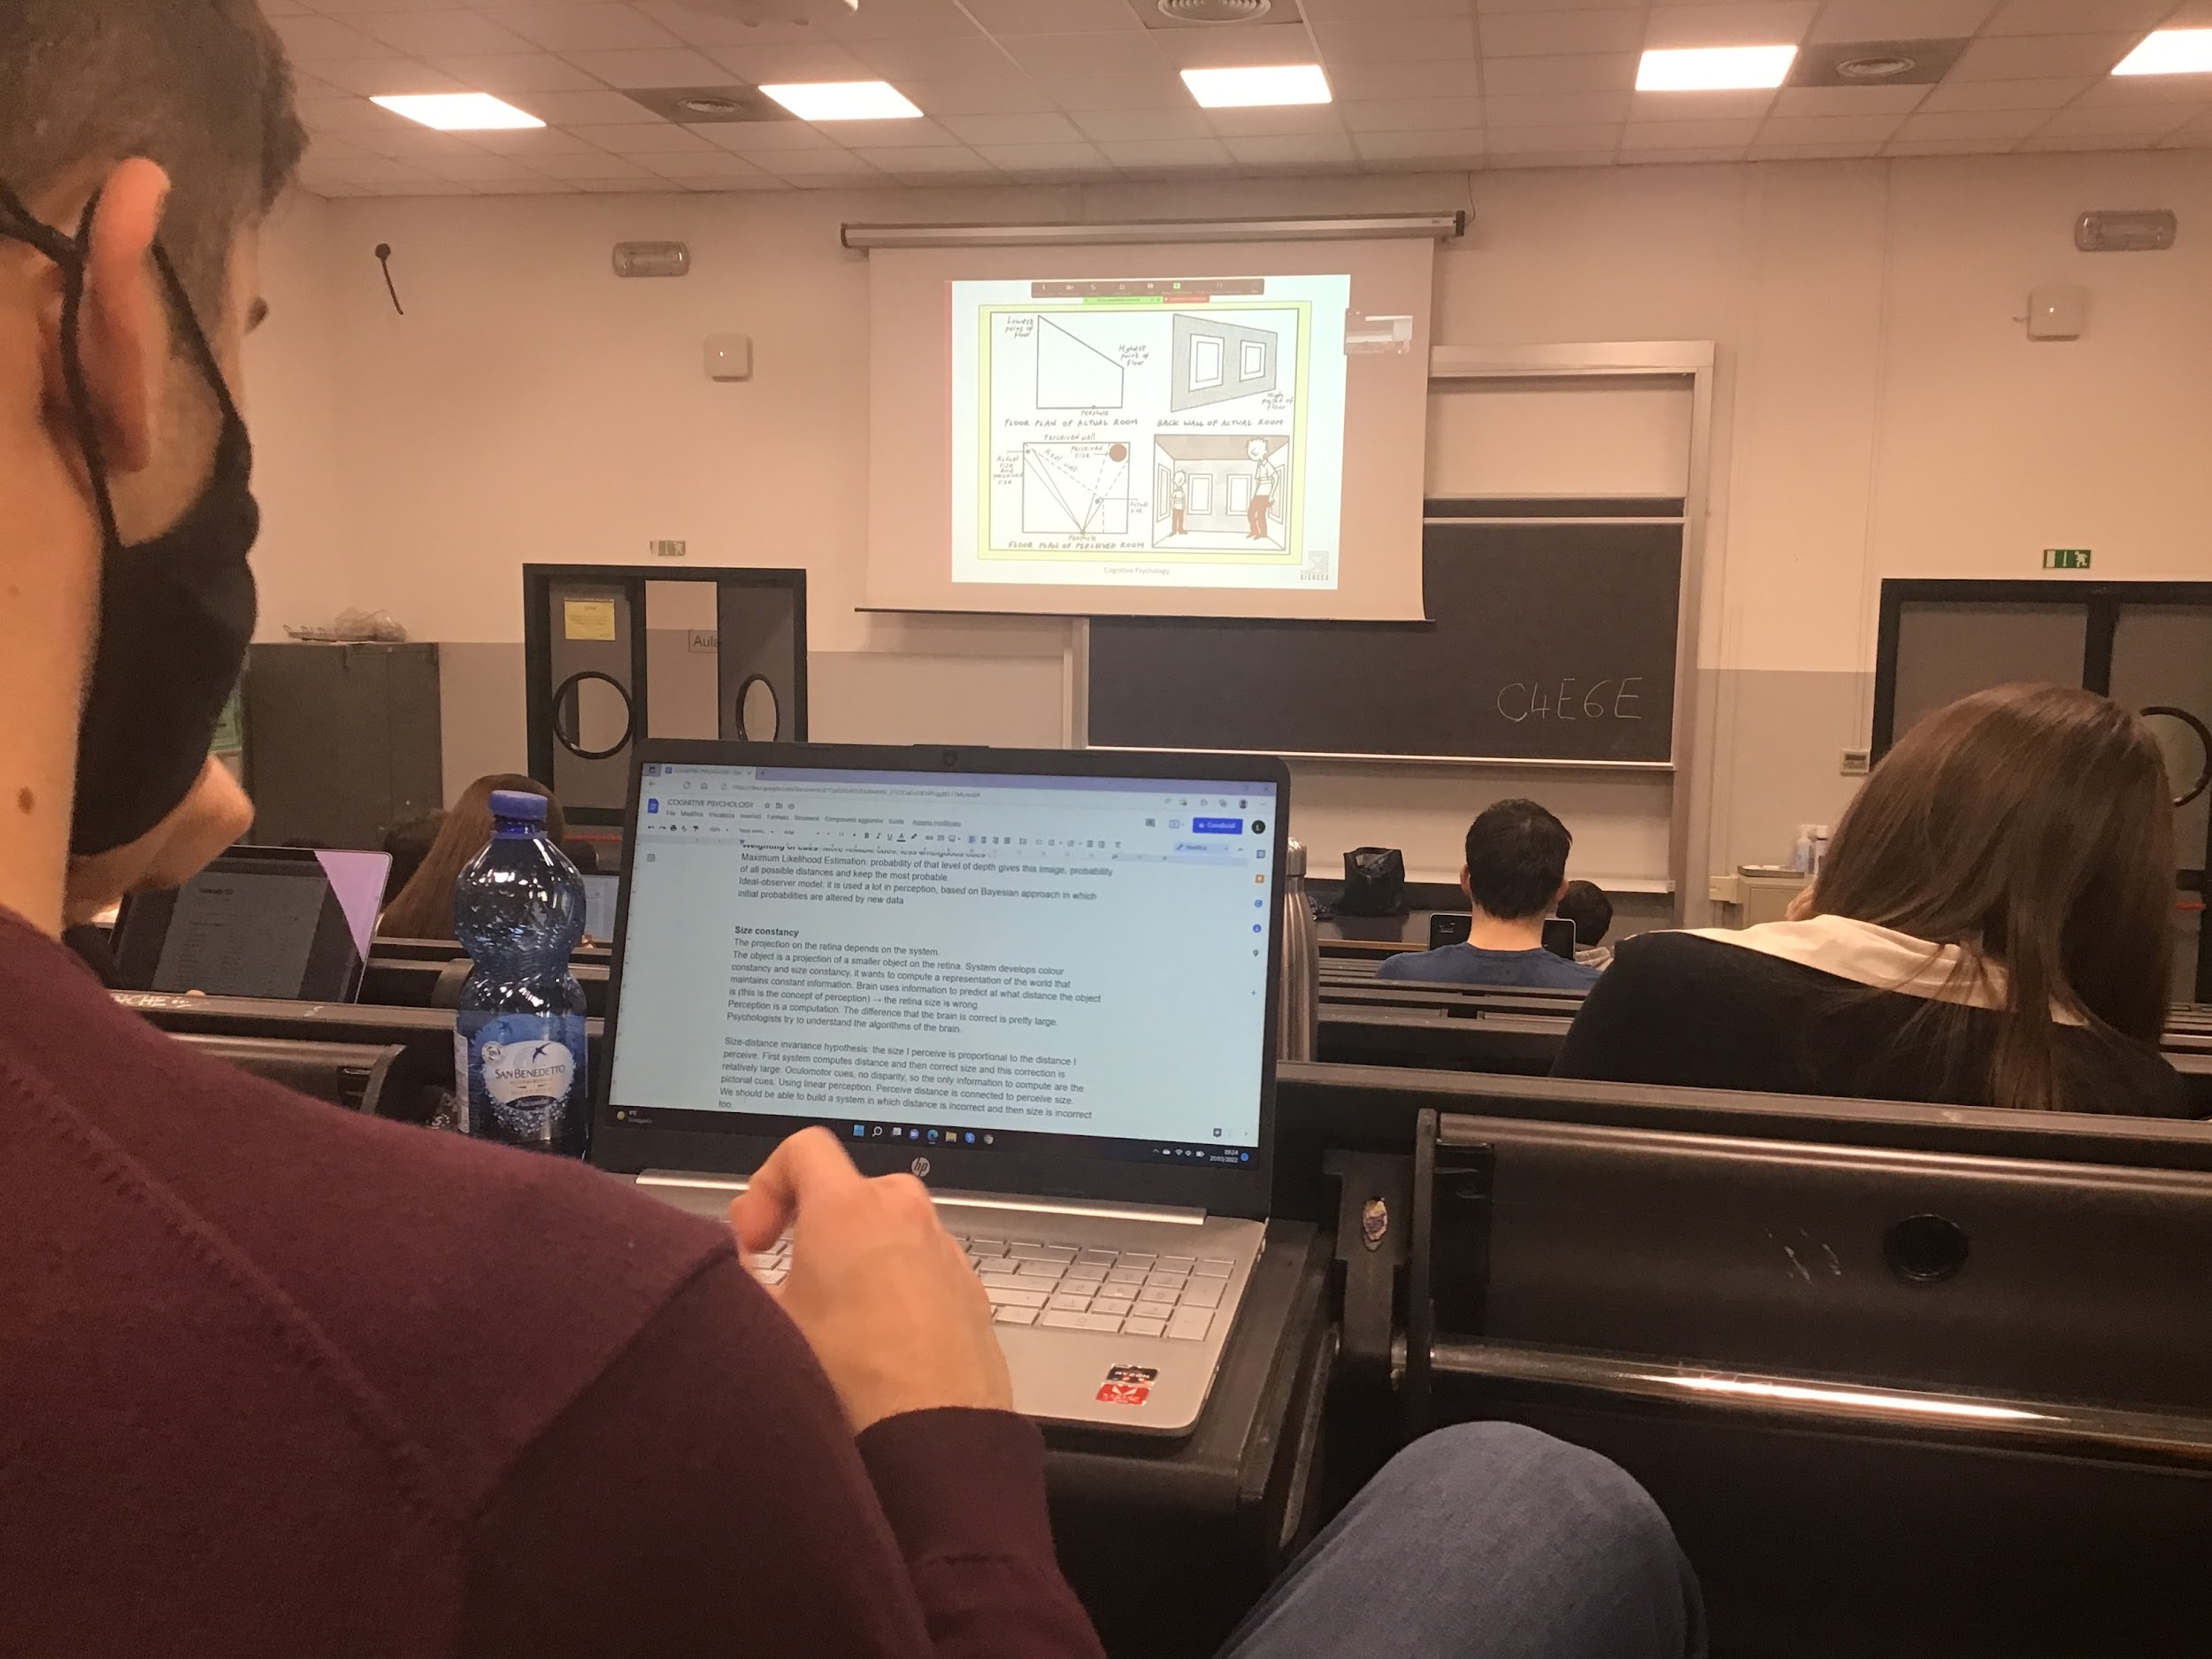 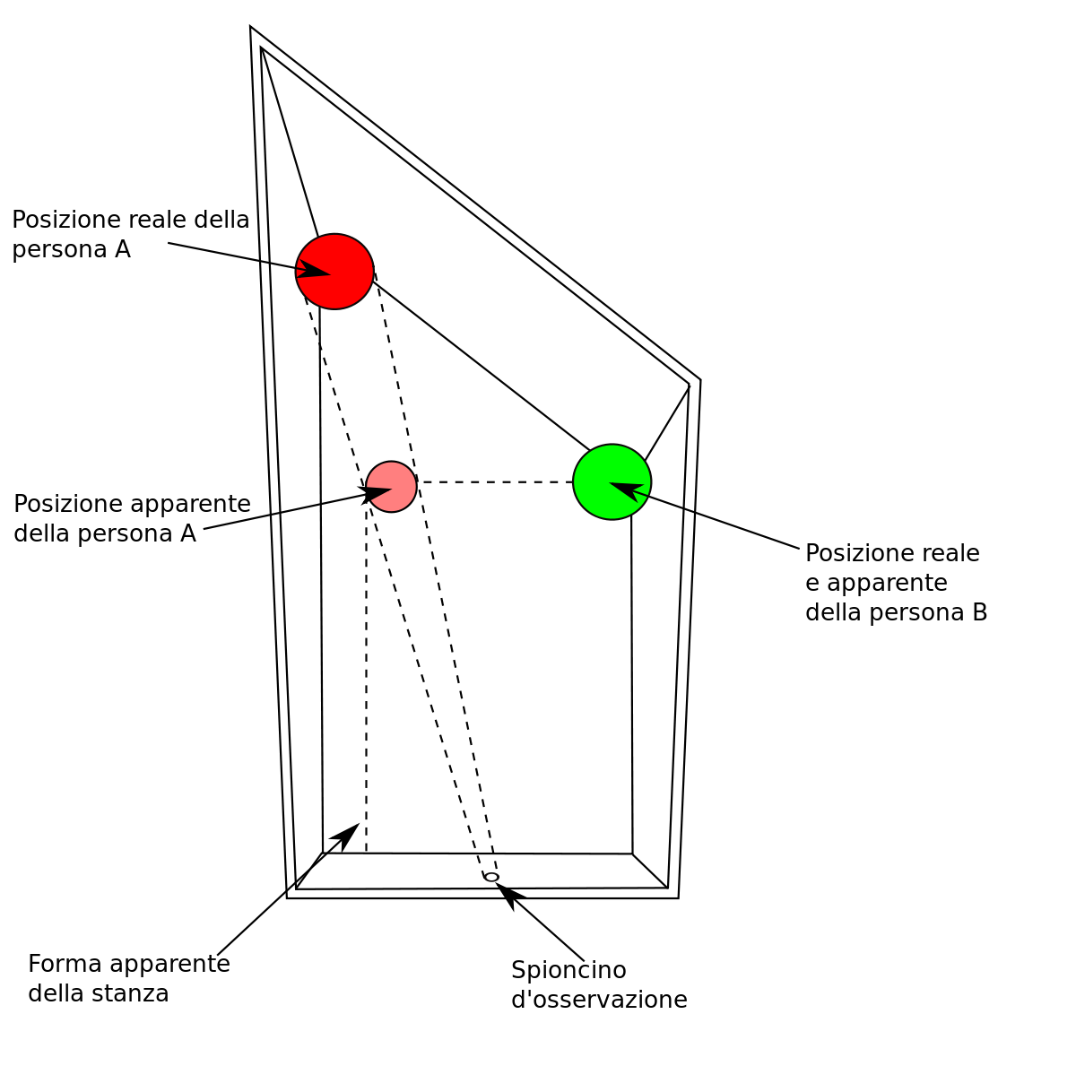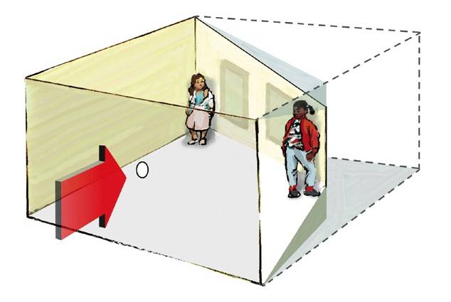

Ames room: room that is not construct in a standard room

The room is not rectangular, back wall that in one side closer to you, also the floor is inclined

Back wall painted windows

But you see a perfectly rectangular room because of the projection

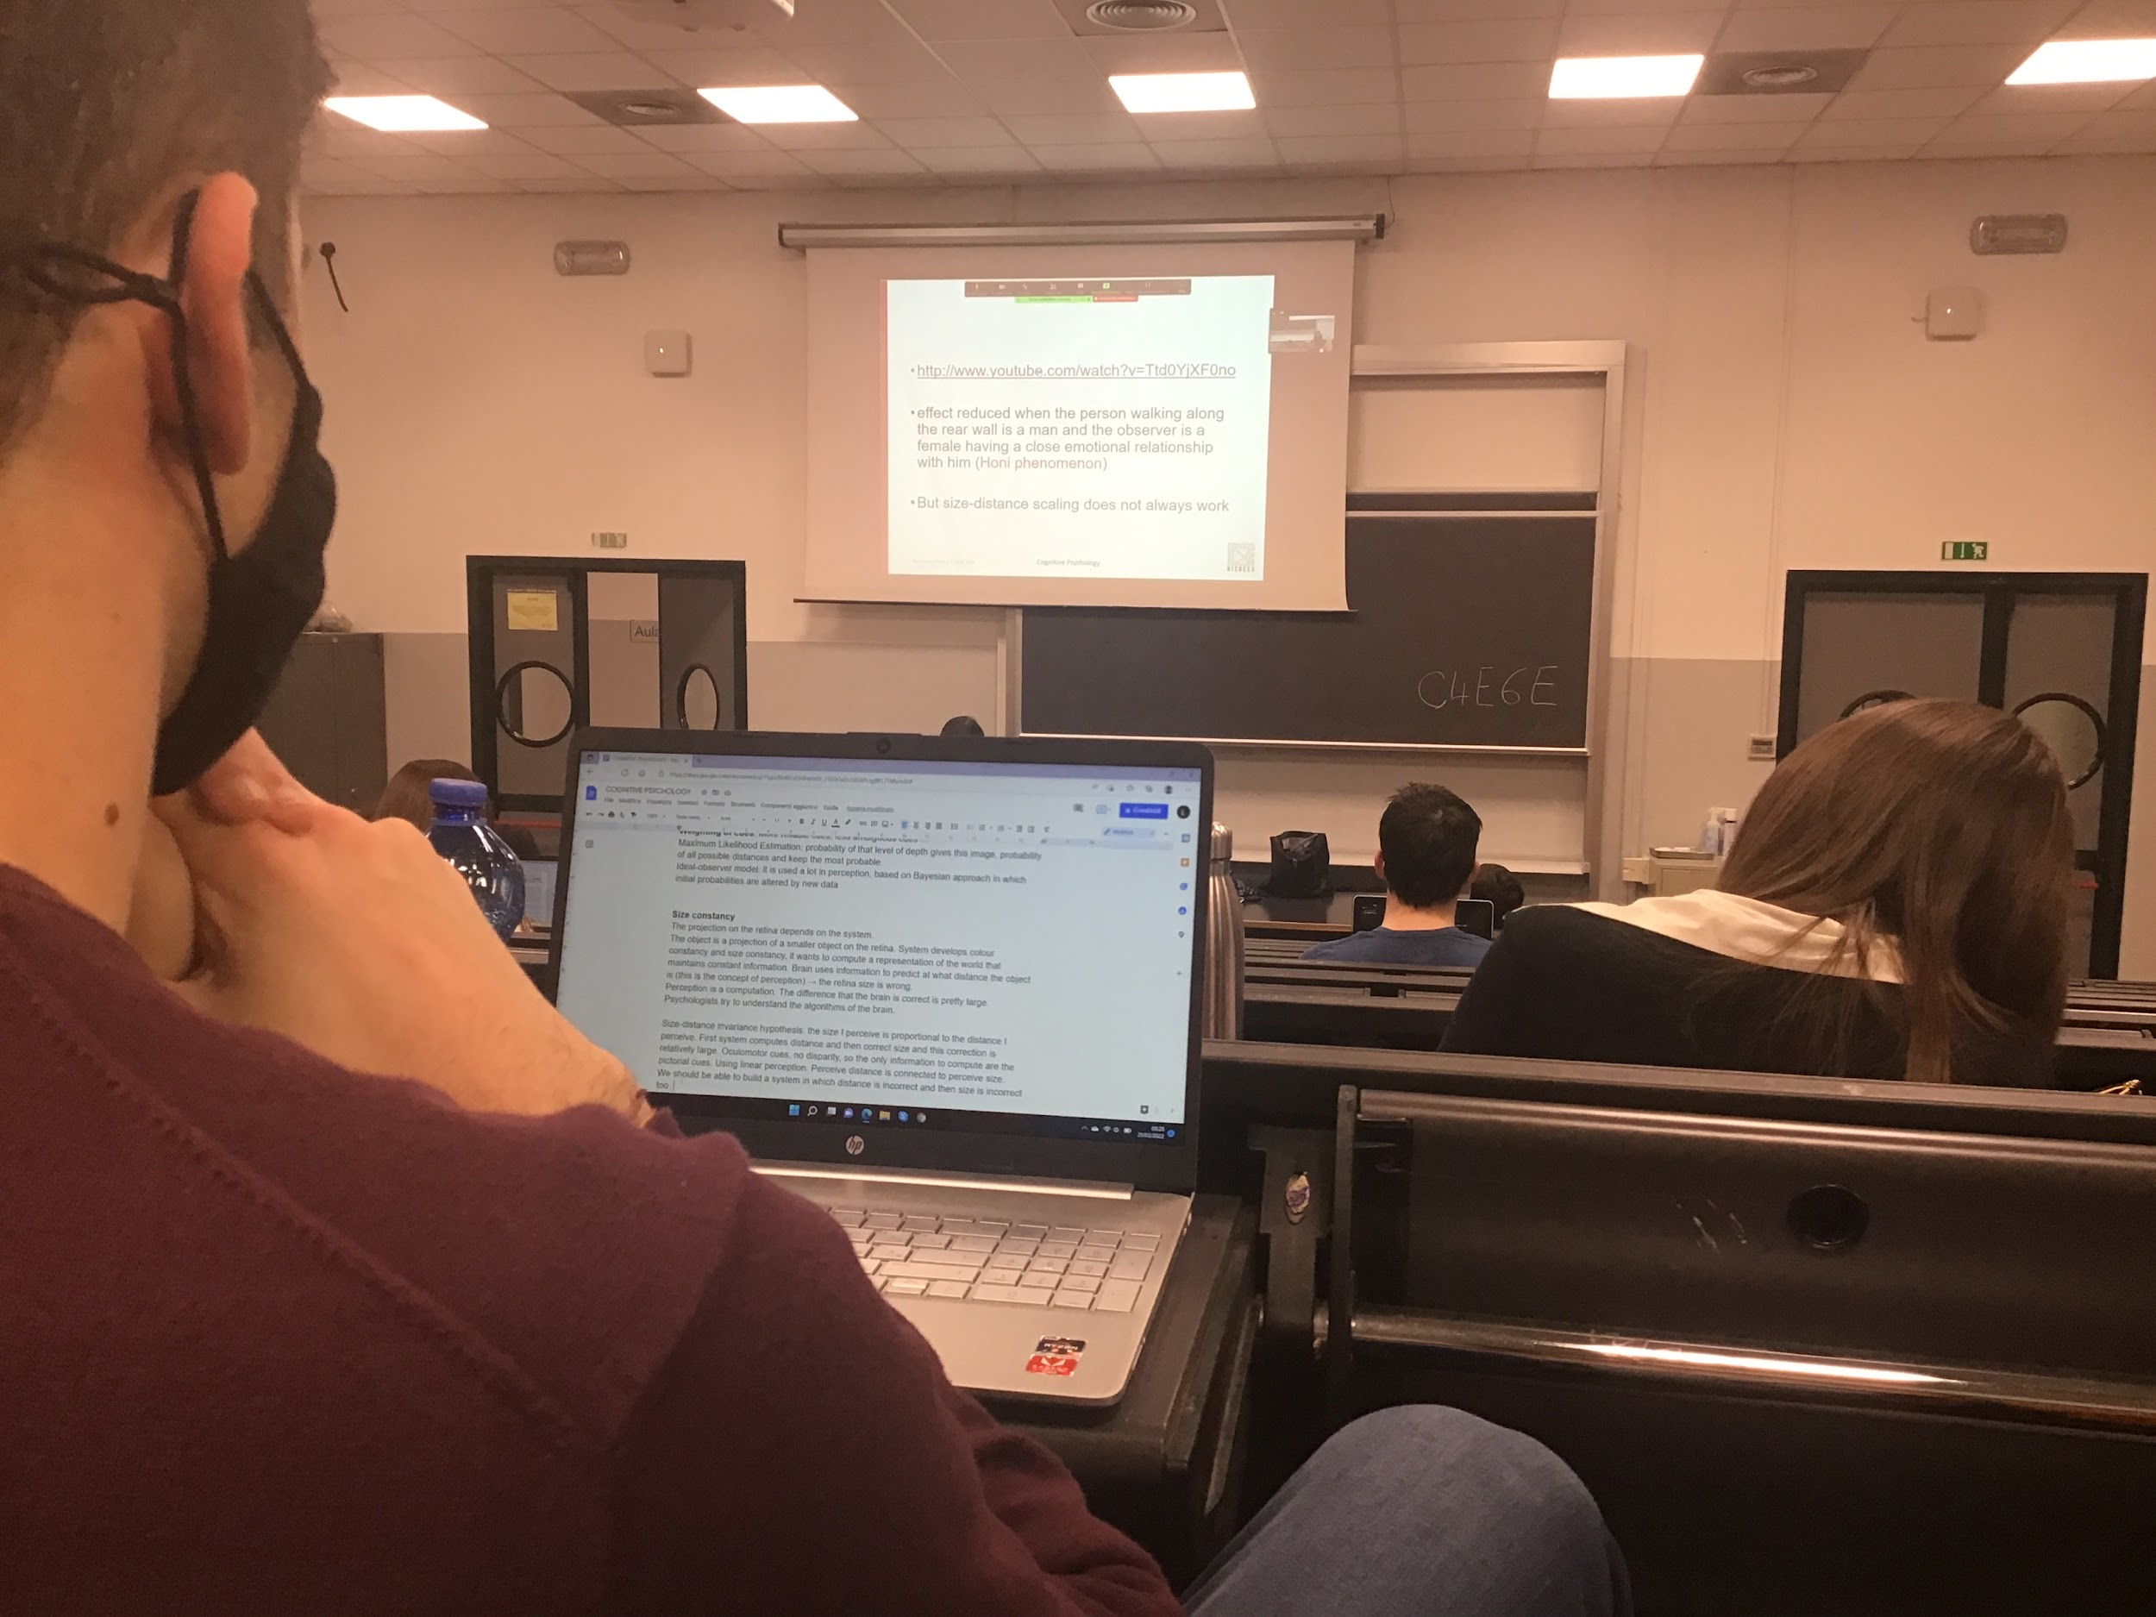

When you look truth the hole, you have the perception that when people are moving they are increasing and decreasing size

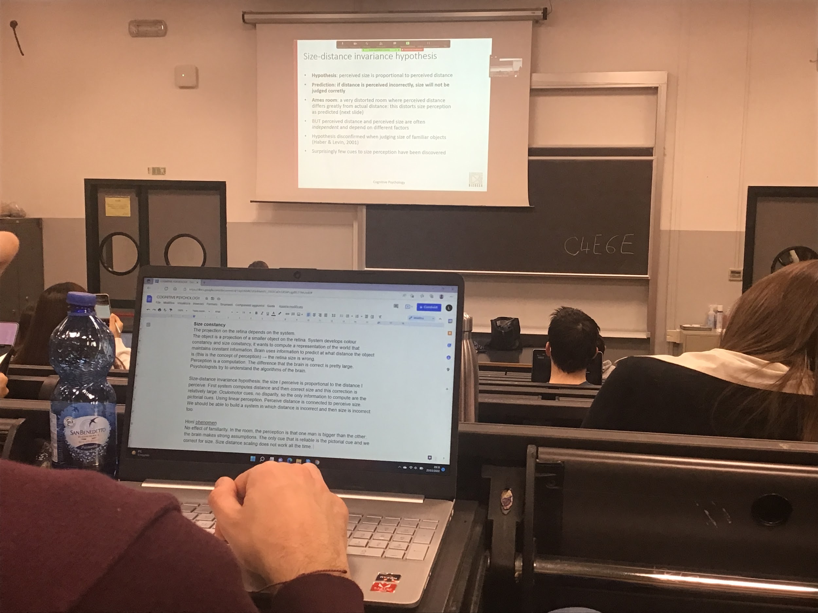

Sometimes there is the influence of familiarity

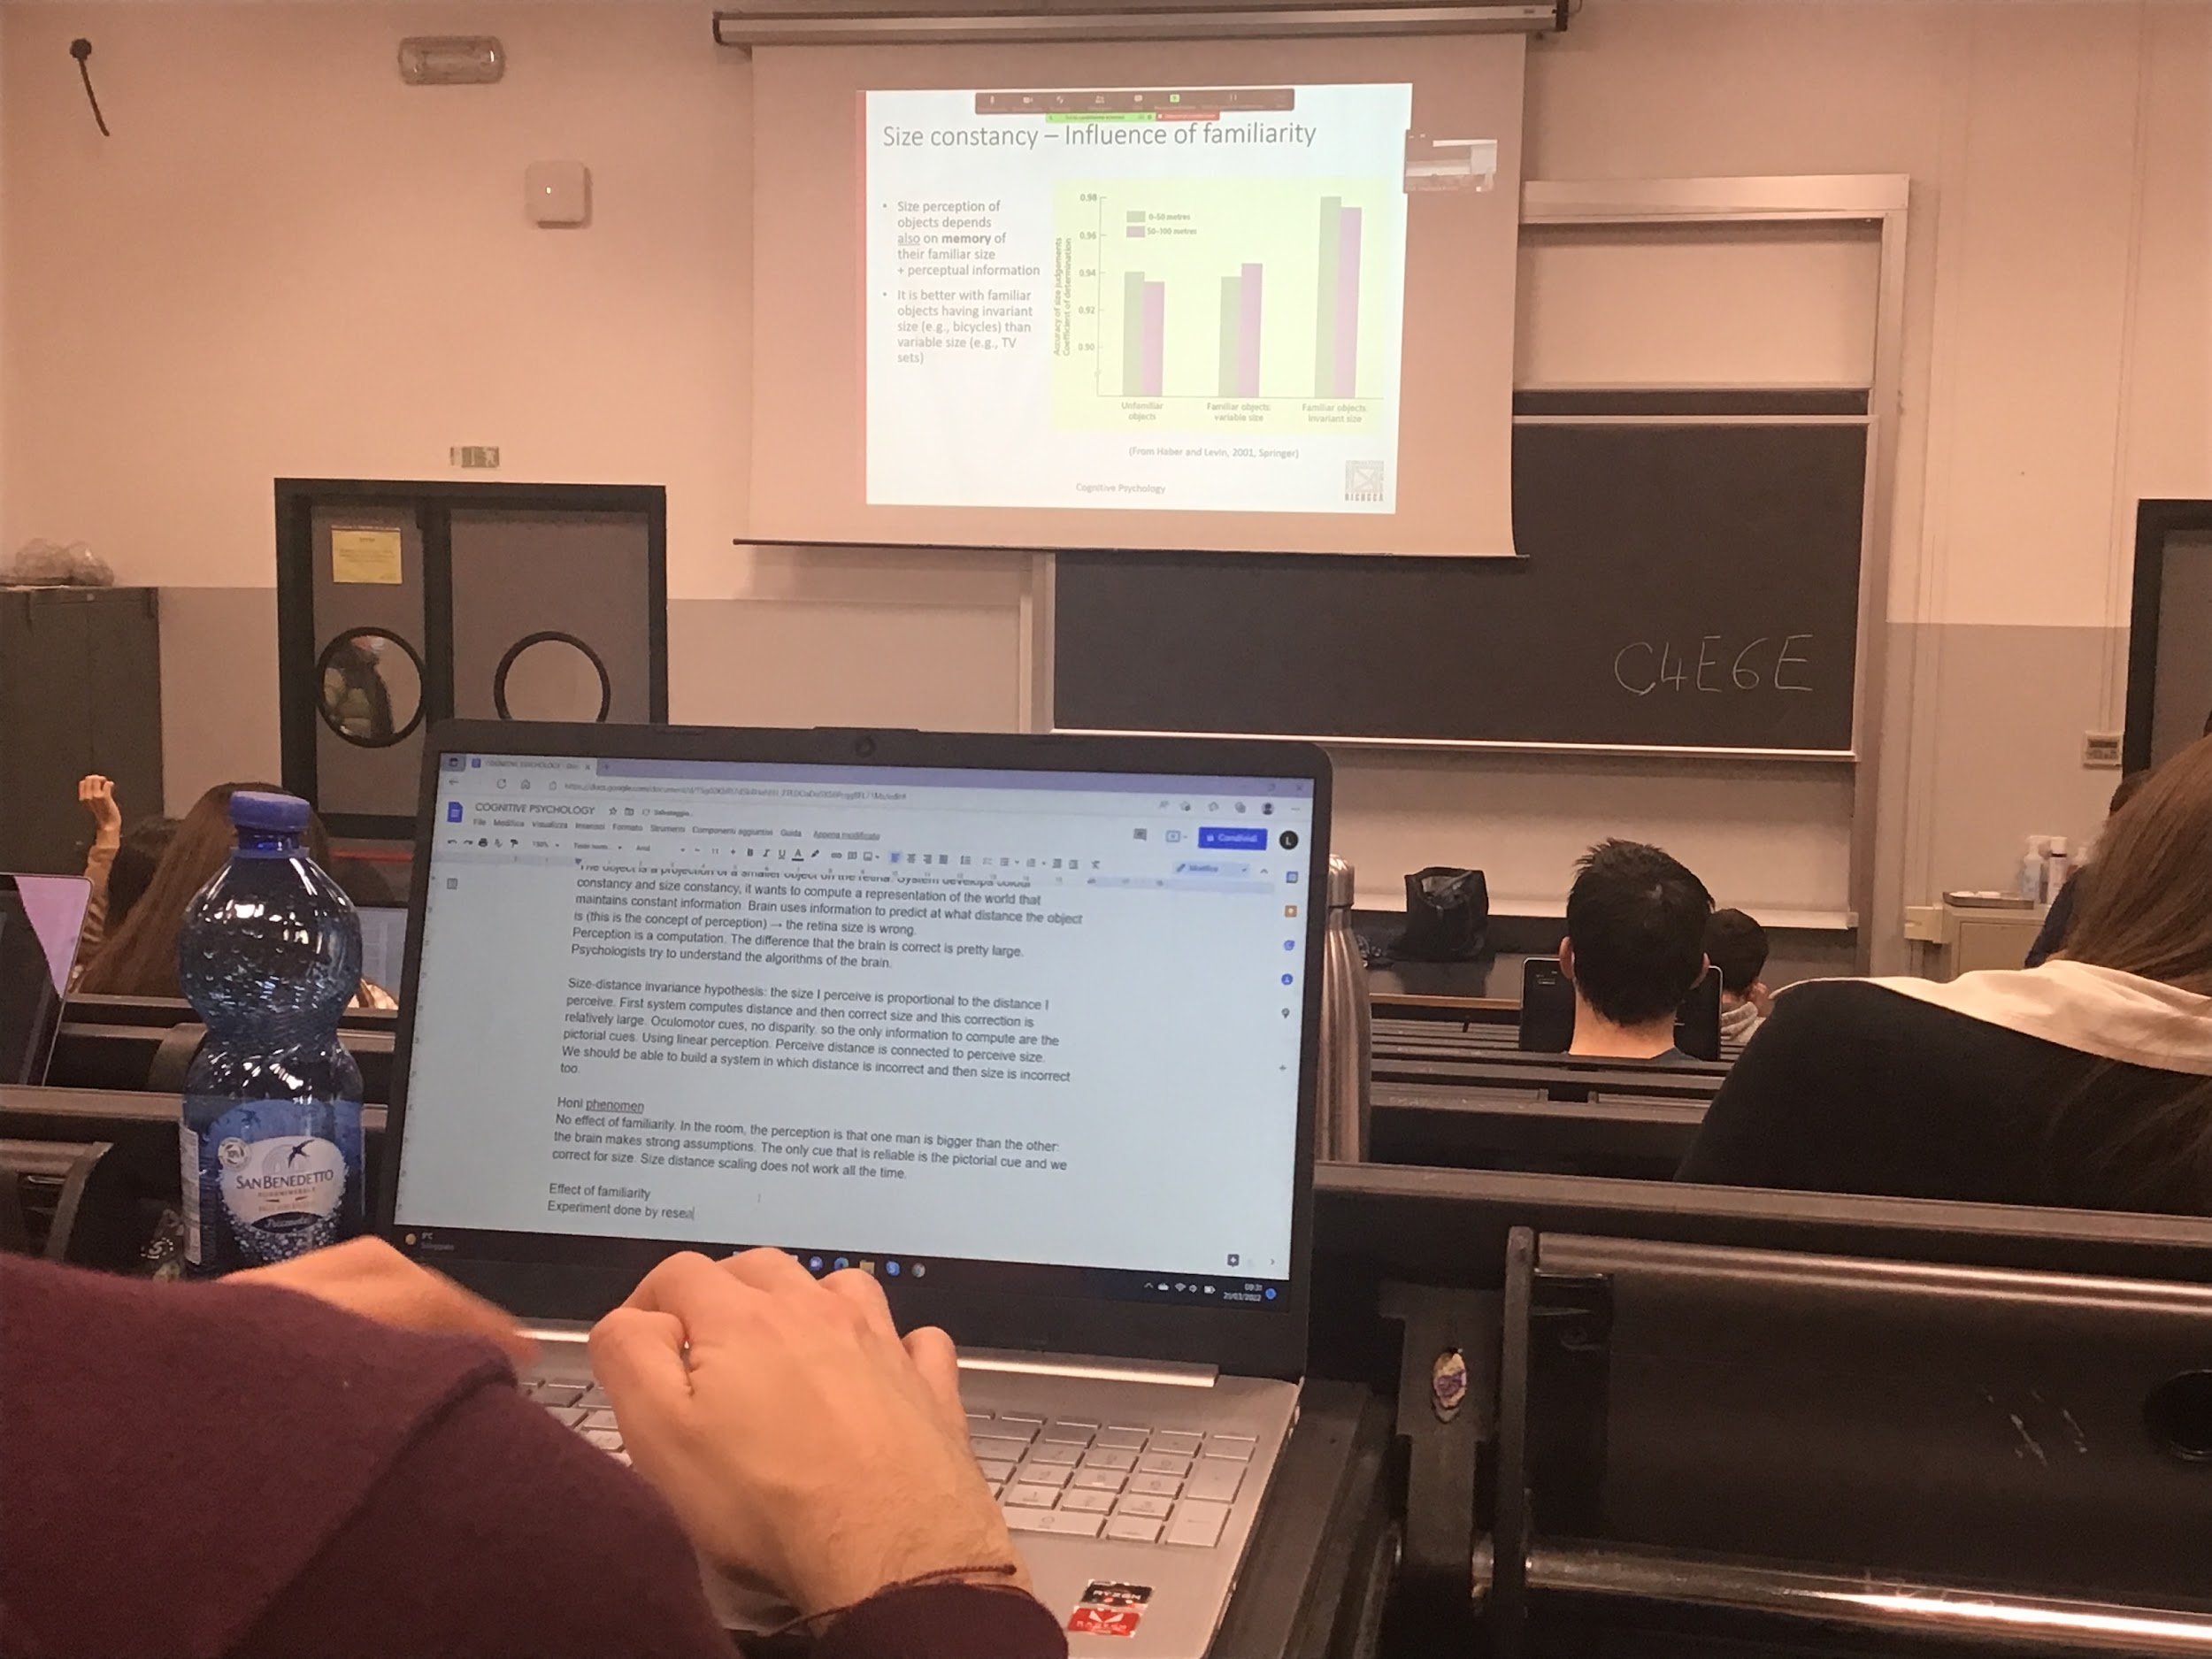

Show objects that they are familiar and not familiar objects.

The differences are smaller

People are better to perceive size of familiar objects

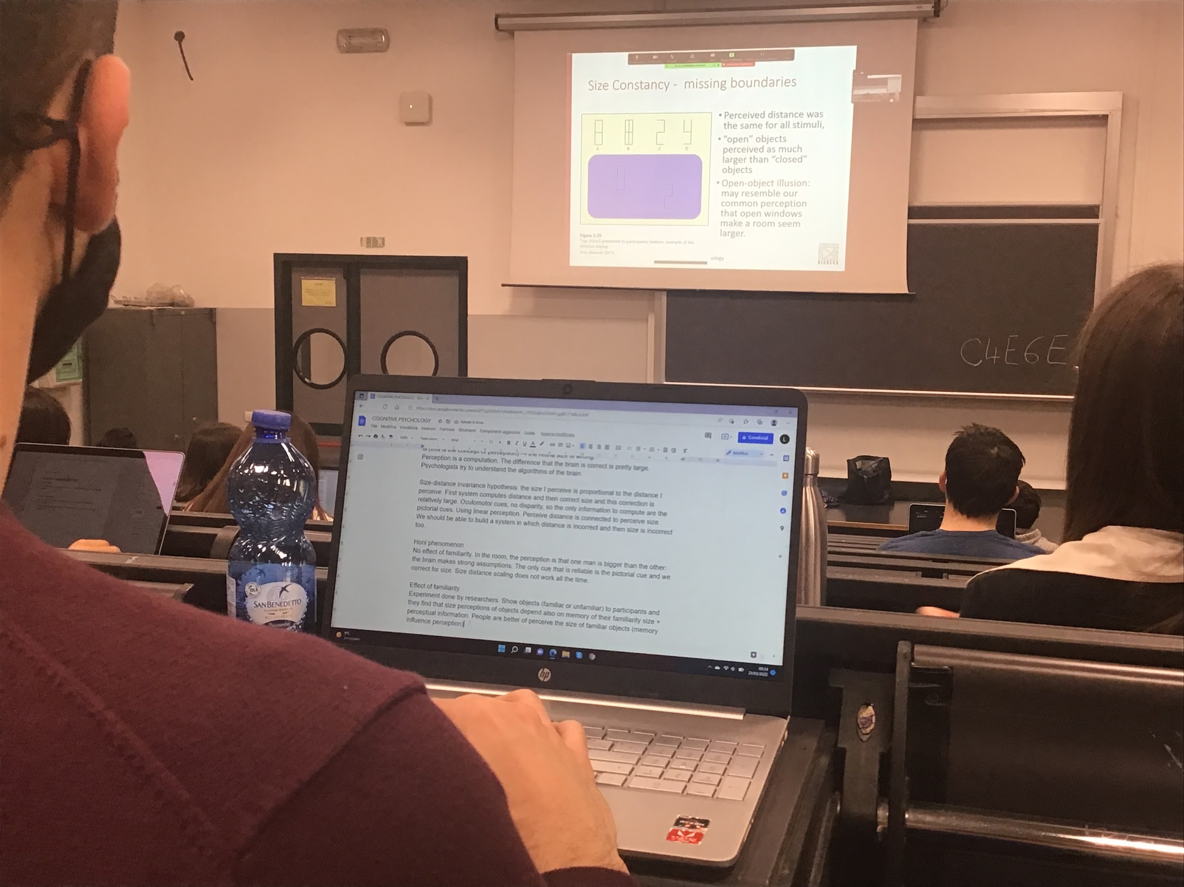

Open object seems larger *open object illusion* try to fill in the openings

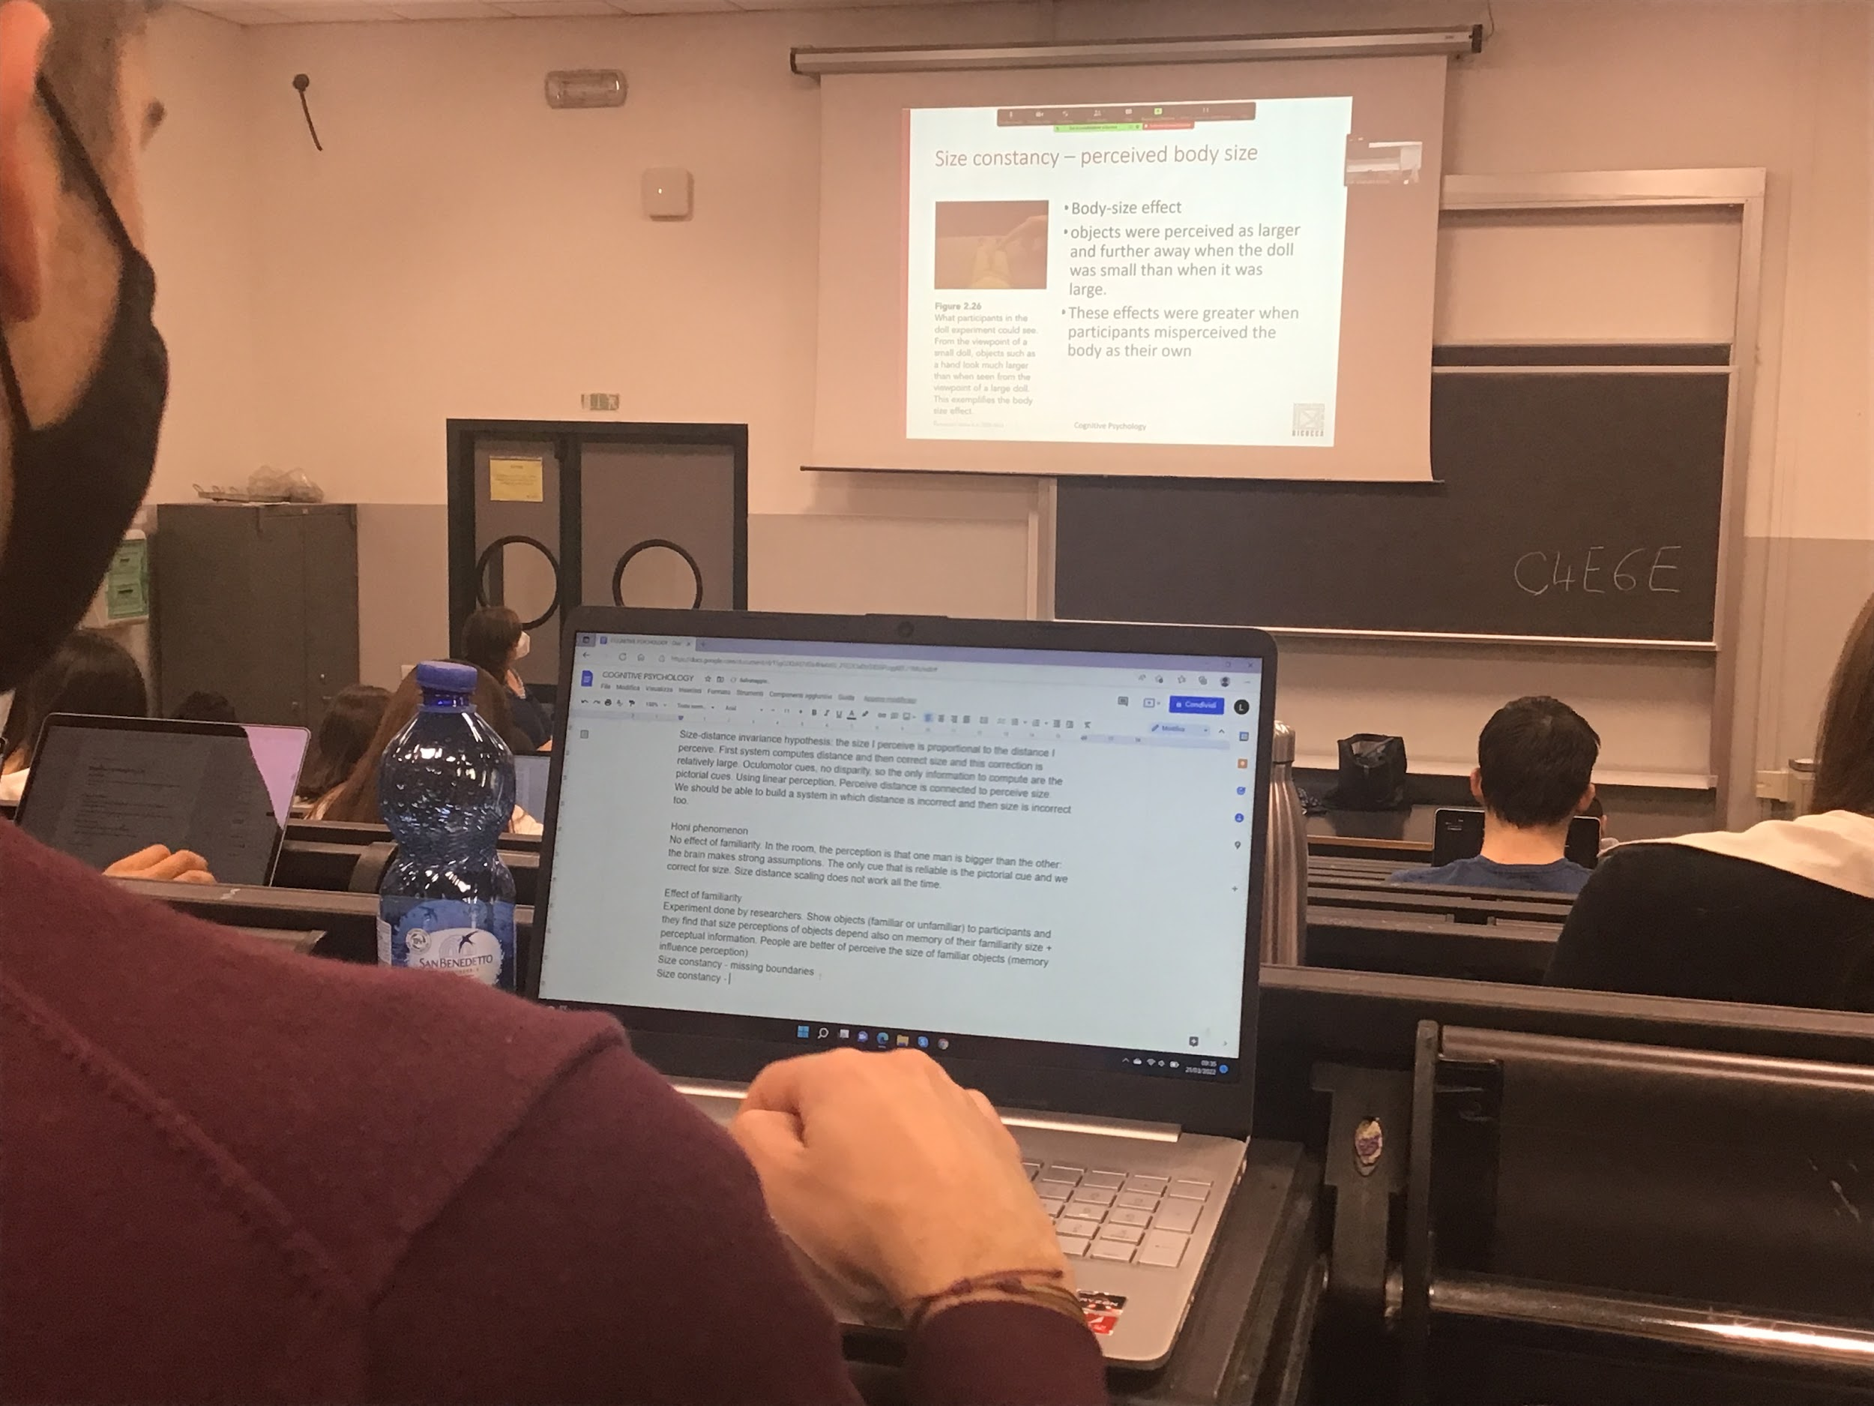

This experiment is connected to a specific effect, I can convince you that your body is what you see in a picture

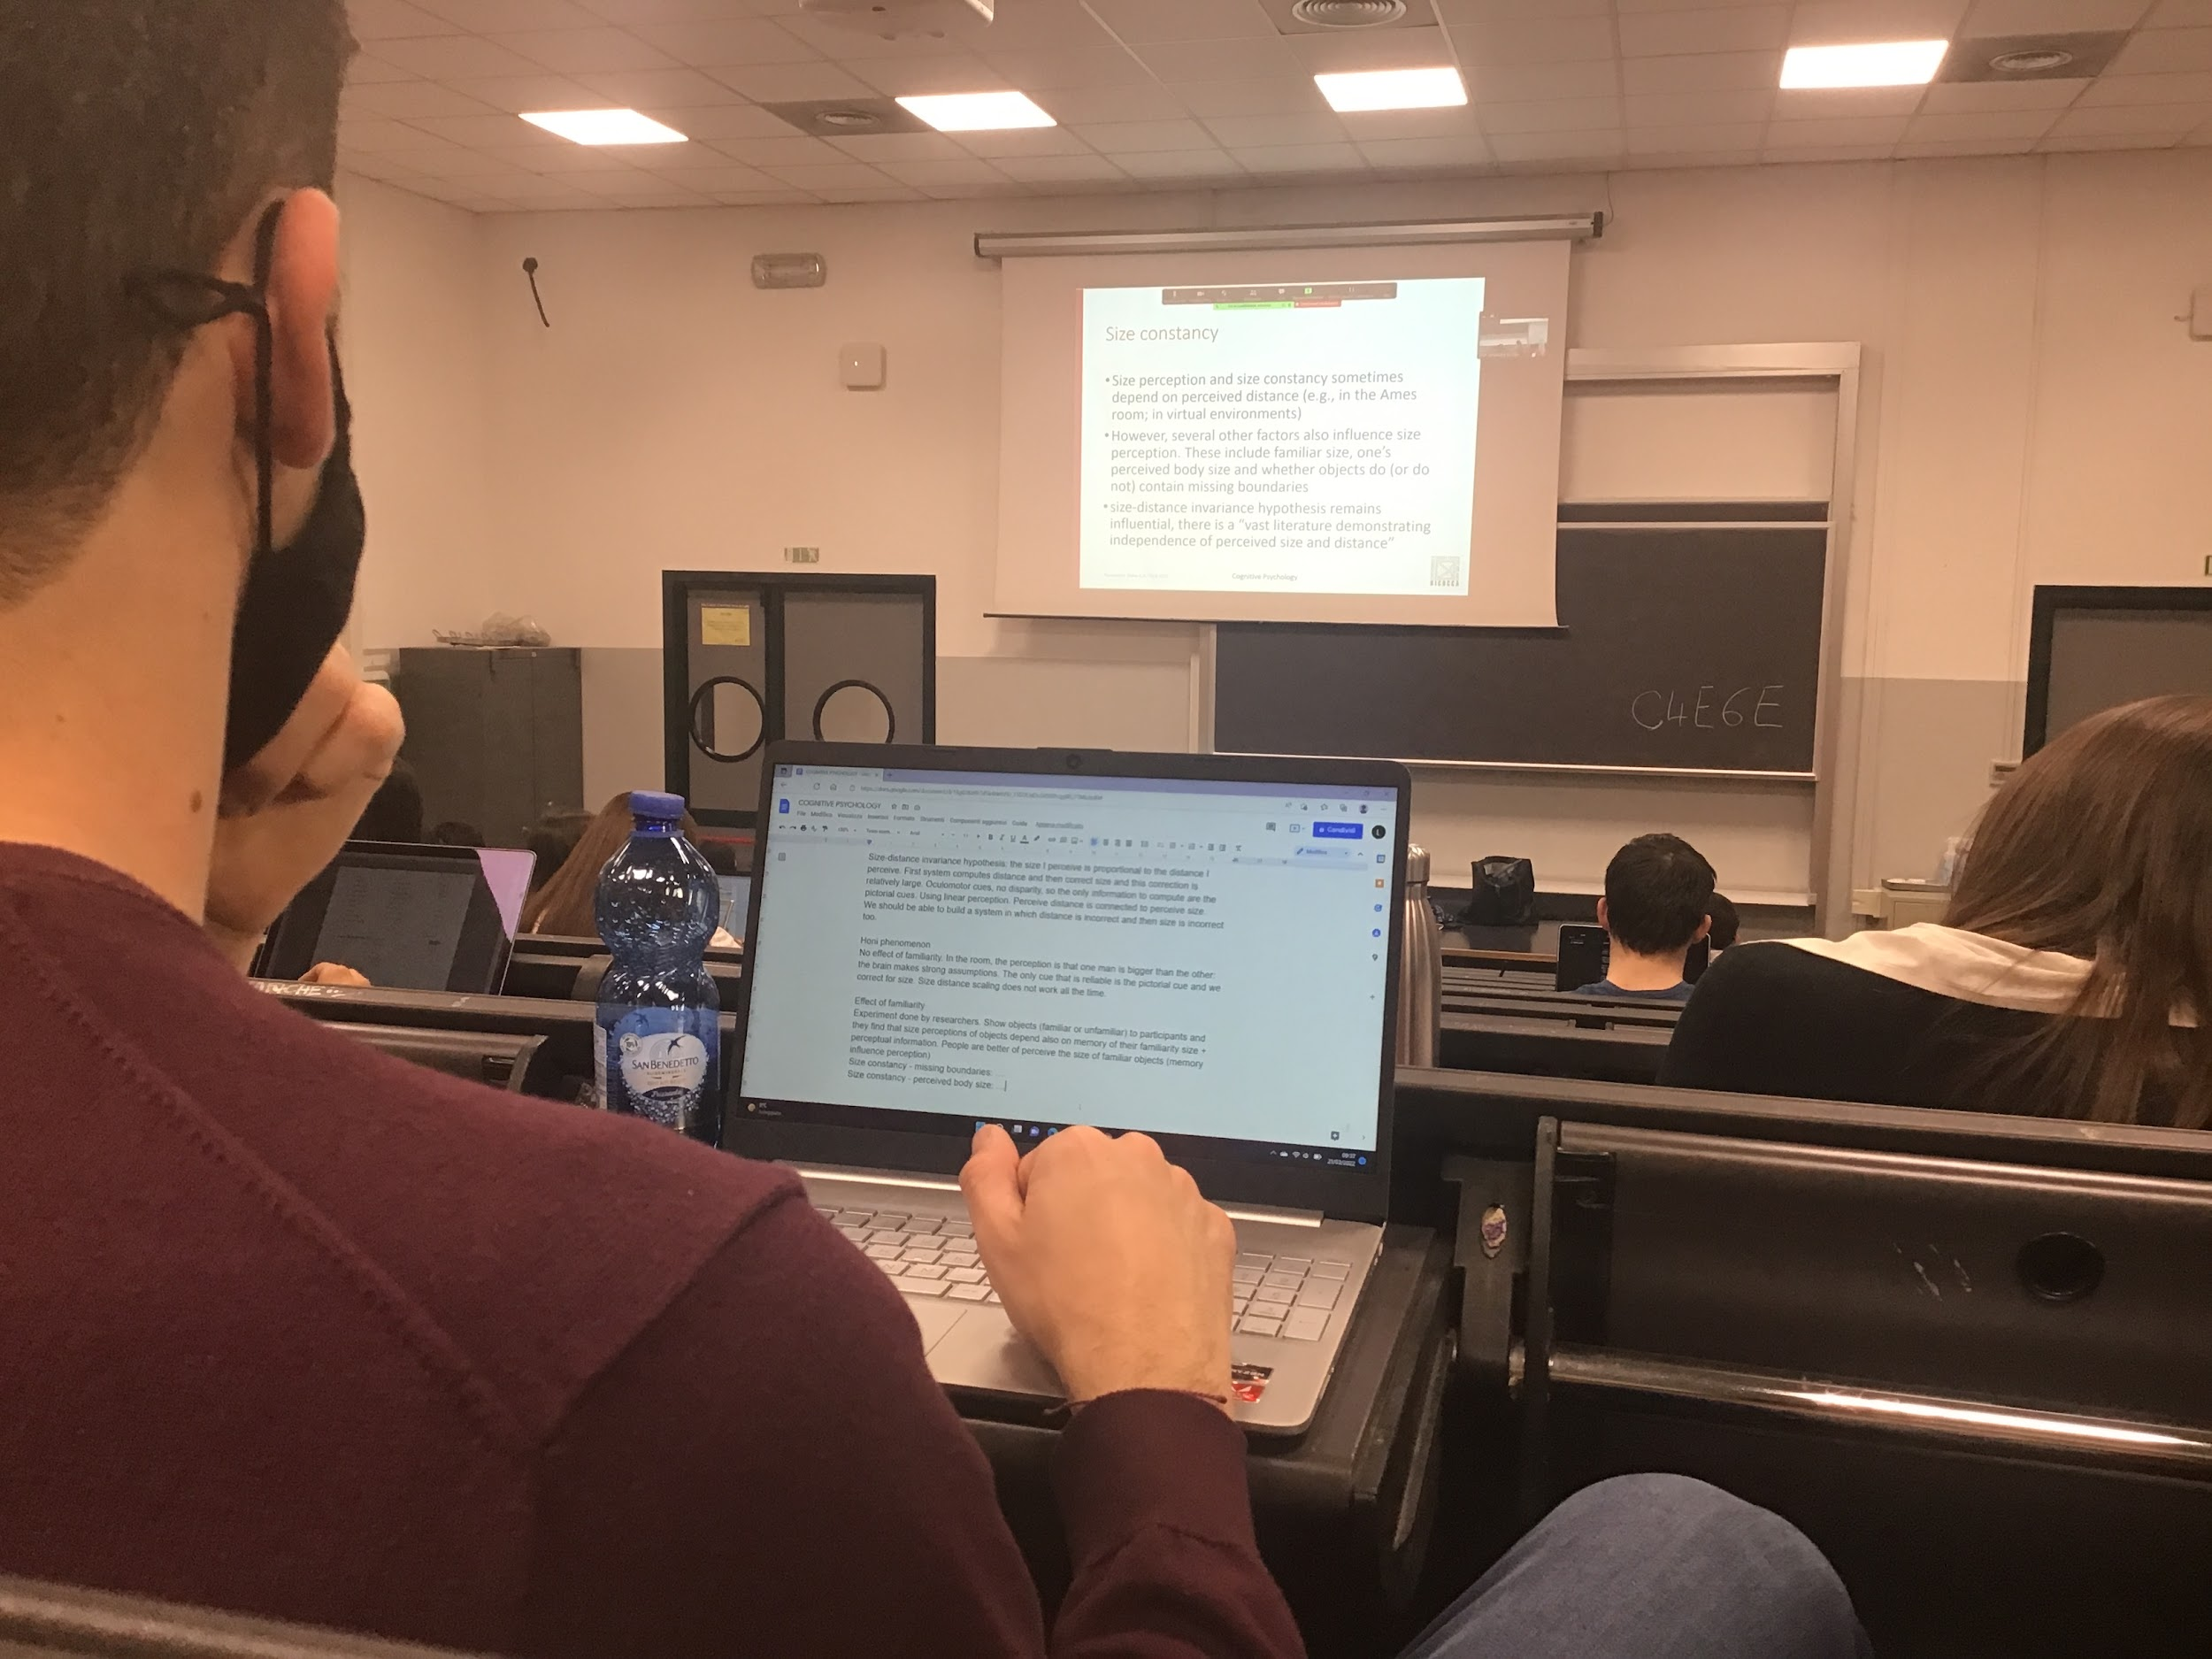

Size constancy is important, we base our computation (most of the times) on perceive distance, this computation can be modulated by other factors (familiar size, perceived body size)

The size distance remains one of the most strongest point, but there are some exceptions

With different pictorial clue the perception can change

**PERCEPTION WITHOUT AWARENESS**

When I perceive something I am aware, when I am not aware not computed or analysed

If what I perceive does not reach consciousness, it will not affect or change your behaviour

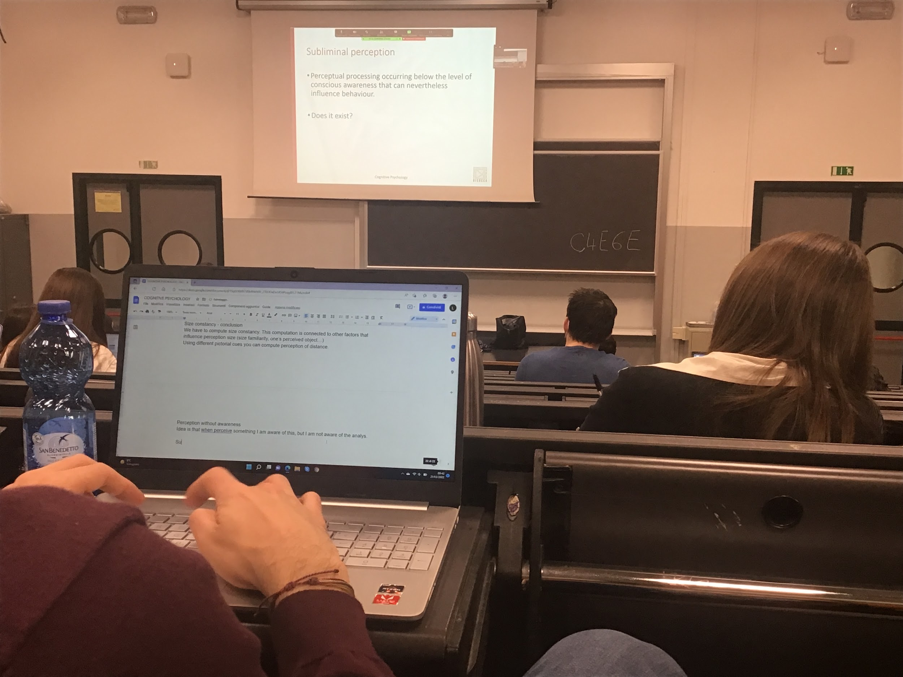

If you are not conscious you don’t change your behaviour

There are some data of perception without awareness, *subliminal perception* presentation of visual stimuli that do not reach consciousness but that they do interfere with your behaviour

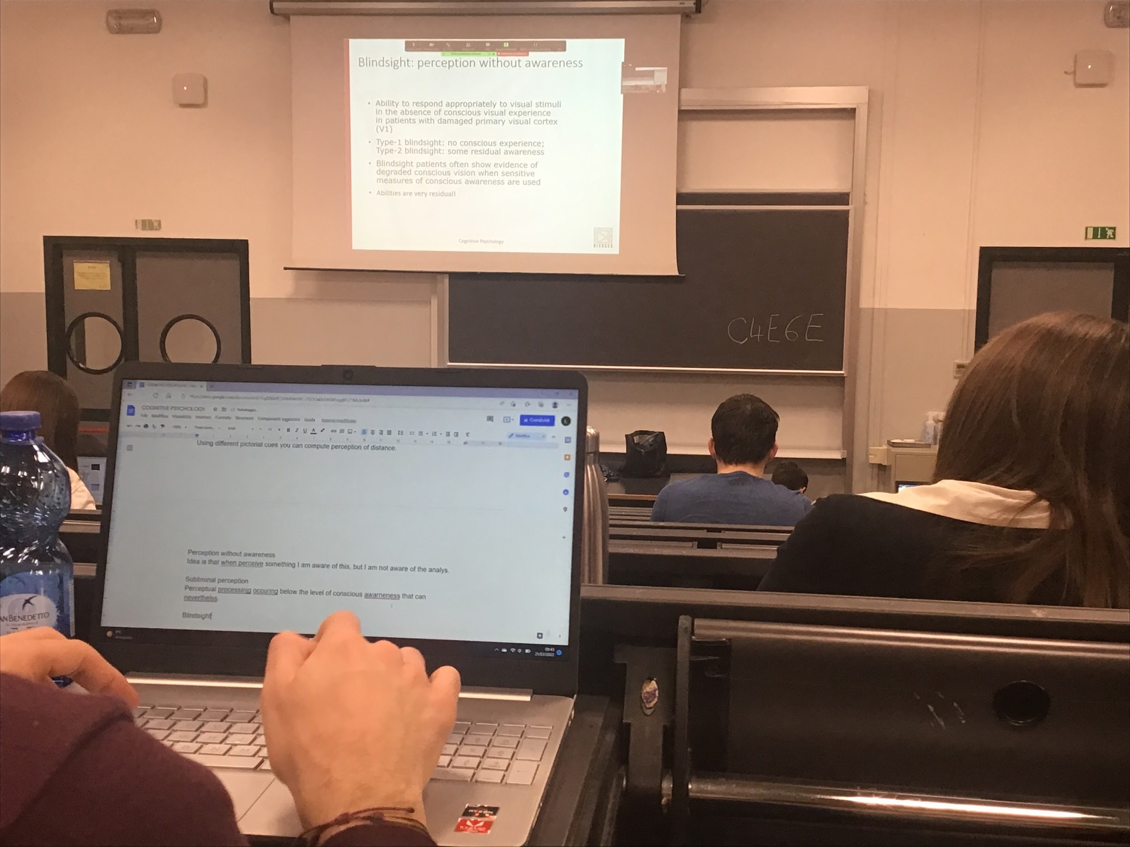

Two types of study on subliminal perception

* Neuropsychological study (a huge group)

There are people with brain lesion (usually in visual cortex V1) and usually only one one side, they don’t see half of the visual sphere but they see the other half

What is on the right is coded on the left V1 and vice versa

Lesion on the right don’t make you see the left side

Those people in the blind field actually have some residual perception

If I cut the visual nerve after the chiams no residual perception

People with this lesion can perform task even if they don’t perceive it

Two types of blind type

* No conscious awareness: feel like nothing happen in the blind field
* Some residual awareness

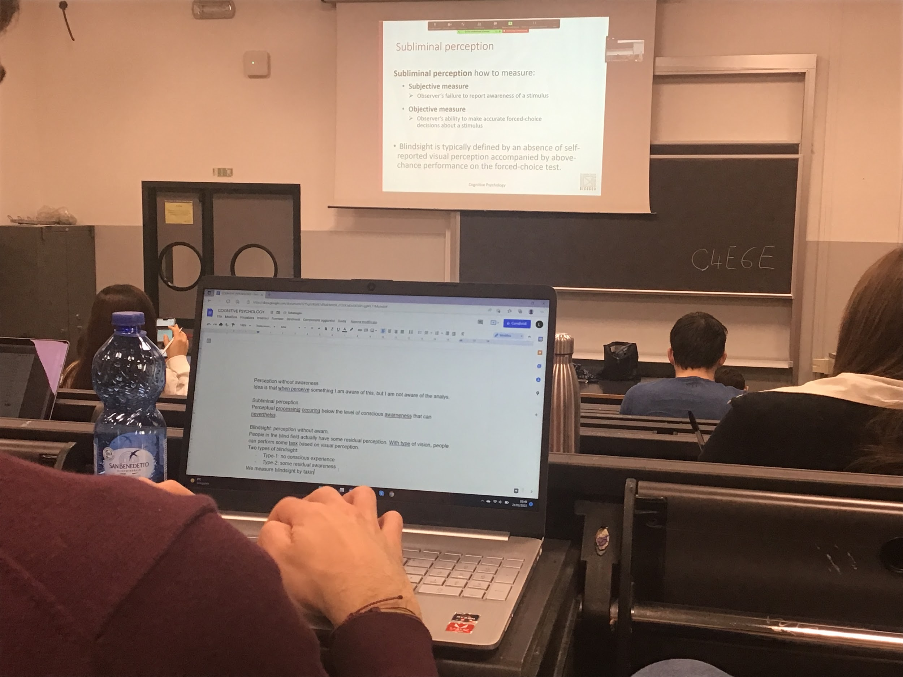

How to compute subliminal perception

Experiment for the same person:

Subjective measure:

* Is there an apple? Yes/no

Objective measure:

* What colour is the apple red/yellow? Forced to tell the colour they have depletion

Most of the time they say they don’t see nothing (subjective measure give nothing) but when you force the search they have detection

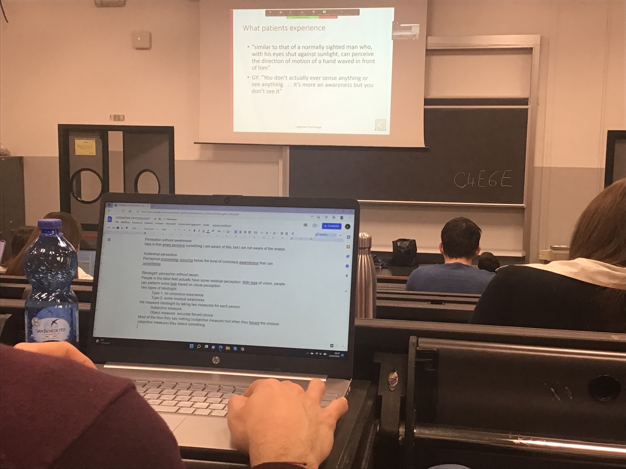

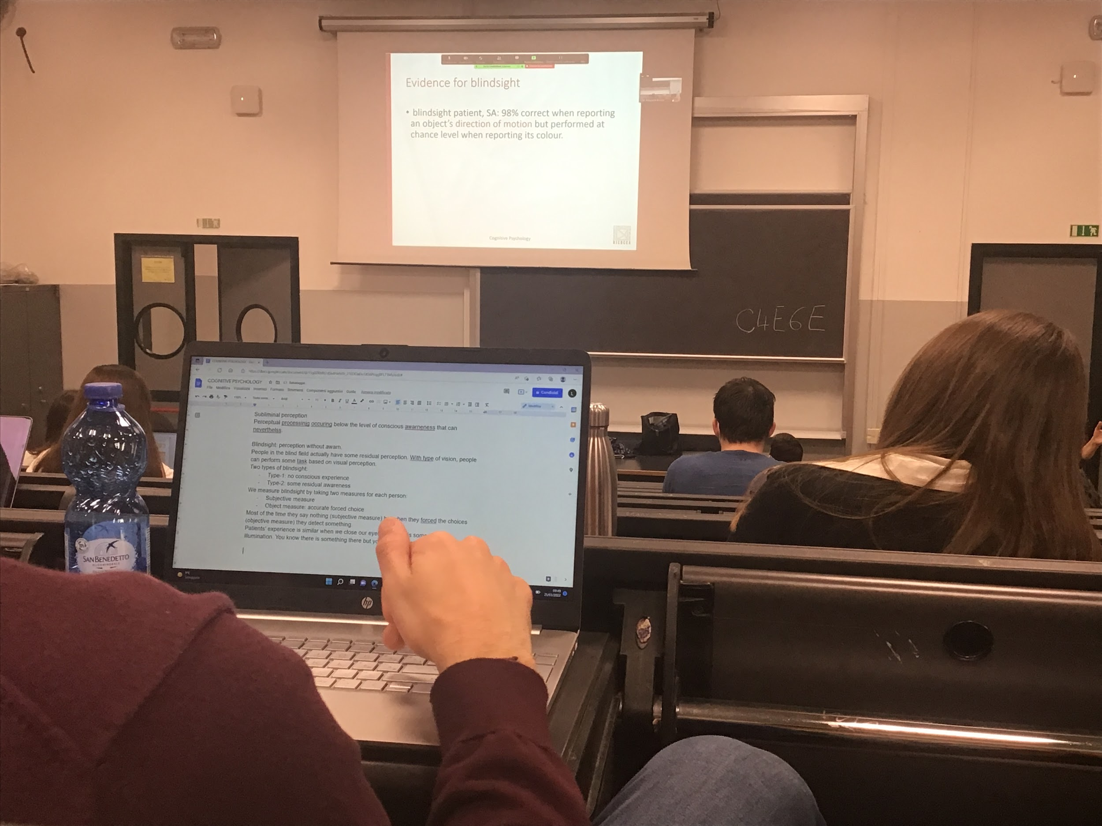

Patient can tell the direction but not the colour

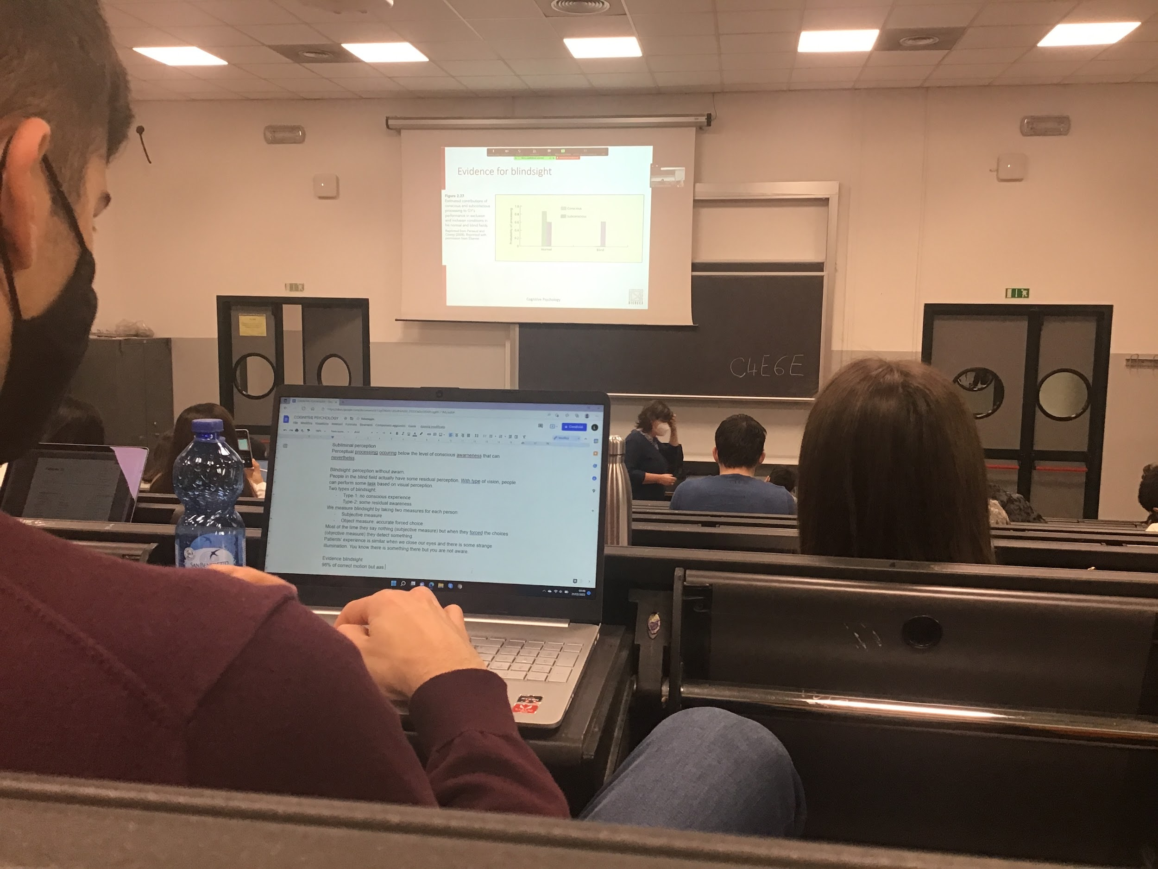

Test people in normal field and blind

Normal field better with conscious

But on blind field only the subconscious response (no conscious response). Something remains with these patients in the blind field

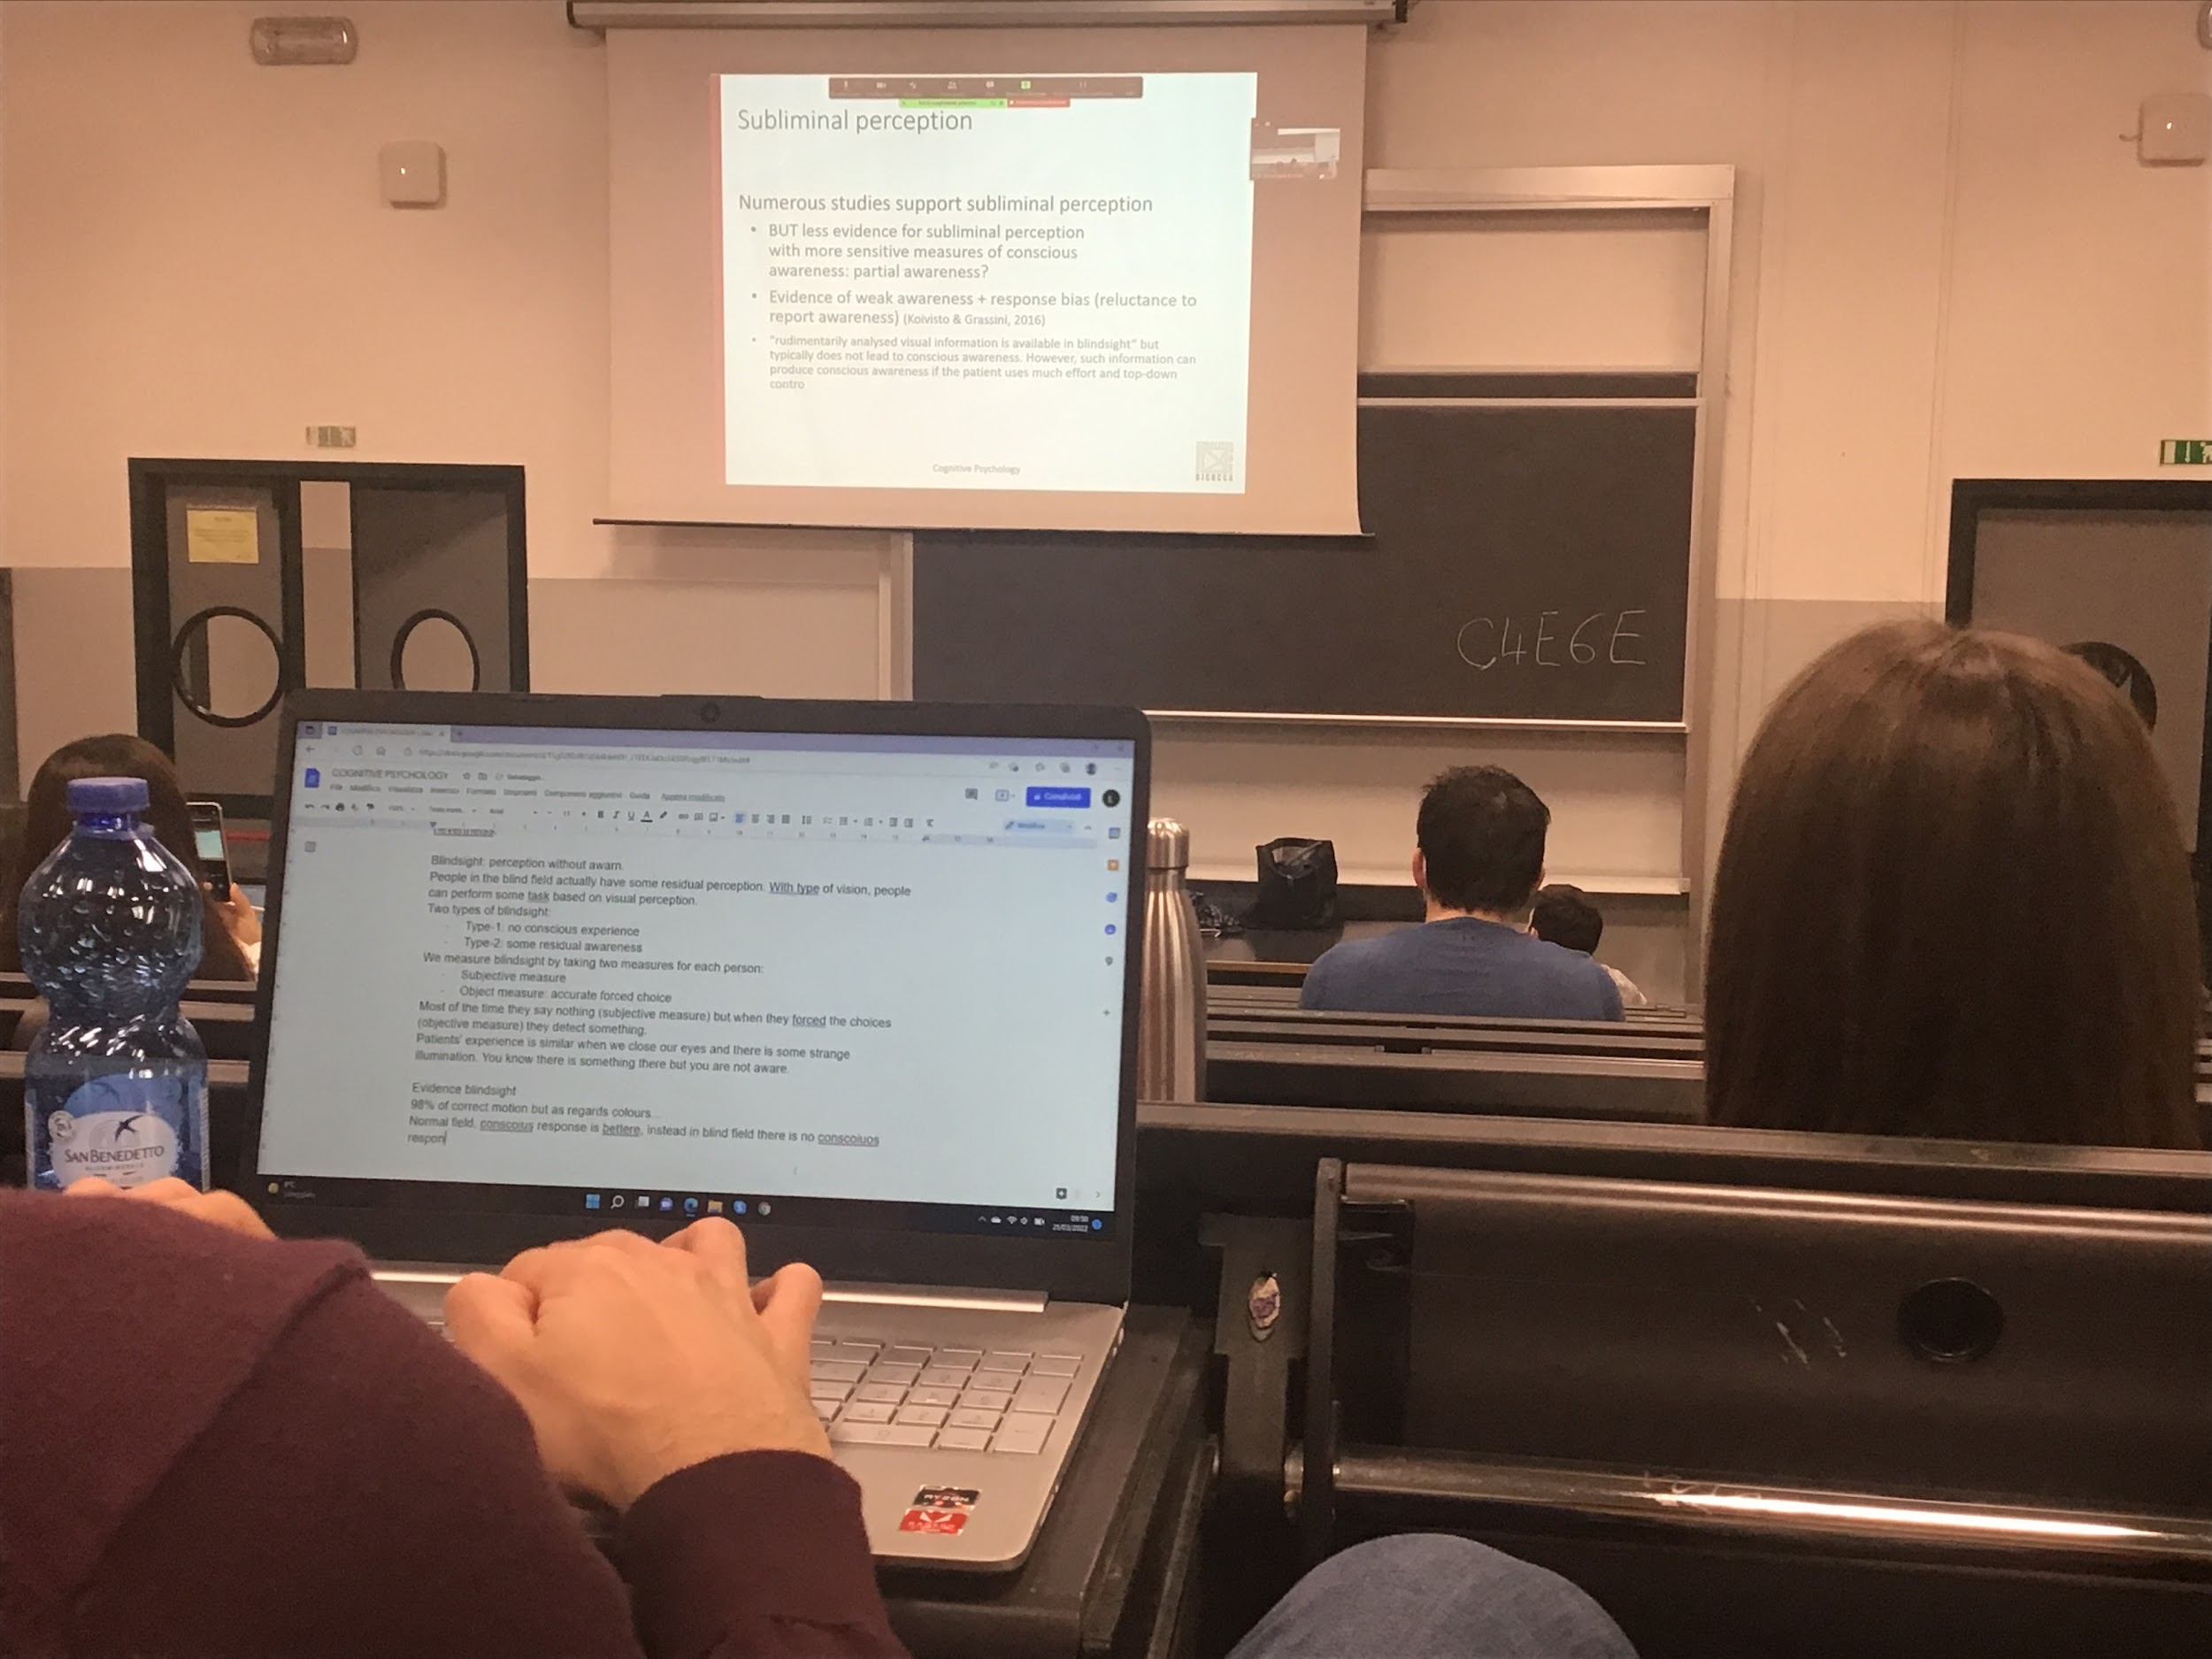

There are many studies that support subliminal perception

The response bias is a problem that we have all the time when we do psychological research

If you want to see if the subject perceive colour, choice between green and red

The question is *is the object red?*

A 100% of the times I ask if the object is red you say yes

The patient can not discriminate the colour

Because if the patient also asks 100% of the time yes on the question *is the object red?*

This problem work with any percentage (also 0% and 100%)

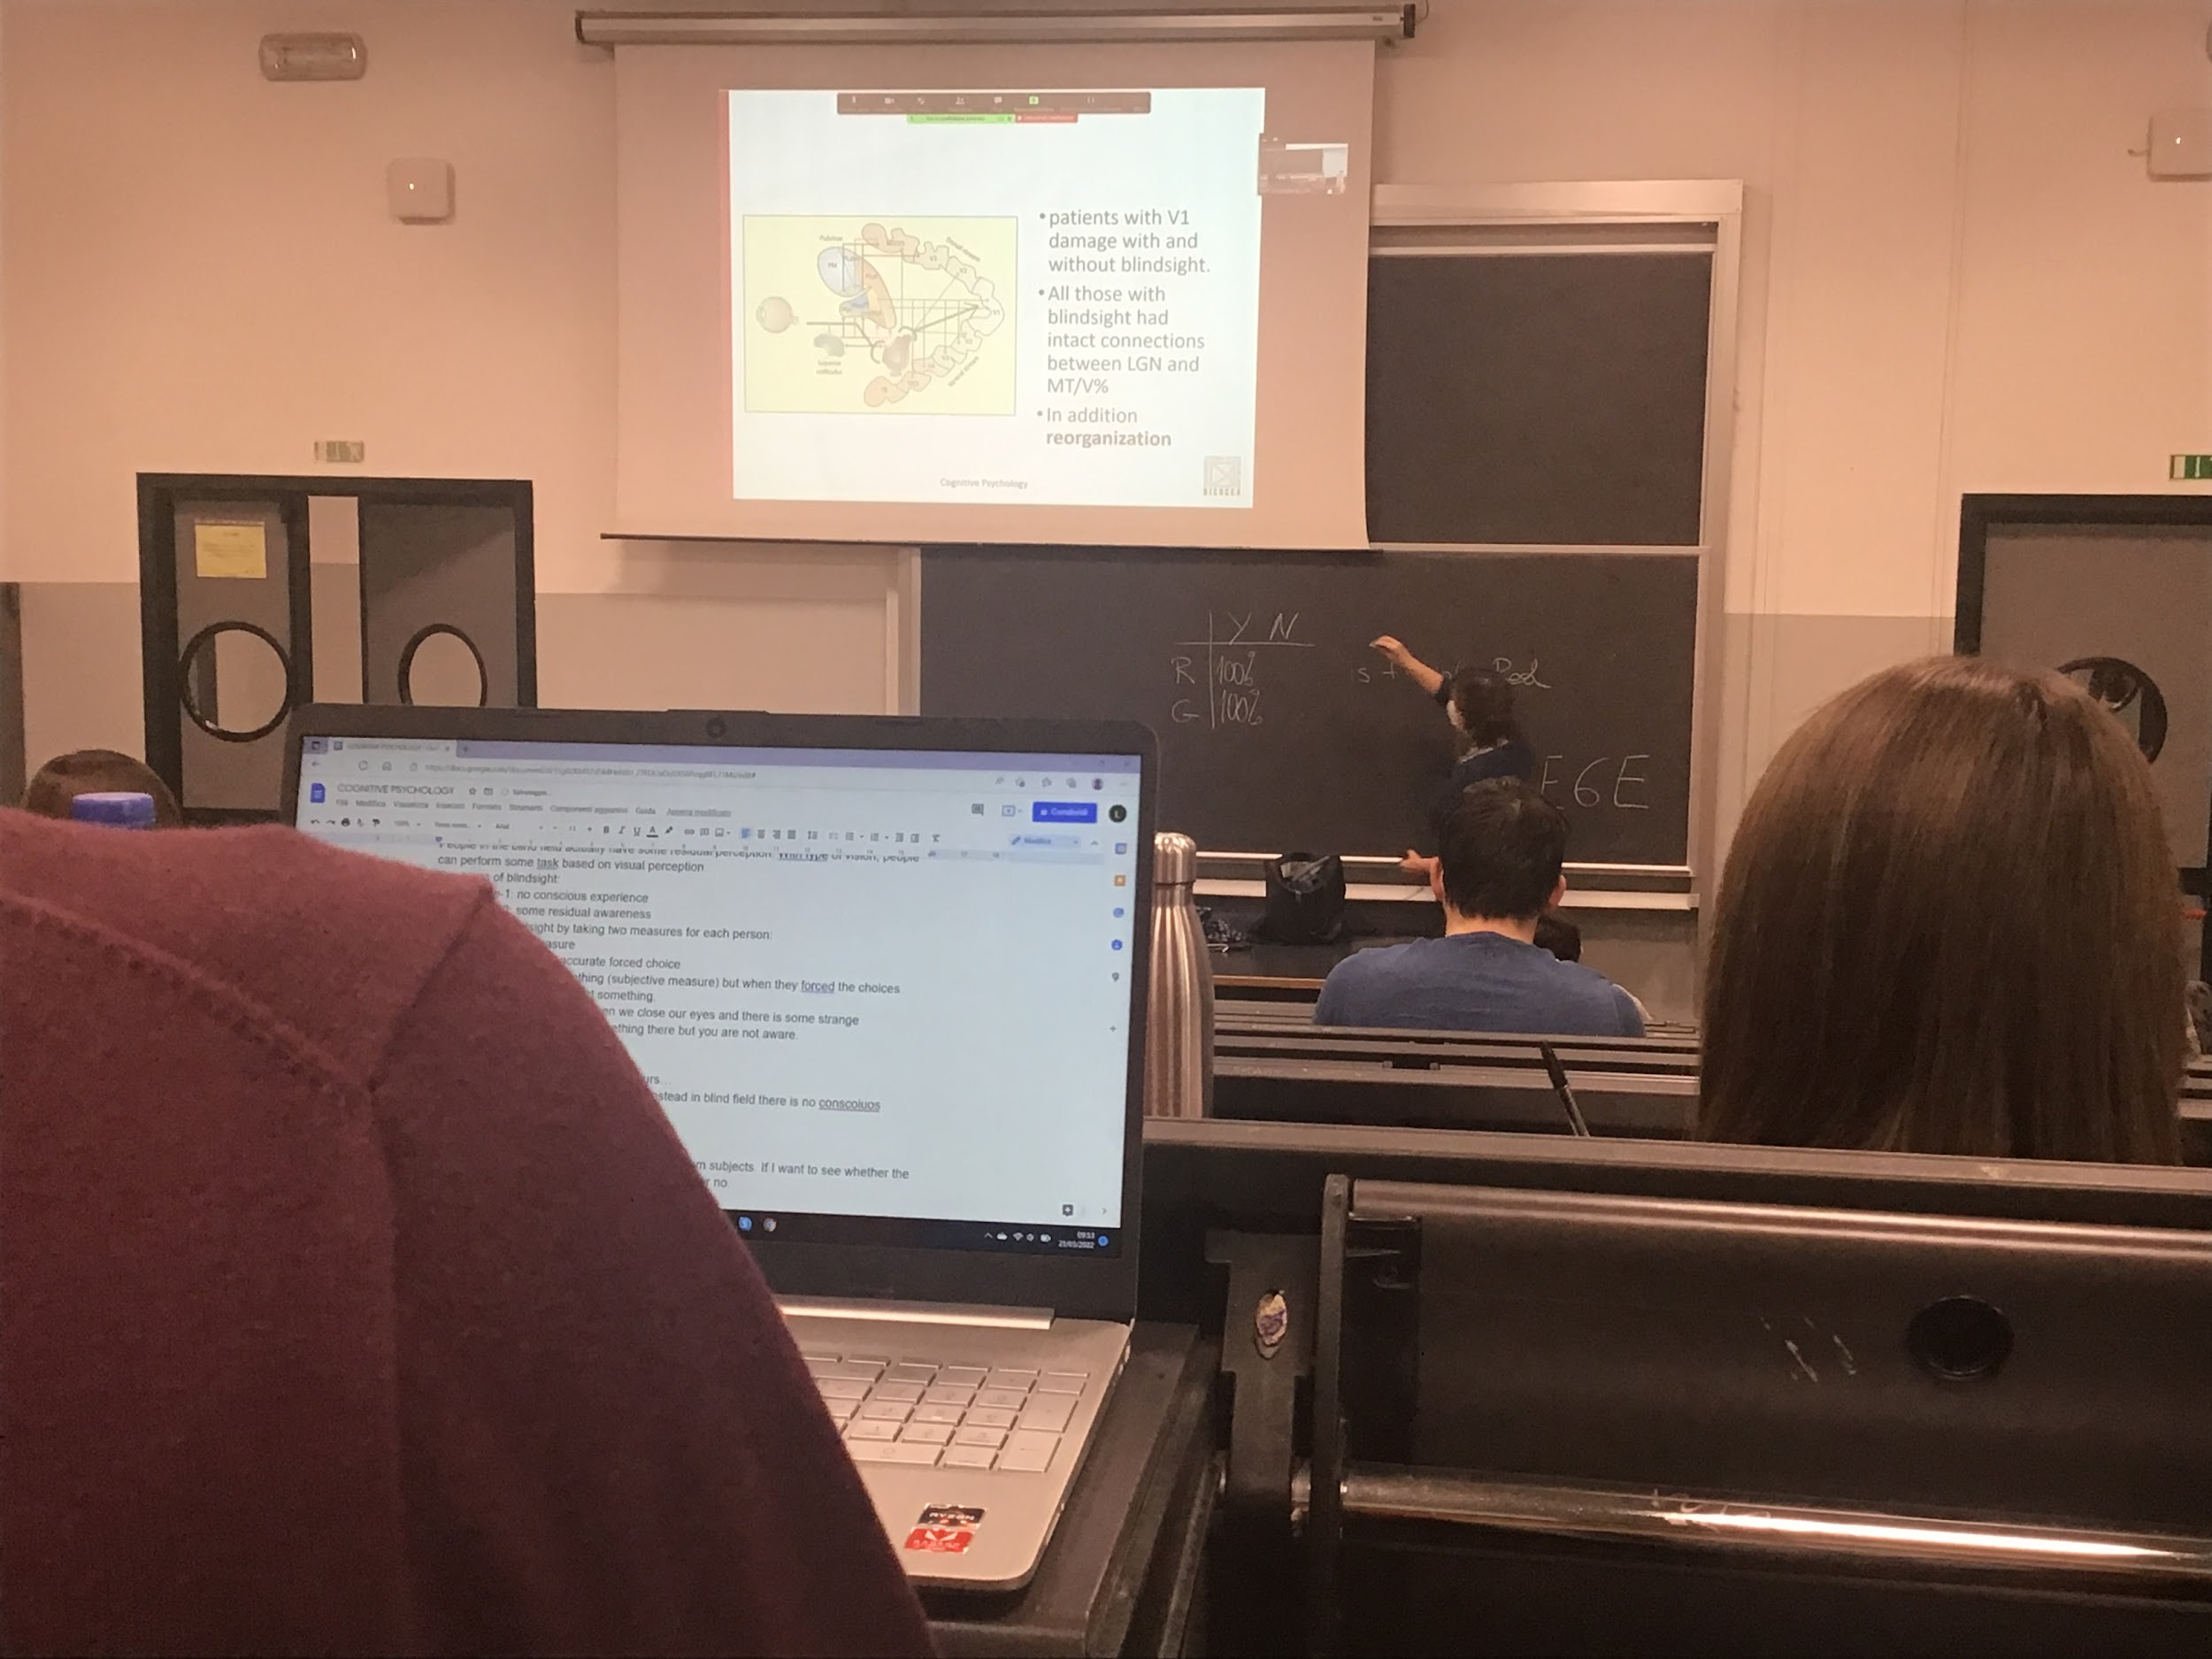

If we look at the lesion with patients with blind side

Informations goes from LGN directly to MTV5

There is also reorganisation of the area

*Perform baias* people can not respond because people prefer to answer no, my tendency to not given a positive answer to the presence of something because I am undecided

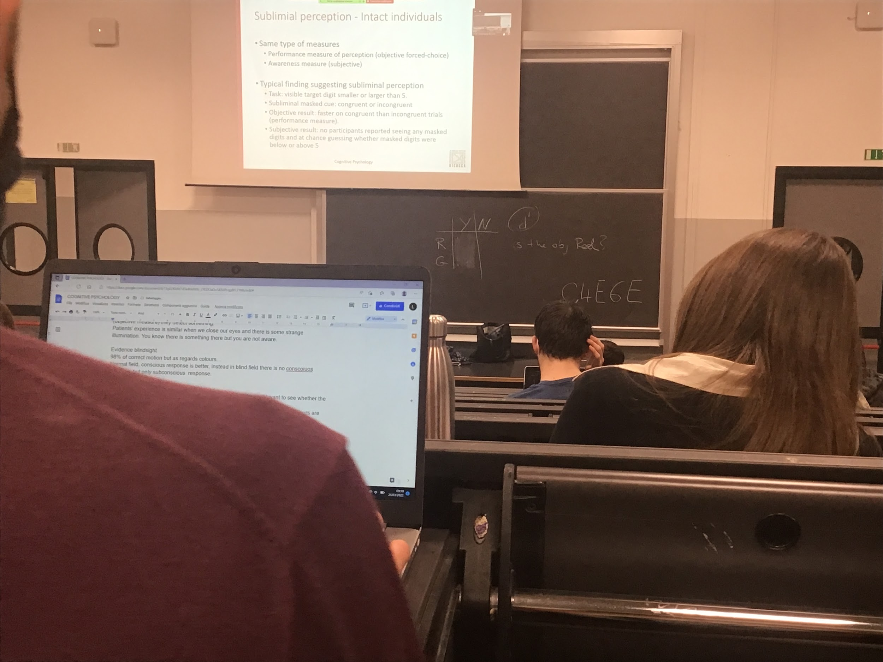

With healthy patients (no brain lesion)

Measure performance

Ask to make an alternative choice and also if you see or not the task

Priming: Subjects are seating in front of a pc show one image for a short time (10ms) then after I show them a mask (usually a random dot square for 100ms) and them I show the correct stimulus

Task: tell me if the number you see is larger or smaller than 5

Not all priming is subliminal

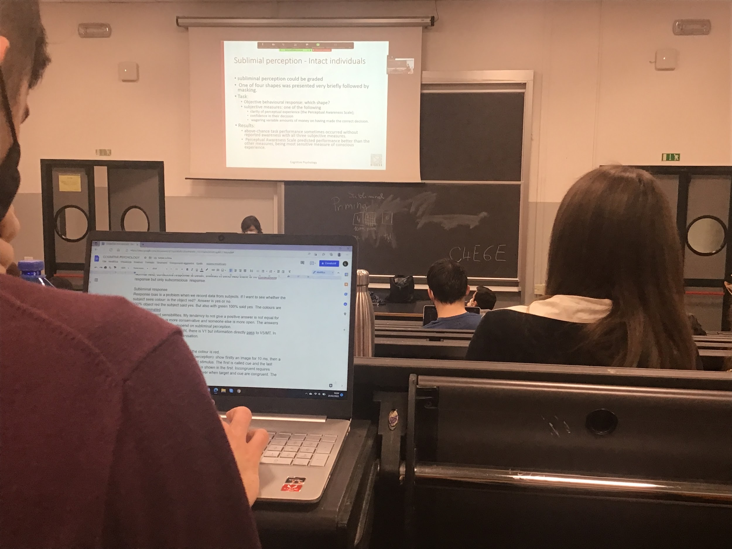

Some subliminal perception can be graded

People have to make two question

How clear what you seen

Depending on the measure you can find some awareness

The best measure is the perception awareness scale

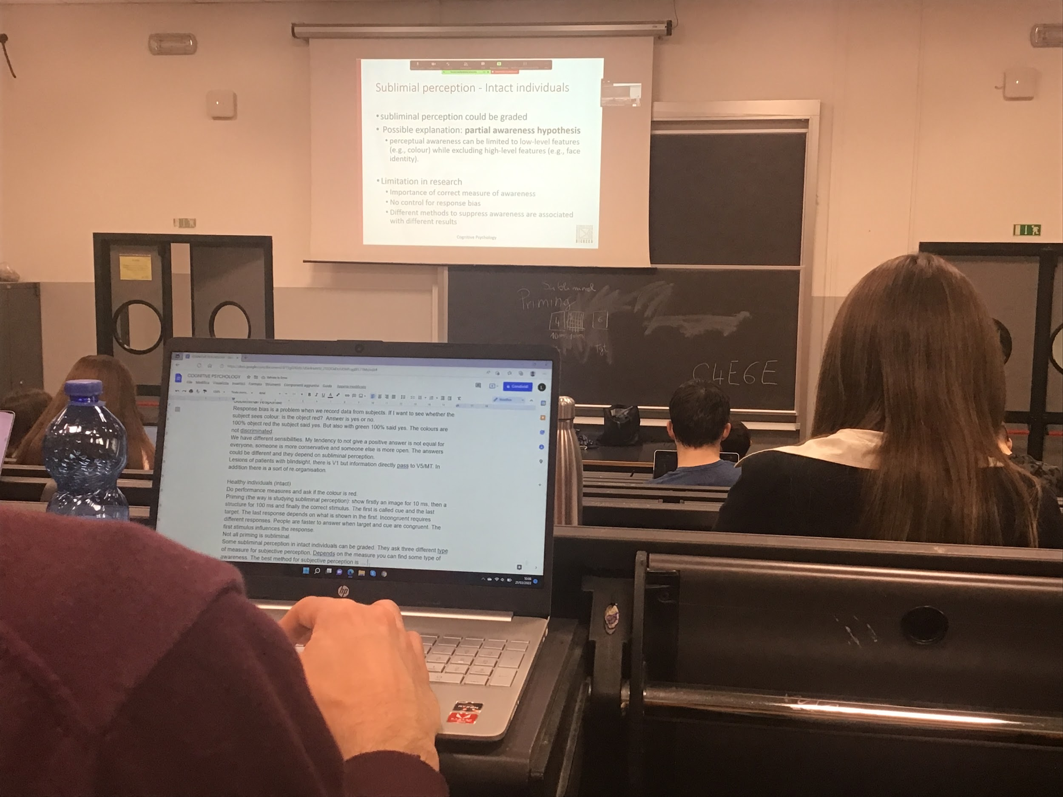

What we can still see when you have the subliminal representation the brain records in any case the low level feature (residual information in V1)

The representation do not reach the high level

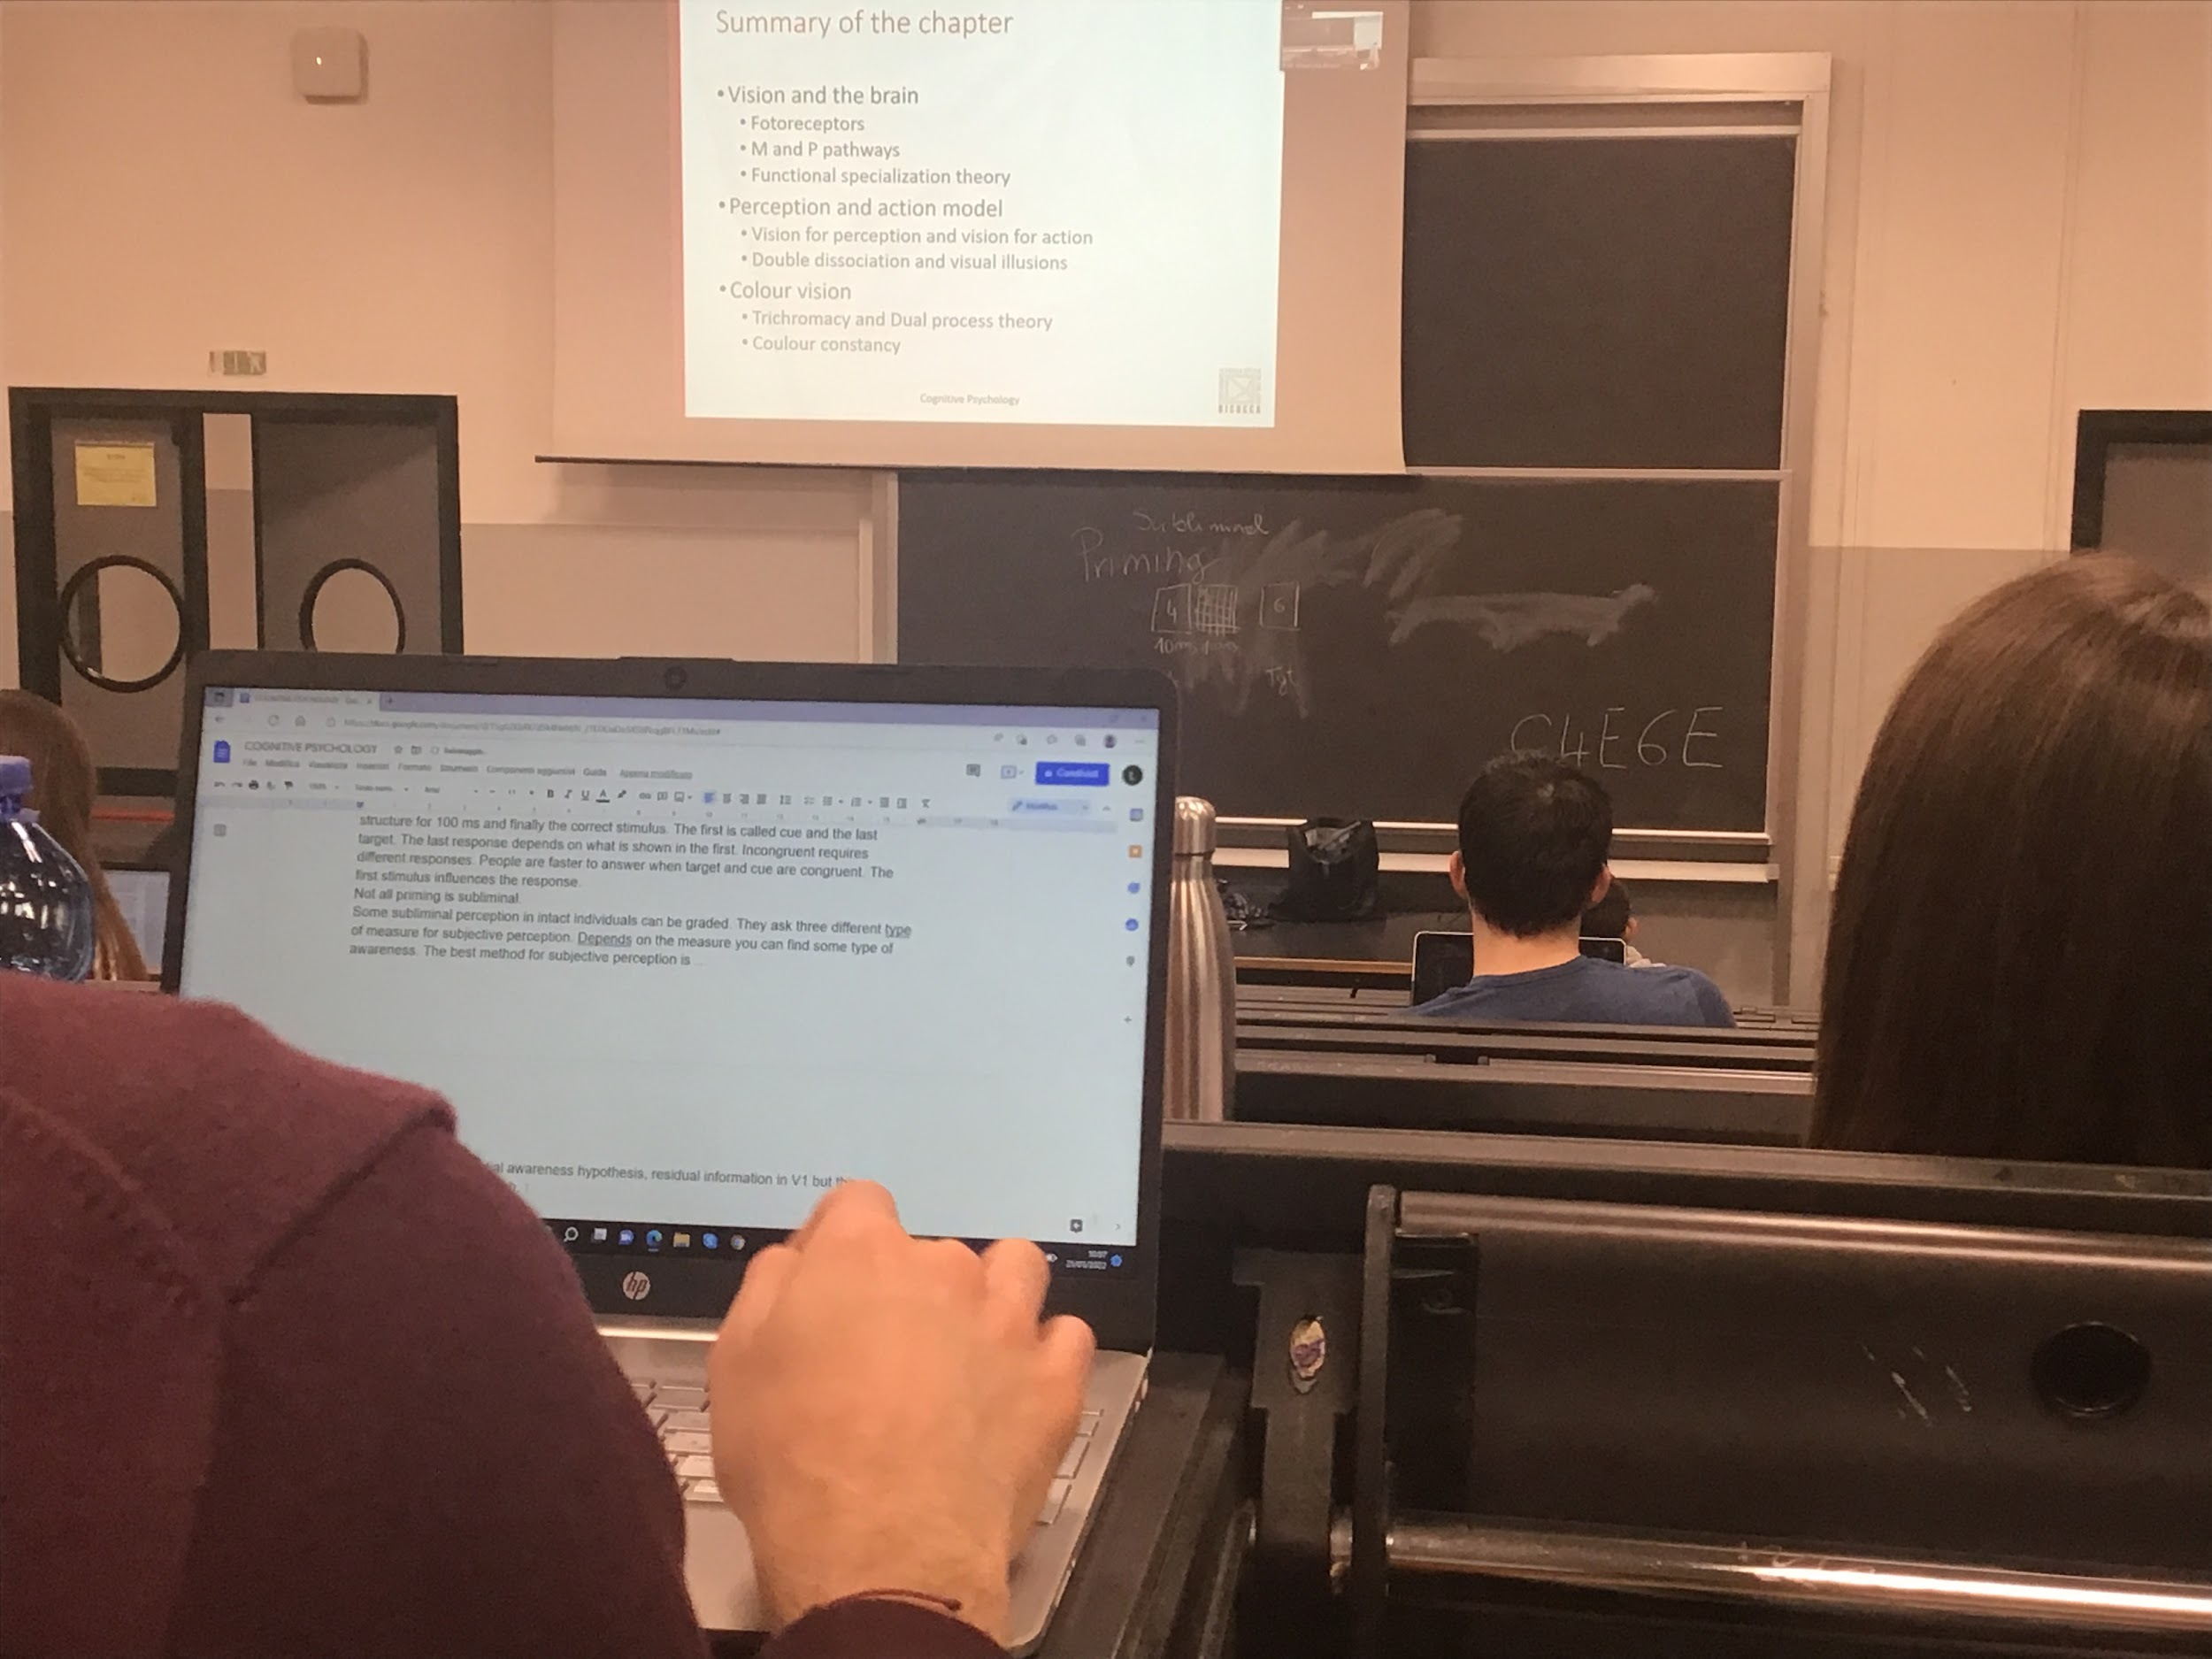

**FACE RECOGNITION**

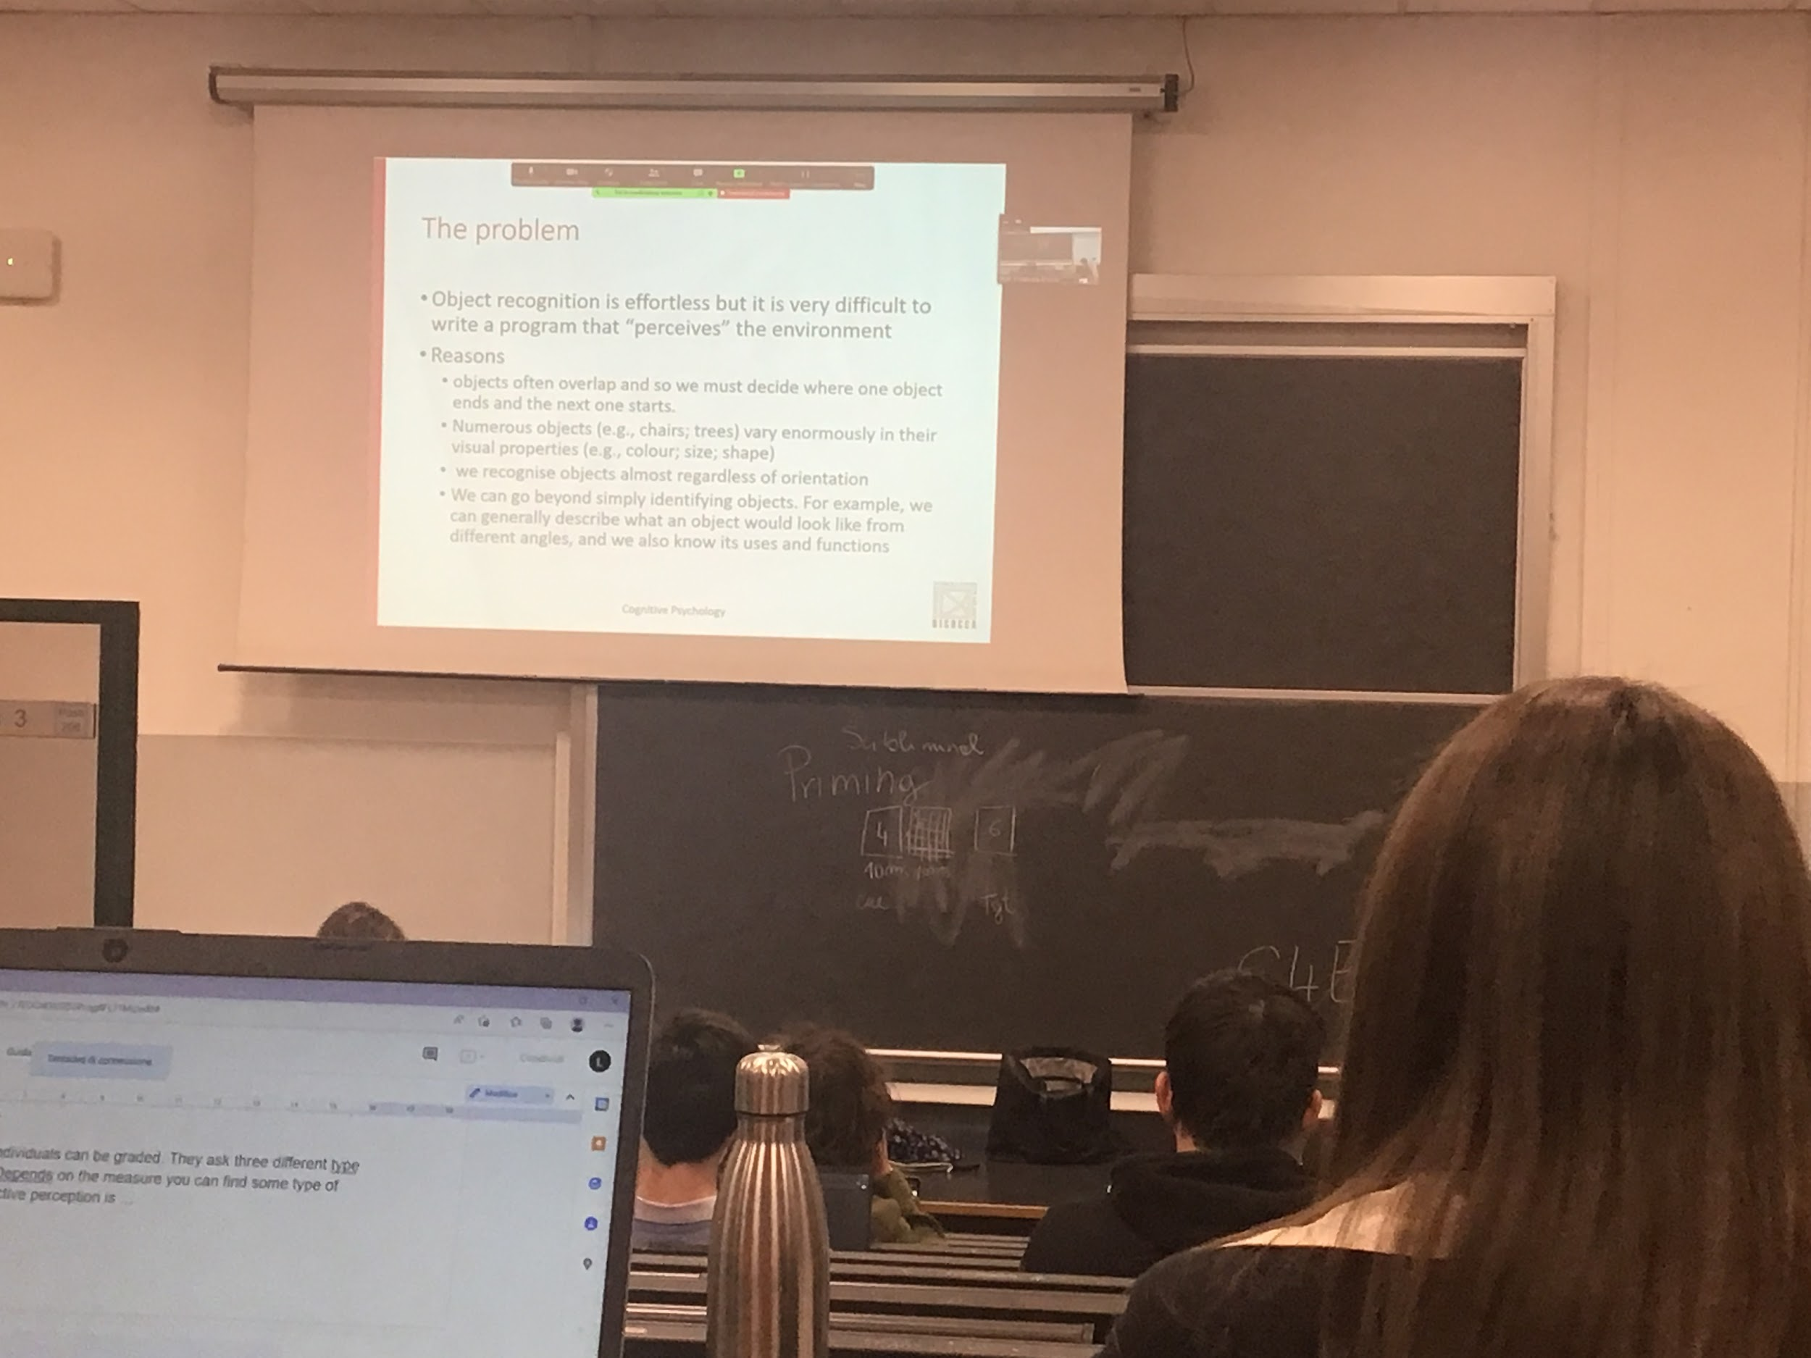

Seems a very easy task to recognise an object, but in reality is an extremely hard task. No programs can perceive the environment

There are specific computer programs that can perform parts of what our visual system can do

Face detection programs can not recognise chairs, dedicate programs for some specific tasks

Be able to recreate a system that reproduce human behaviour is impossible

The problem is that objects are not transparent, most of the times there is only one part (the other part is covered) many objects do not have a standard form (many types of tree, chairs…) all need to be classified on the same concept

Also people have different colours, sizes, shapes, tall, short, skinny, fat…

Recognizing objects is difficult. Even if we have a single isolated object the projection on the retina can be different depending on the relative position of the object with respect to us

Any of this projection has to be associated with the same object

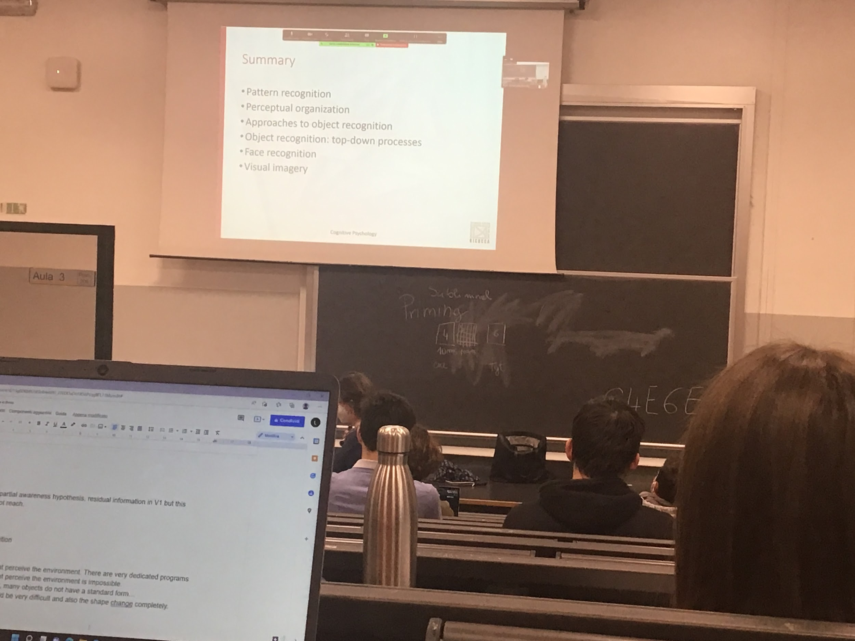

Object recognition

Face recognition

Face recognition is separate, is a specific recognition task, we are discriminating between different individuals that have the same structure (all the faces have two eyes, one nose…) more or less

Pattern recognition: object recognition in 2D. We do this a lot (*reading* is pattern recognition). In many situations we don’t need to recreate a 3D information.

Perceptual organisation: from the general images put together different parts that belong to the same object.

**PATTERN RECOGNITION**

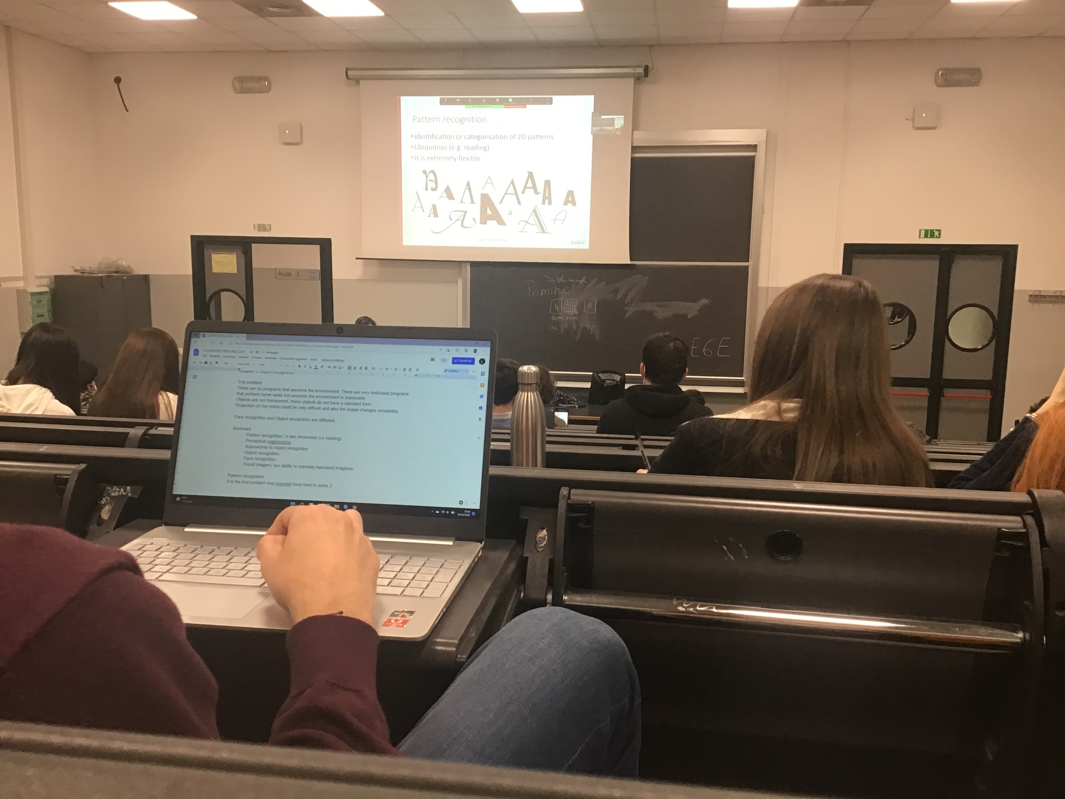

Pattern recognition: first problem that visual scientist tried to solve

The idea is not simple, requires the identification or categorisation of 2D patterns

The system is extremely flexible, because they stimuli are not prototypical

Those are all capitals letter A, all of them has to be classified as the same letter

First step: identification of feature, typical characterization, letter A need to diagonal line and one horizontal

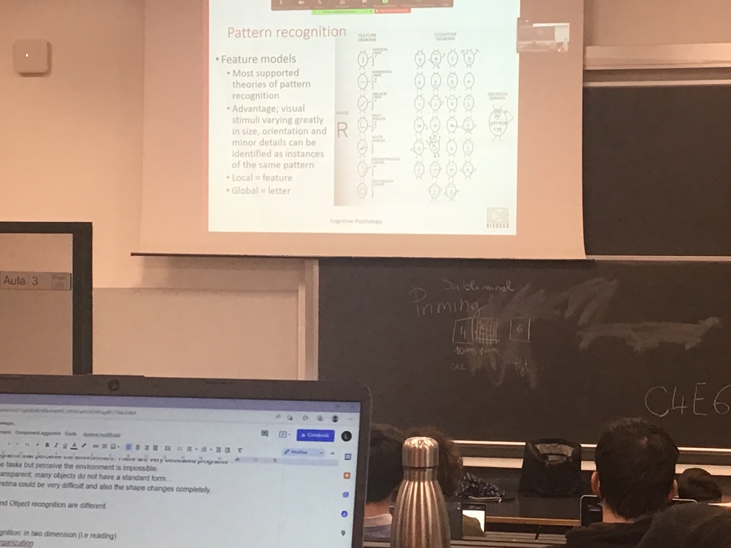

The advantage of this theory is that they can adapt very easily to change in the stimulus (size…)

There is a local computation of the features and then a global aggregation of the letter

This idea has been put to question, use this type of stimuli, big letter made by small letter

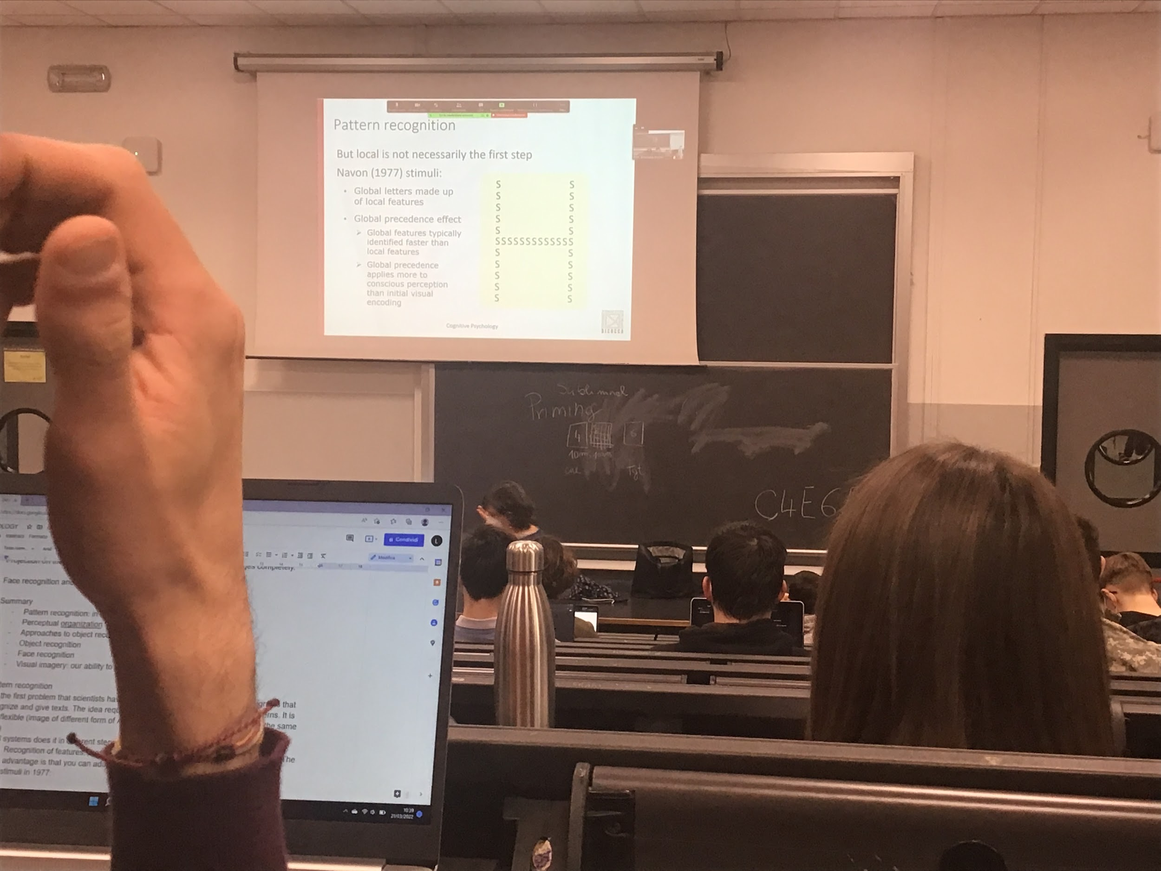

Task of the subject was to identify the small letter or the larger letter

The different stimuli were done like this

This is an incongruent stimulus: local land global are different

Local and global stimuli can be also the same letter (congruent stimuli)

The results:

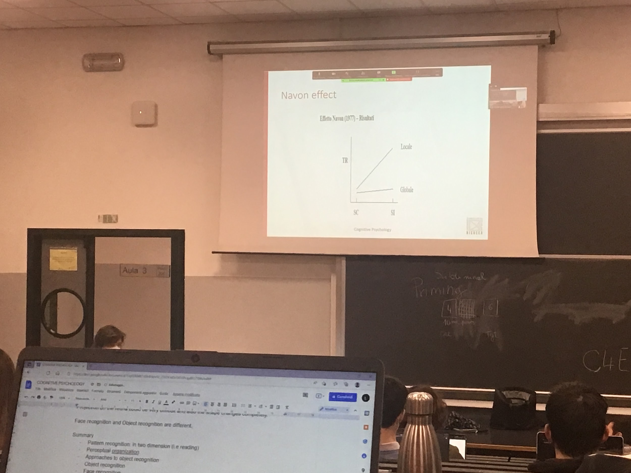

SC: cognitive stimuli

SI: incognitive stimuli

When the stimuli are congruent you are fast, similar speed to identify big or small letter

When they are incongruent the larger letter interfere with the small letter

In the example H’s we are faster to say H than S. the big global form is interfering with your task

This data seems to be contrary to the hypothesis of the features model

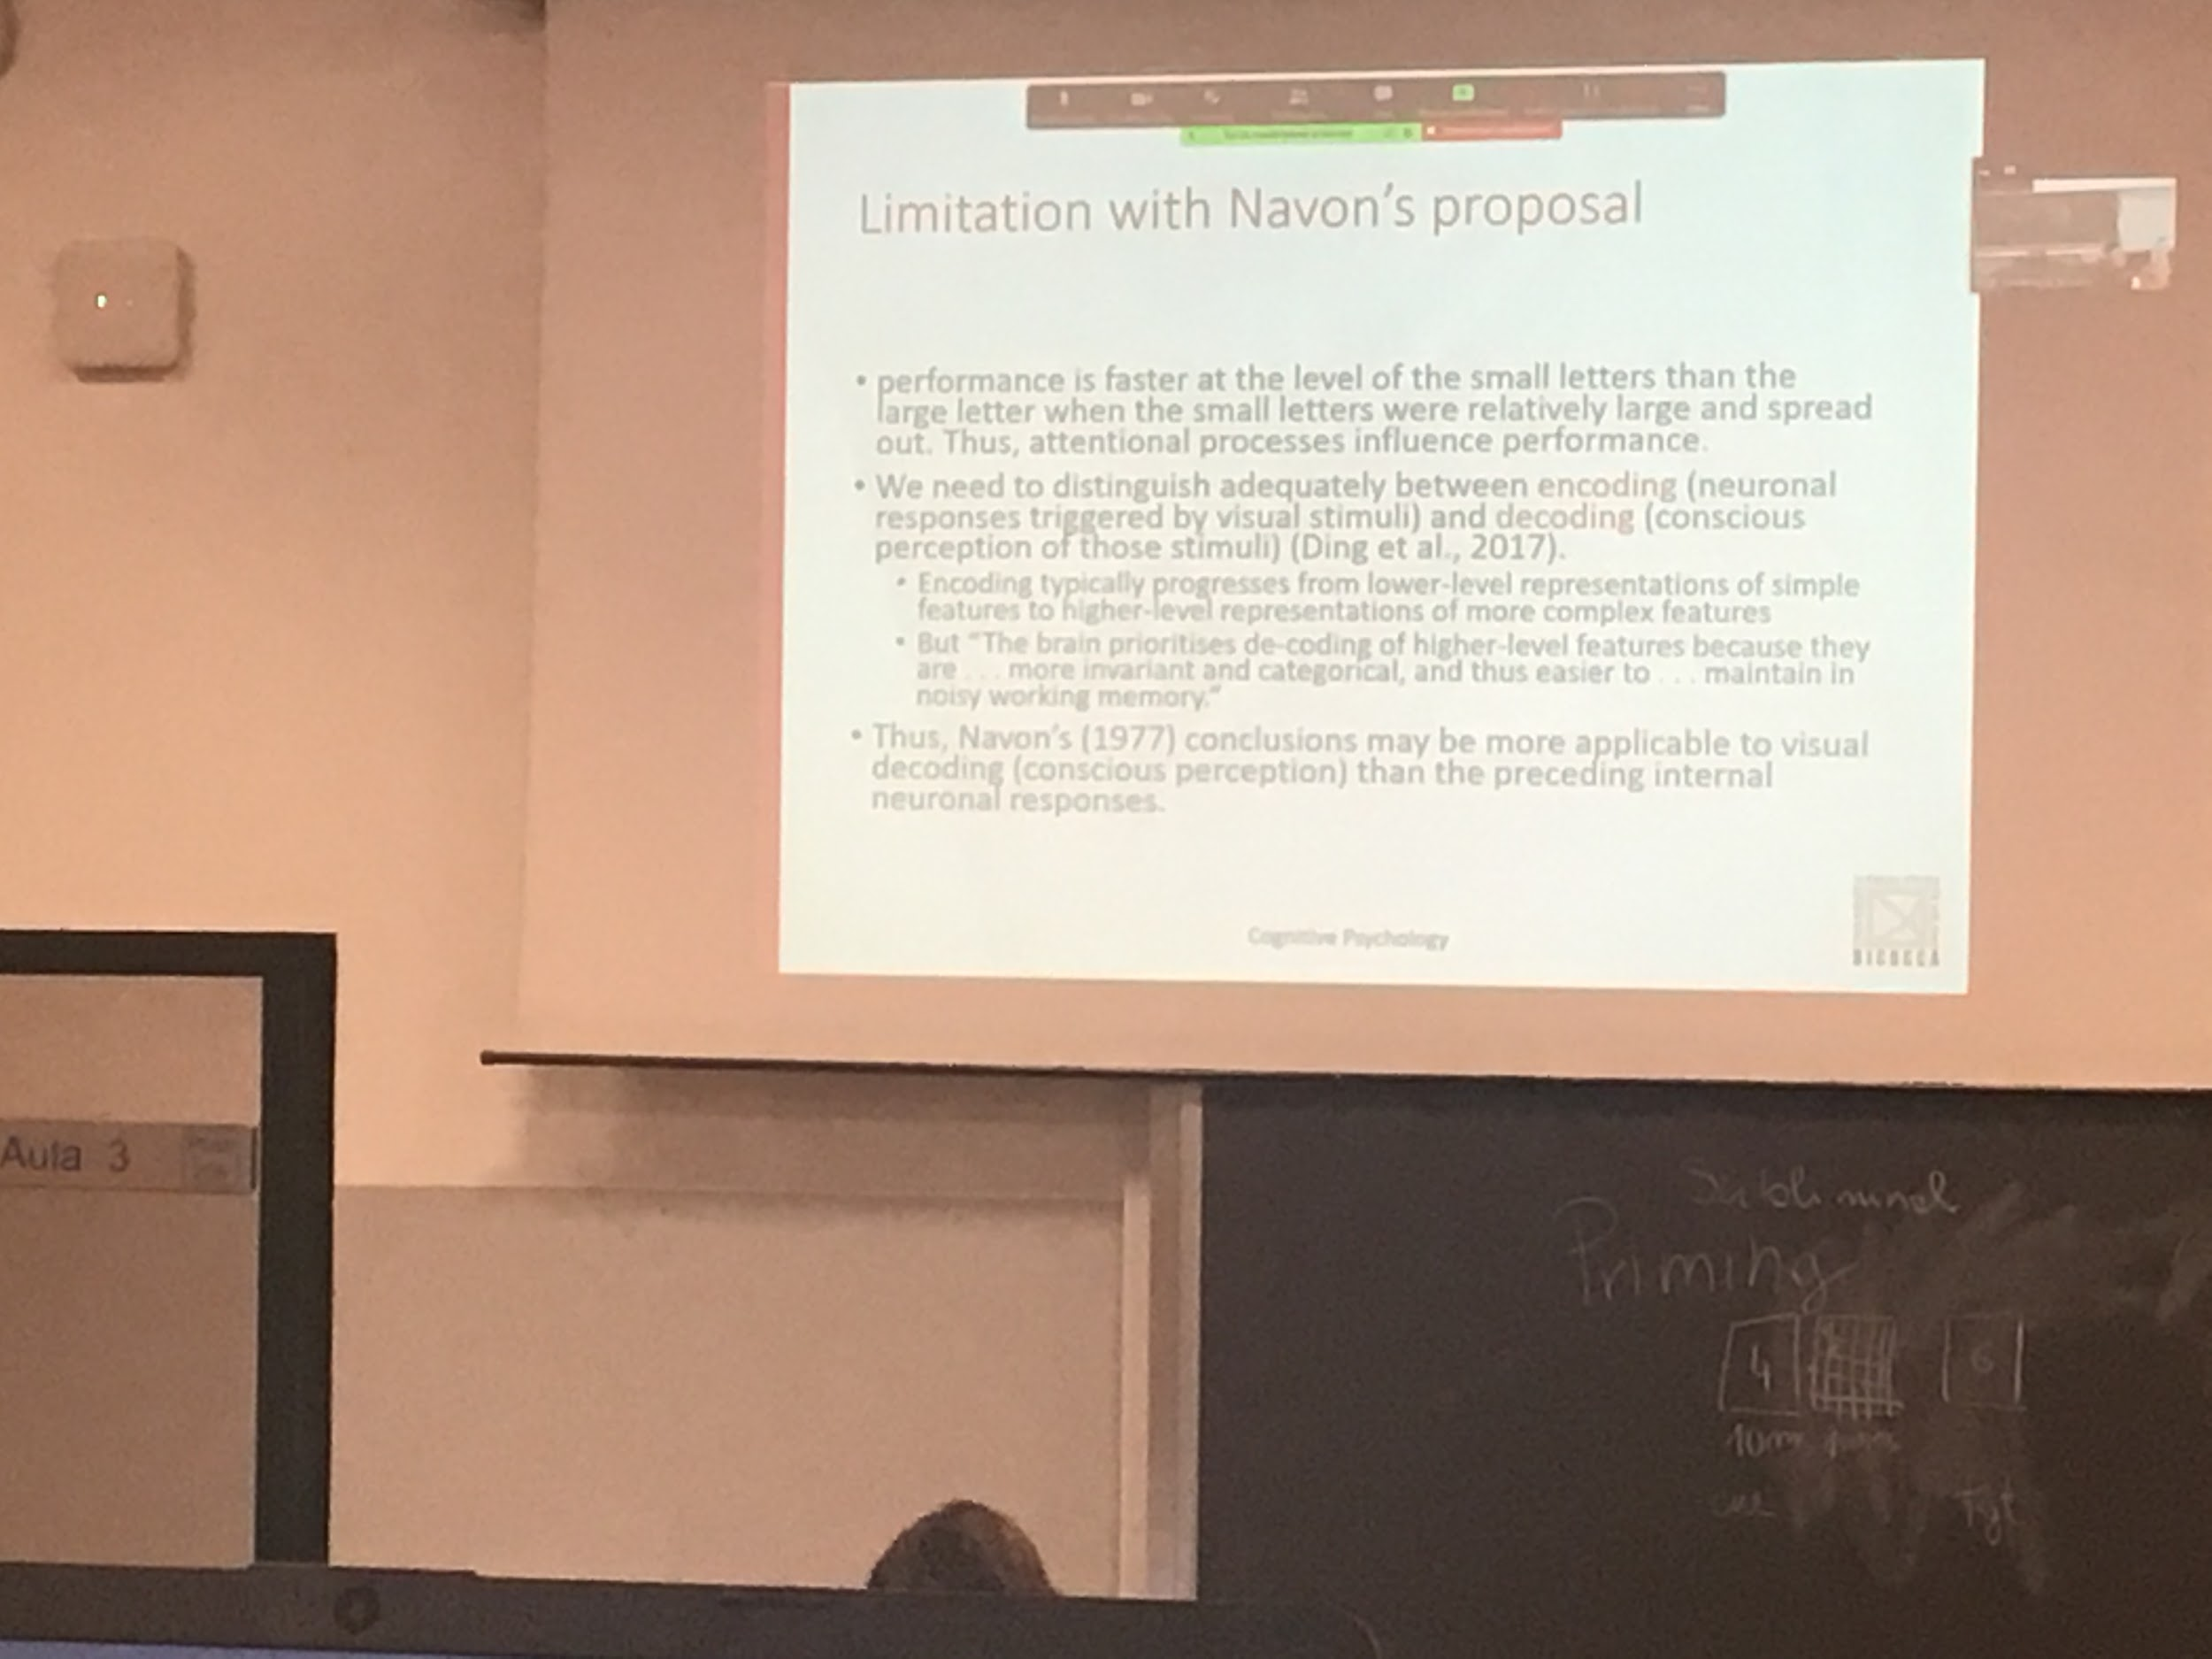

The feature model work well for the encoding

There is influence top-down. Conscious perception interfere with the bottom half procedure

Top-down and Bottom-up: information goes from the eye (stimulus) to V1 and then it spreads. The information comes from the stimulus and is computed in different steps up to when we perceive it. There is informations in memory that can influence the coding come down

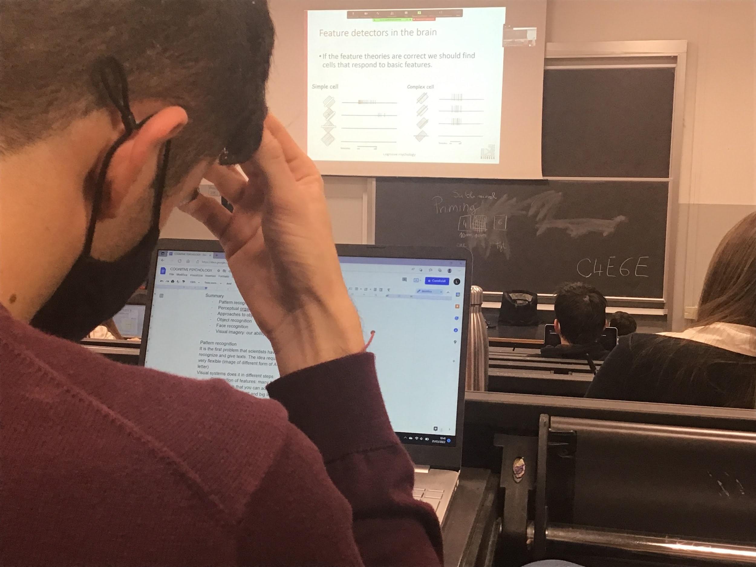

There are been find cells in V1 that responds to bars oriented in a given orientation

Different types of stimuli, there were looking but didn't find anything

By change they discover that V1 codes borders that goes in specific direction,

There are different categories

The simple cell is a cell that has a receptive field that is rectangular with 2 ares, one off and one on

These cells codes specific orientation of bars in our perceptive field.

There are different categories of cell:

* simple cells: cell that has a rectangular receptive field with two areas, one on one off that have a specific orientation. Response when there is a bar in the area their activity starts. Codes the presence of a specific bar in a specific orientation in a specific part of our visual field
* Complex cells: don’t have on and off area, detect the presence of the bar in any part of the visual sphere
* Hyper complex cells

Speaks of activity recorded by the electrons

When there is nothing on there is no stimuli

Between turning on and off there is activity

When there is nothing on there is no activity all the time.

When at a certain point we turn on the bar and we turn it off between on and off we have activity in the cell.

When the bar is later we have activity when we turn it off.

These data shows that at least the bottom up root perform some kind of visual detection

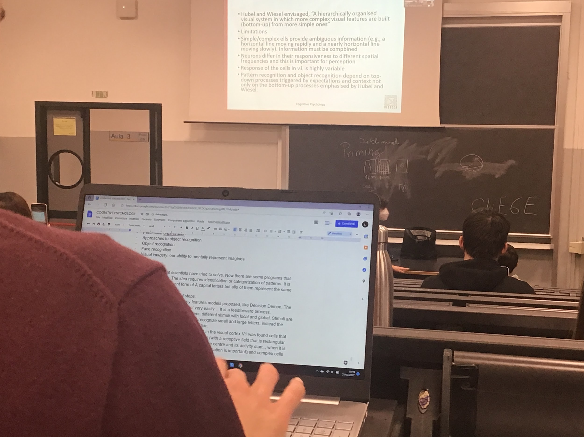

V4 cells that respond to complex

There are limitations:

* everything is bottom up.
* there are different responses in v1
* different cells codes >> different orientations in the same area

**PERCEPTUAL ORGANISATION**

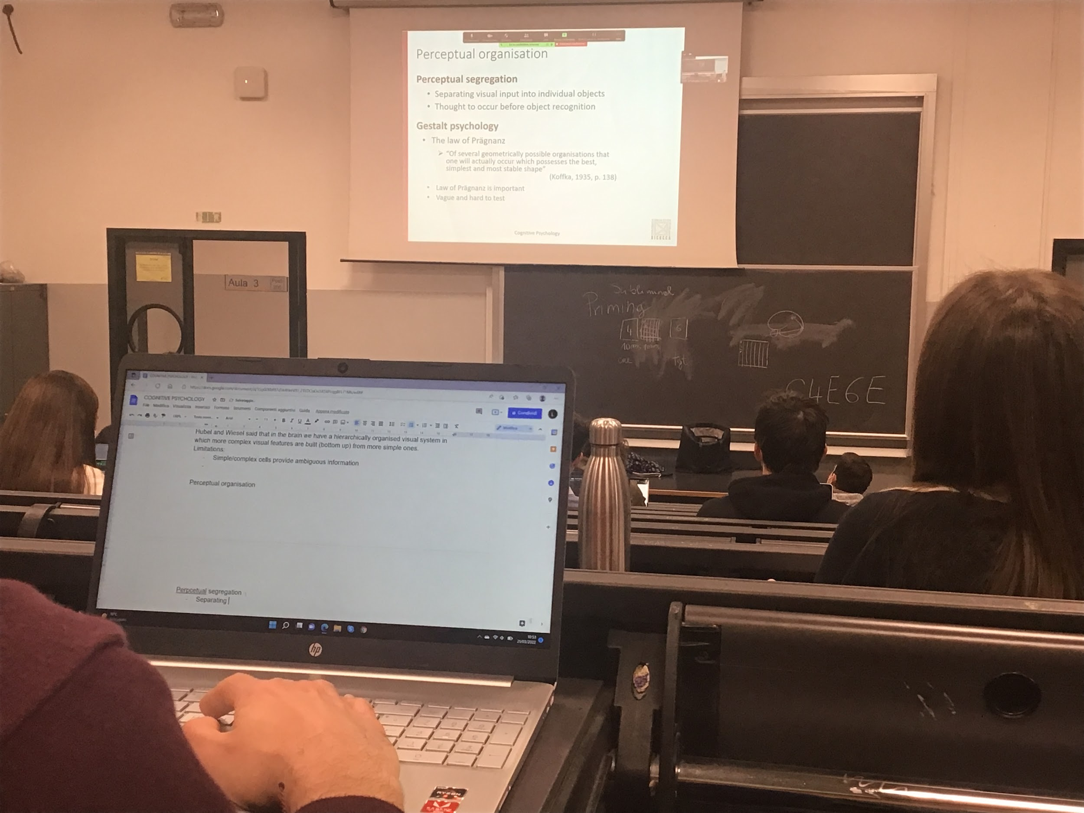

More complex program

Printed characters are separated easily, there is white space between characters

Usually in normal life we have to separate all the parts that we have in different objects

The brain has to group different parts, the way it does always try to find combination for simplest and most stable shape

Brain chooses simplest response

**Proximity**:

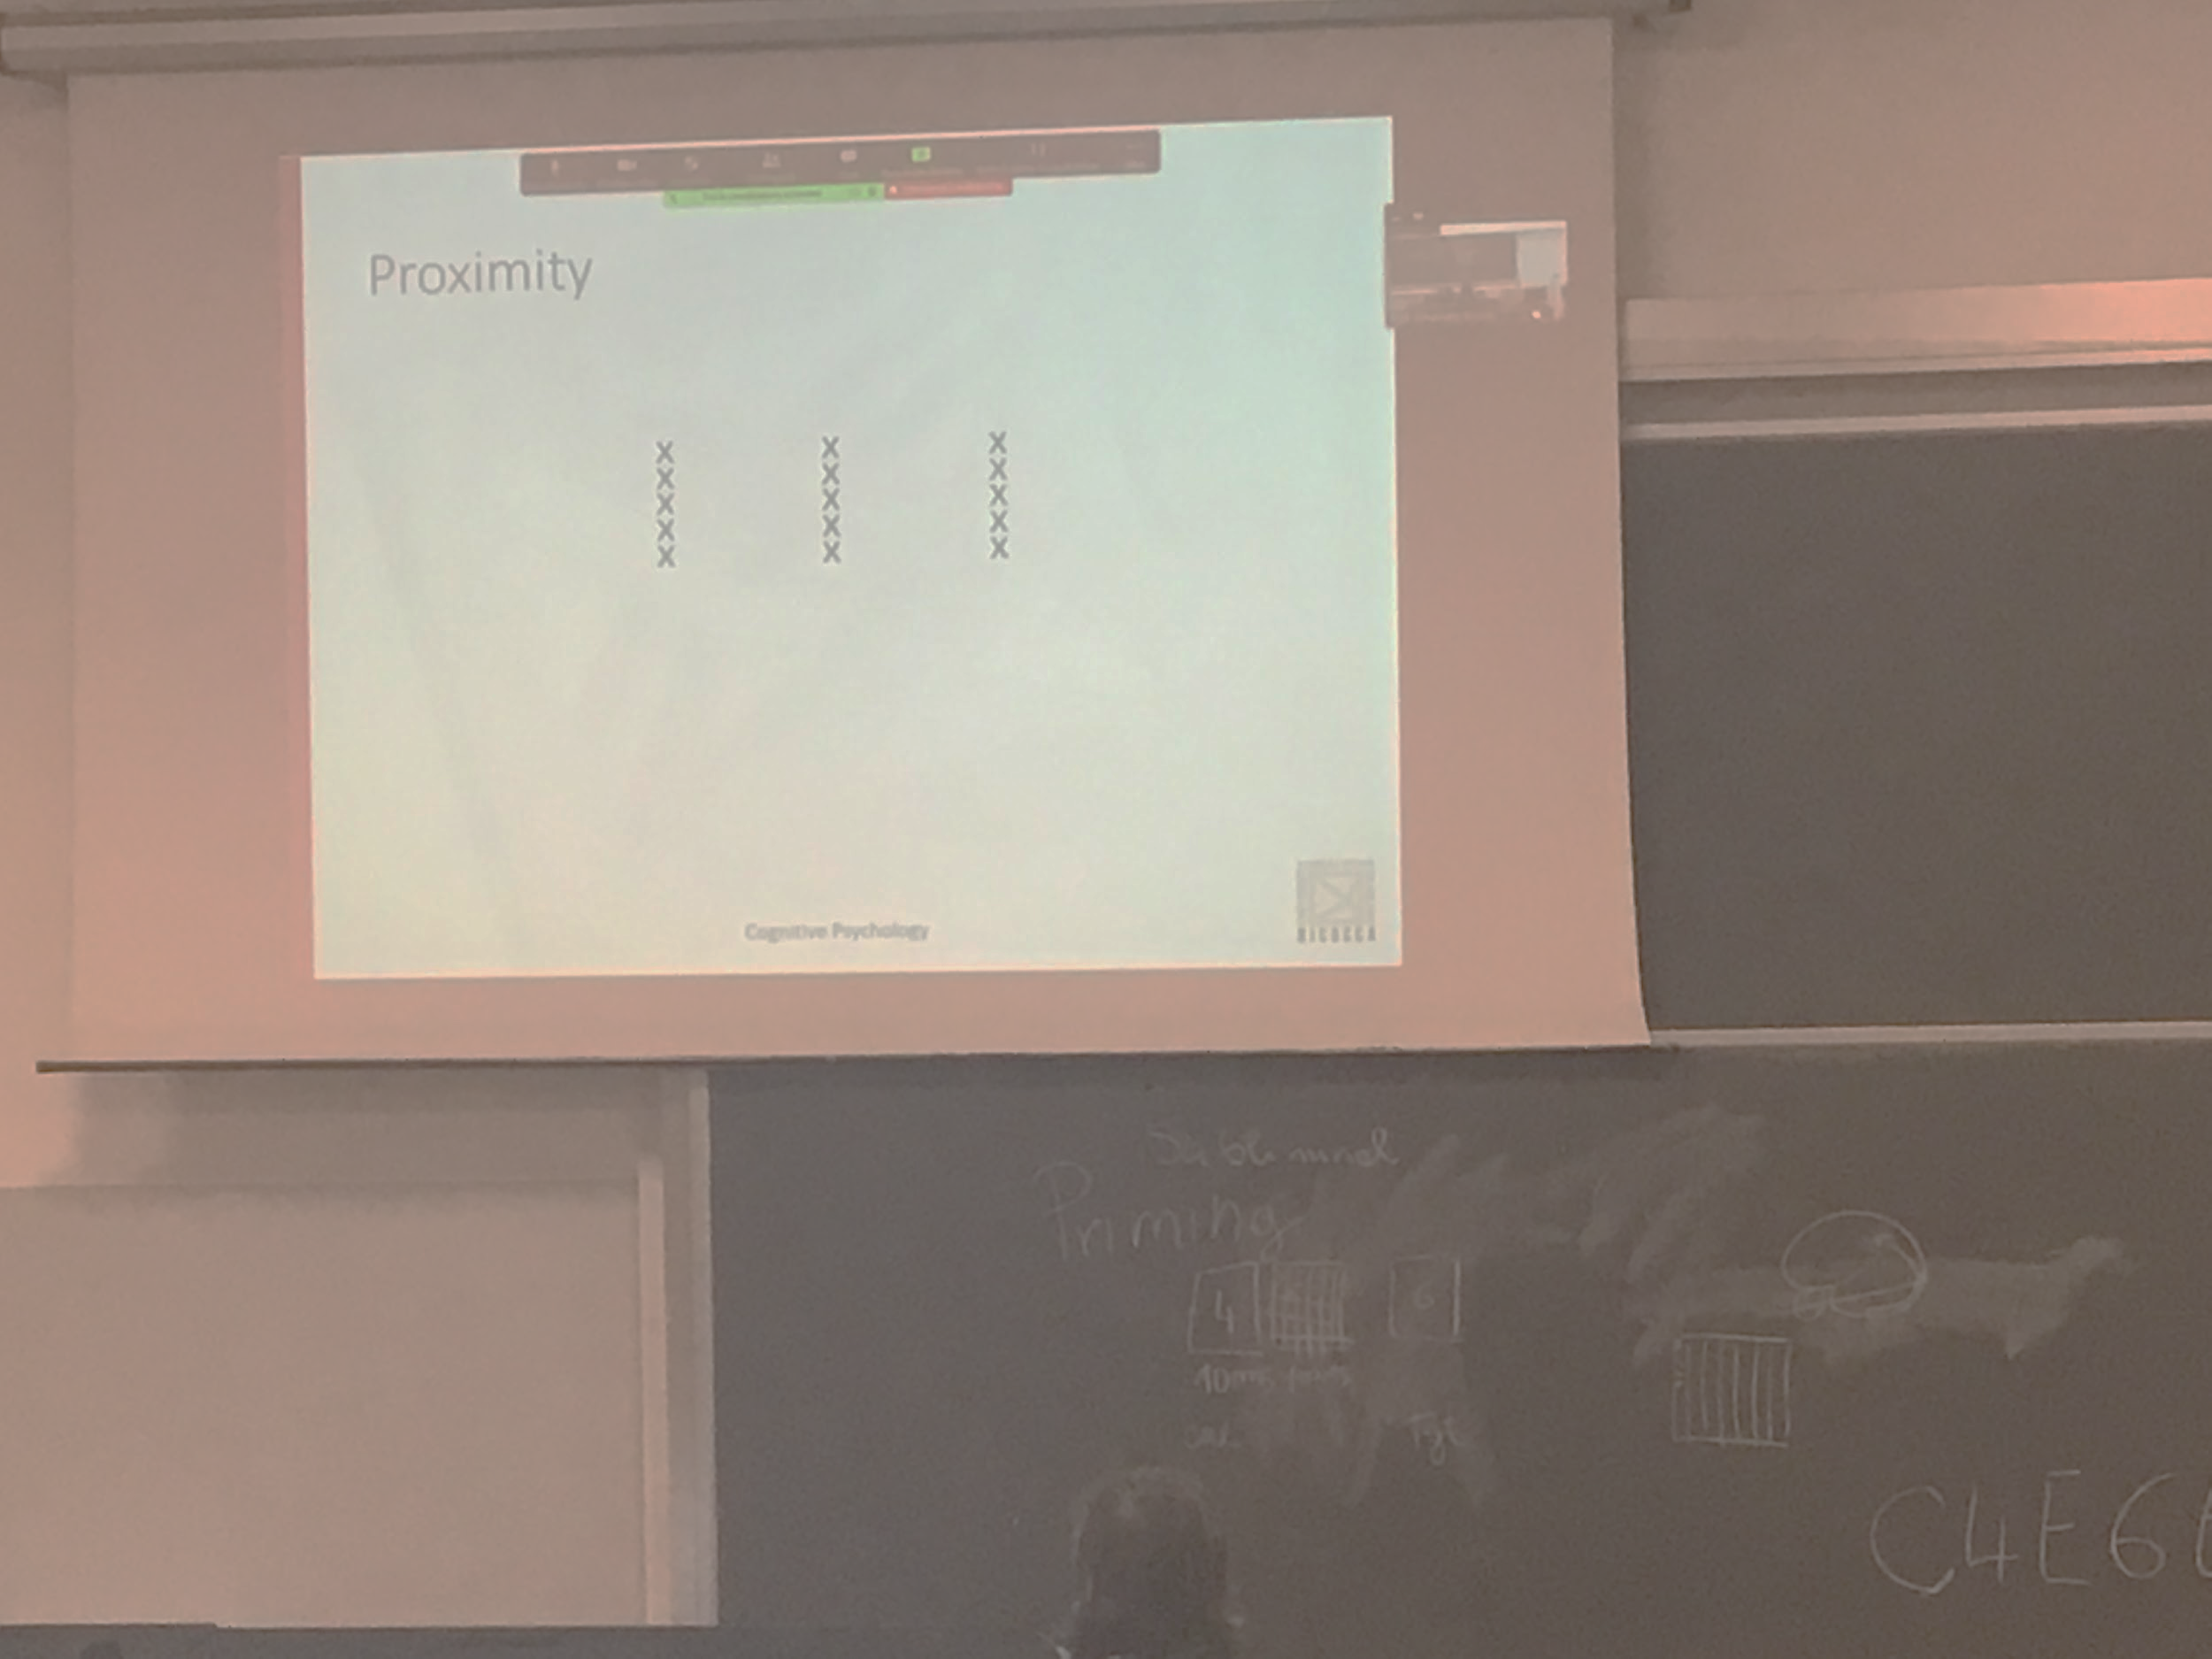

If we have multiple parts you put together the part that are closed by

Describe the image as 3 columns of x, not 5 rows of x

**Similarity**: group

Mettere immagine

**Common faith**:

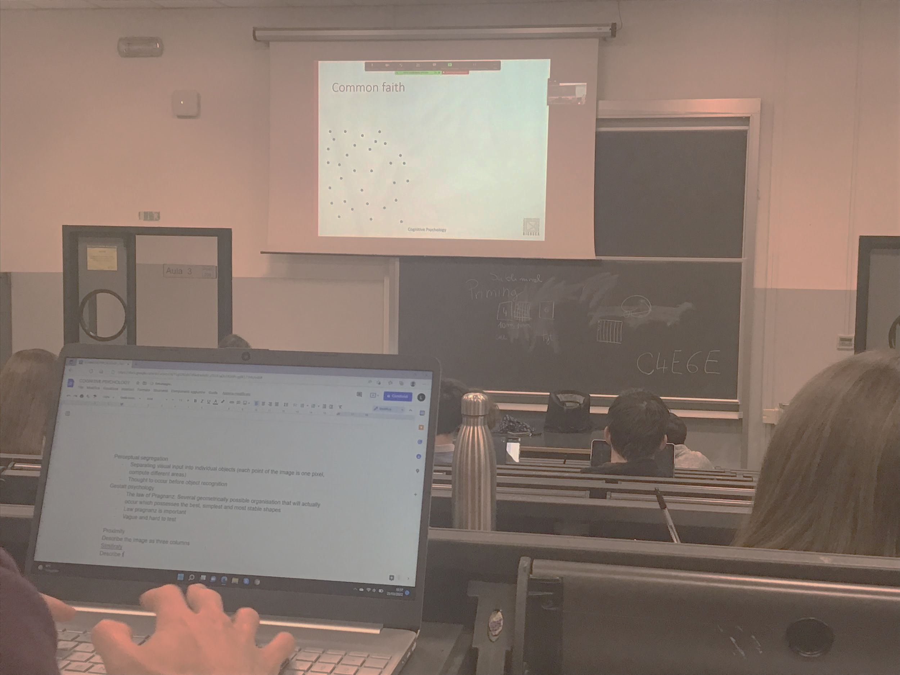

Three does comes together at the same time are like an object, same speed and same directions are consider to belong to the same object

**Good continuation**:

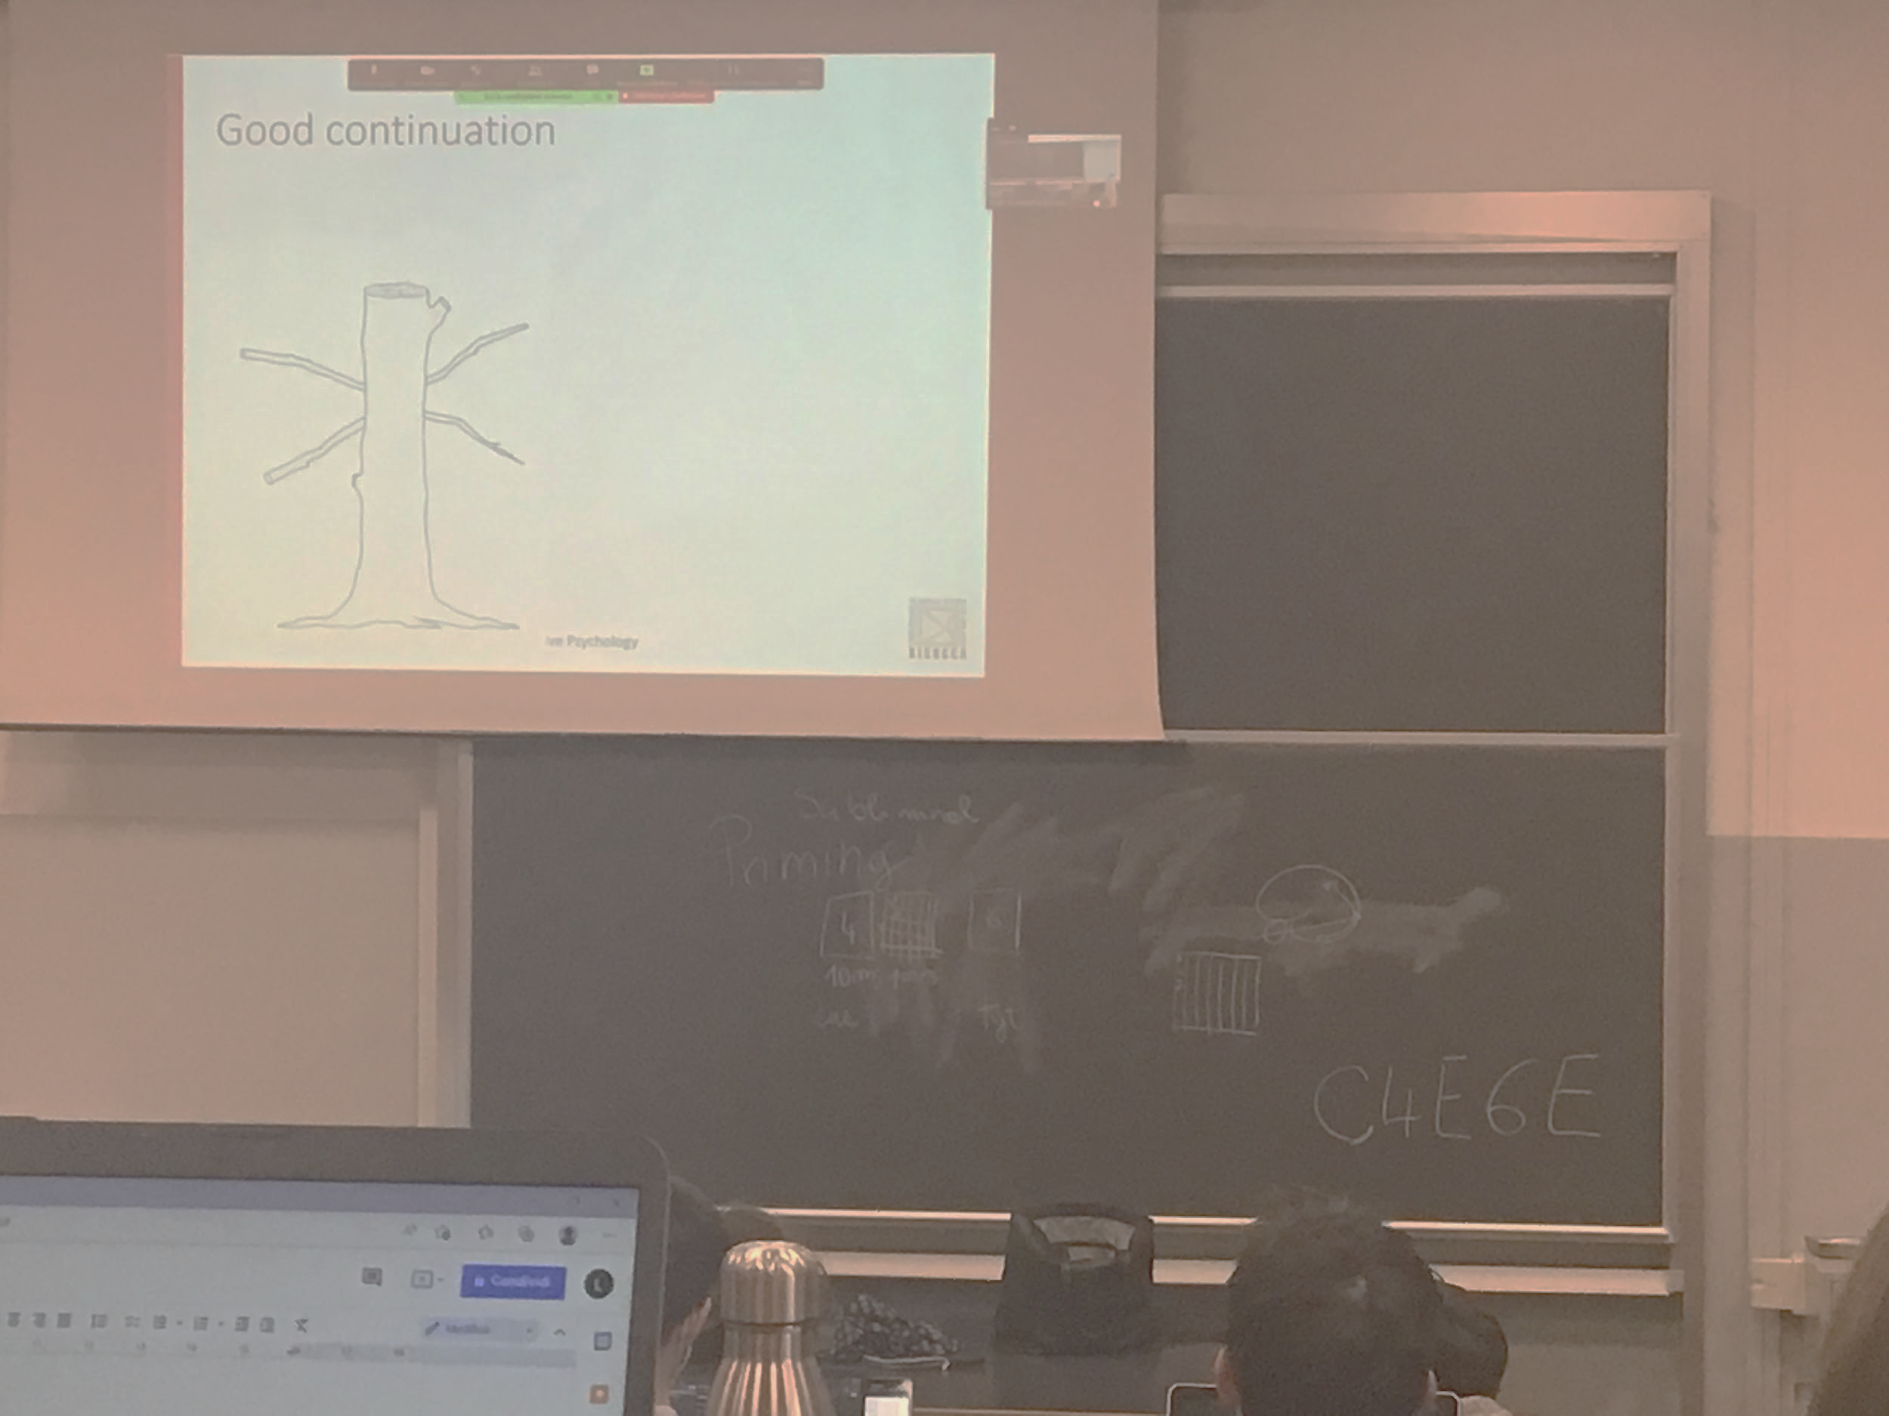

The representation image in our brain is that two sticks are crossing

When something else is blocking our view we think that the object continue in the same direction, but instead they are crossing

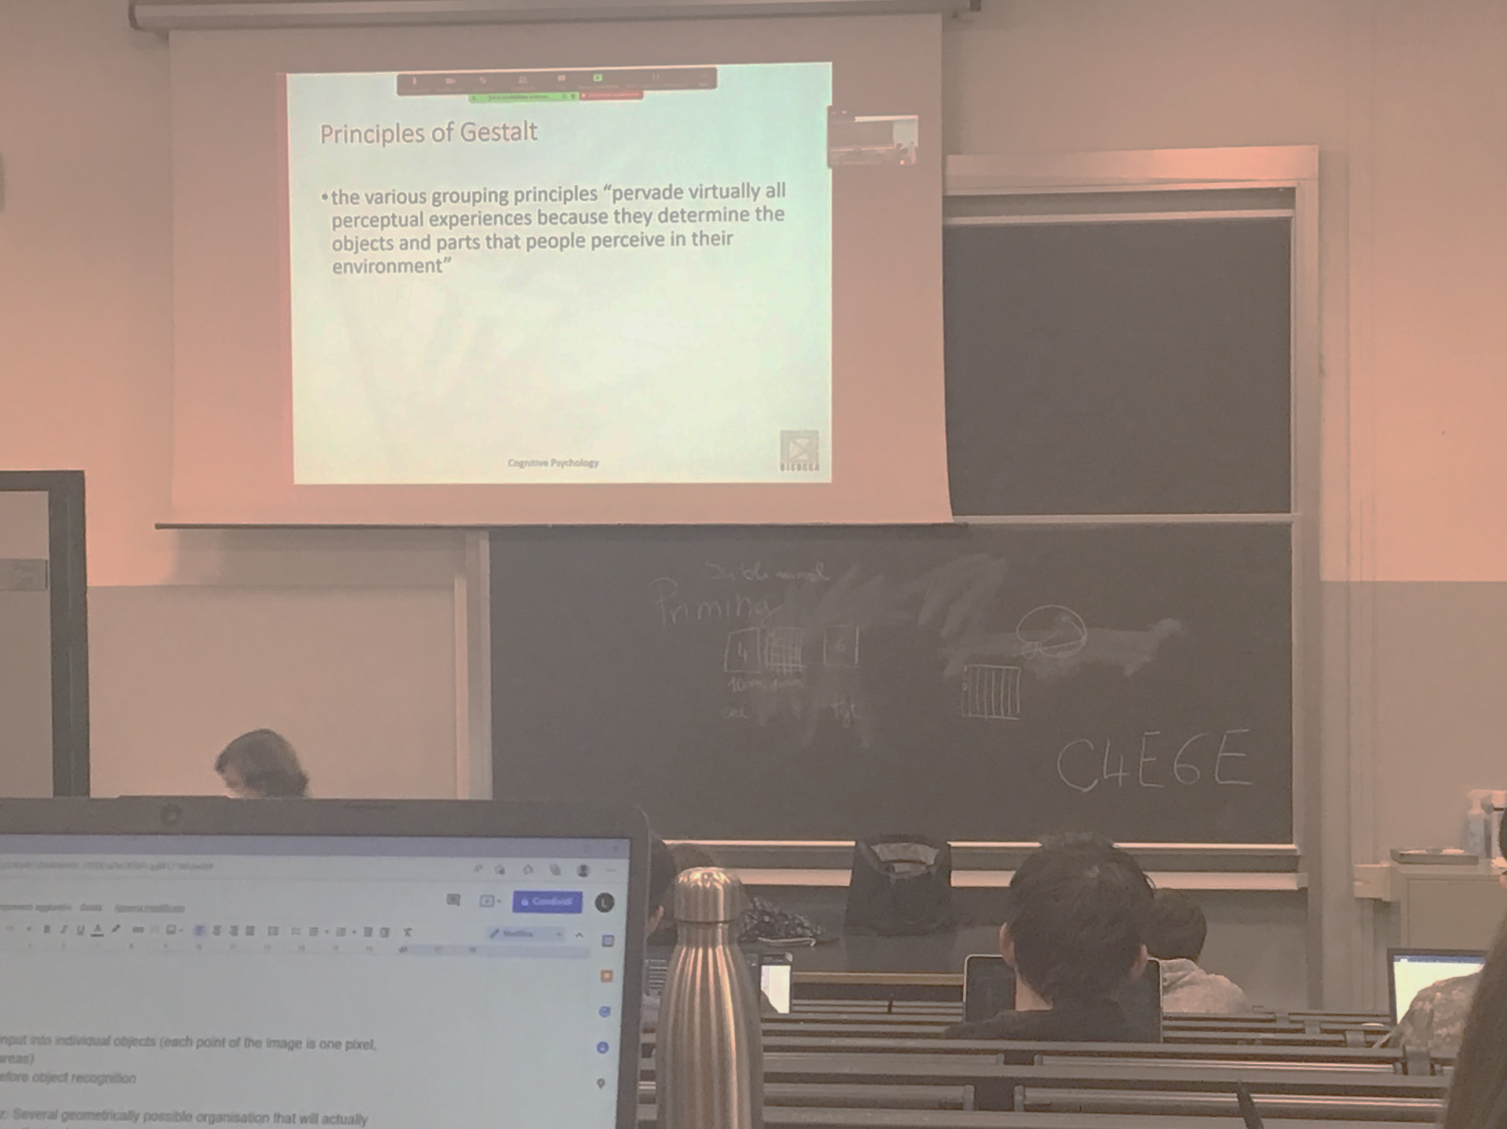

These principles of gestalt are very strong. Work with our perception all the time

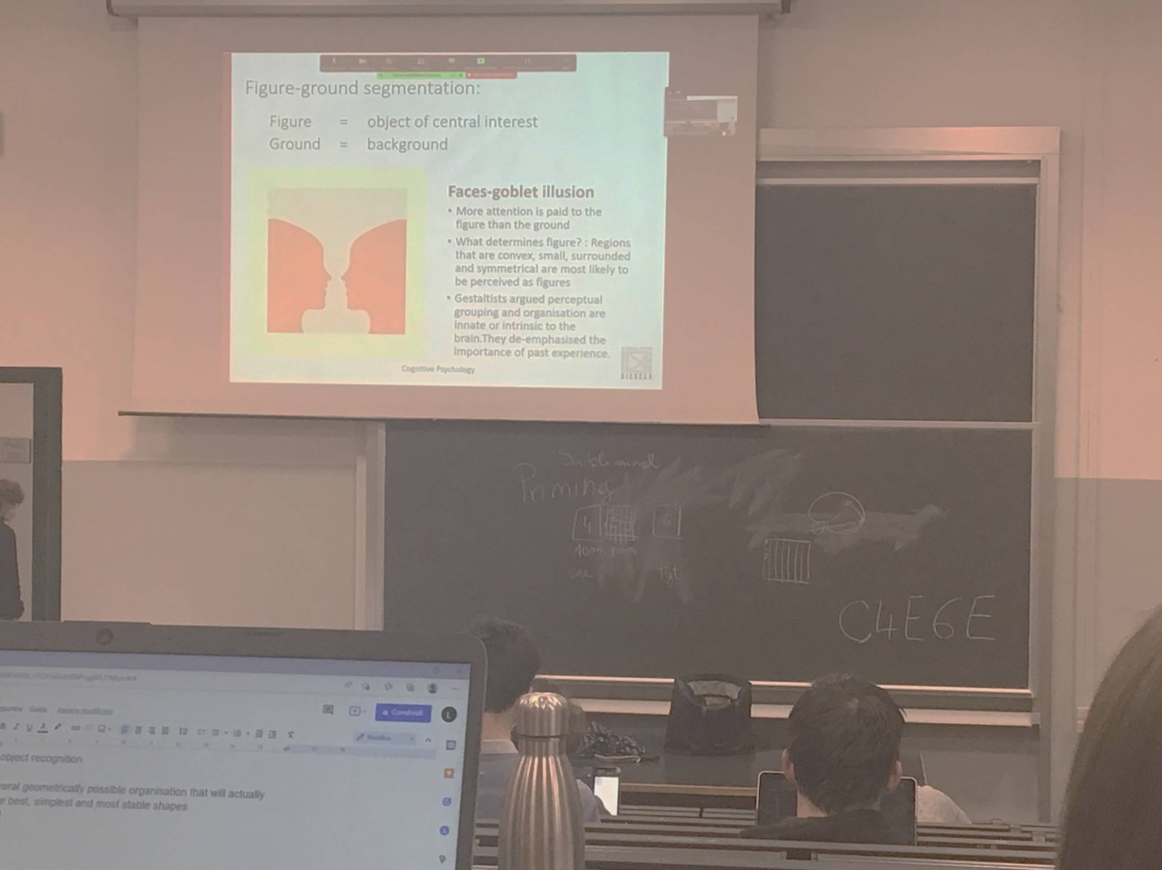

Idea of figure ground segmentation:

when the brain interpret the image it classifies different areas as objects or as background

Objects: analysed more in details

Background: not very analysed in detail

There could be multiple object, but they are discriminated from the background

The attention is on the objects

Face-globes illusion

The figure gets a different status than the background

Can’t see the two object at the same moment

Classification object background is forced: the system always decided that there is an object in front of a background

How do we find objects? Is an uneasy task: two choices

In normal images there are possible interpretations

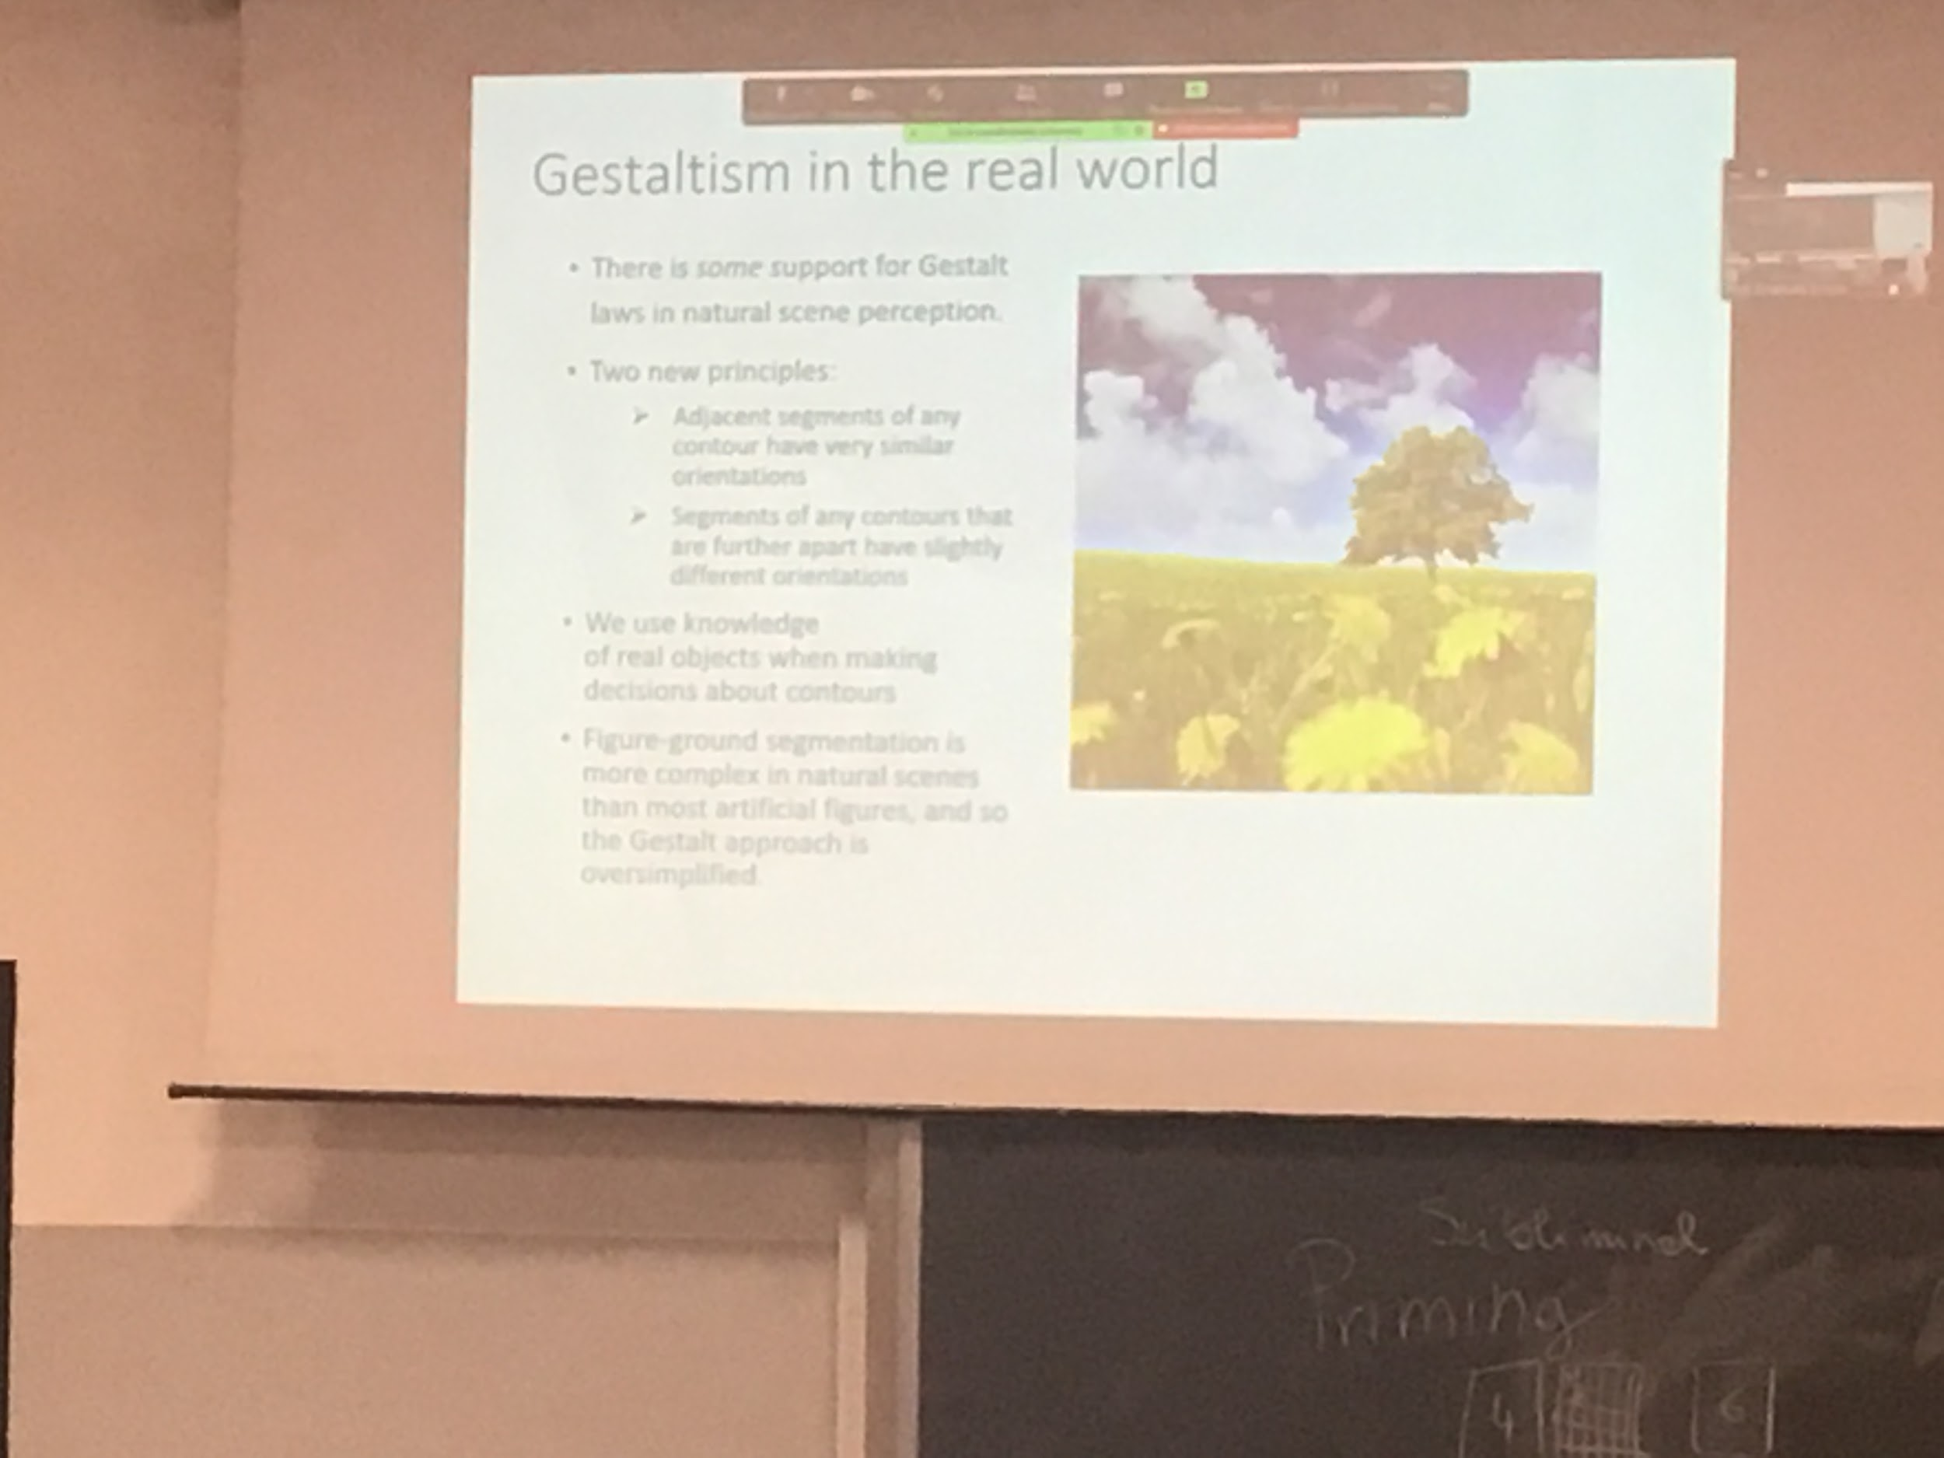

Contrary to what the testable said there is knowledge that we use to segregate top-down

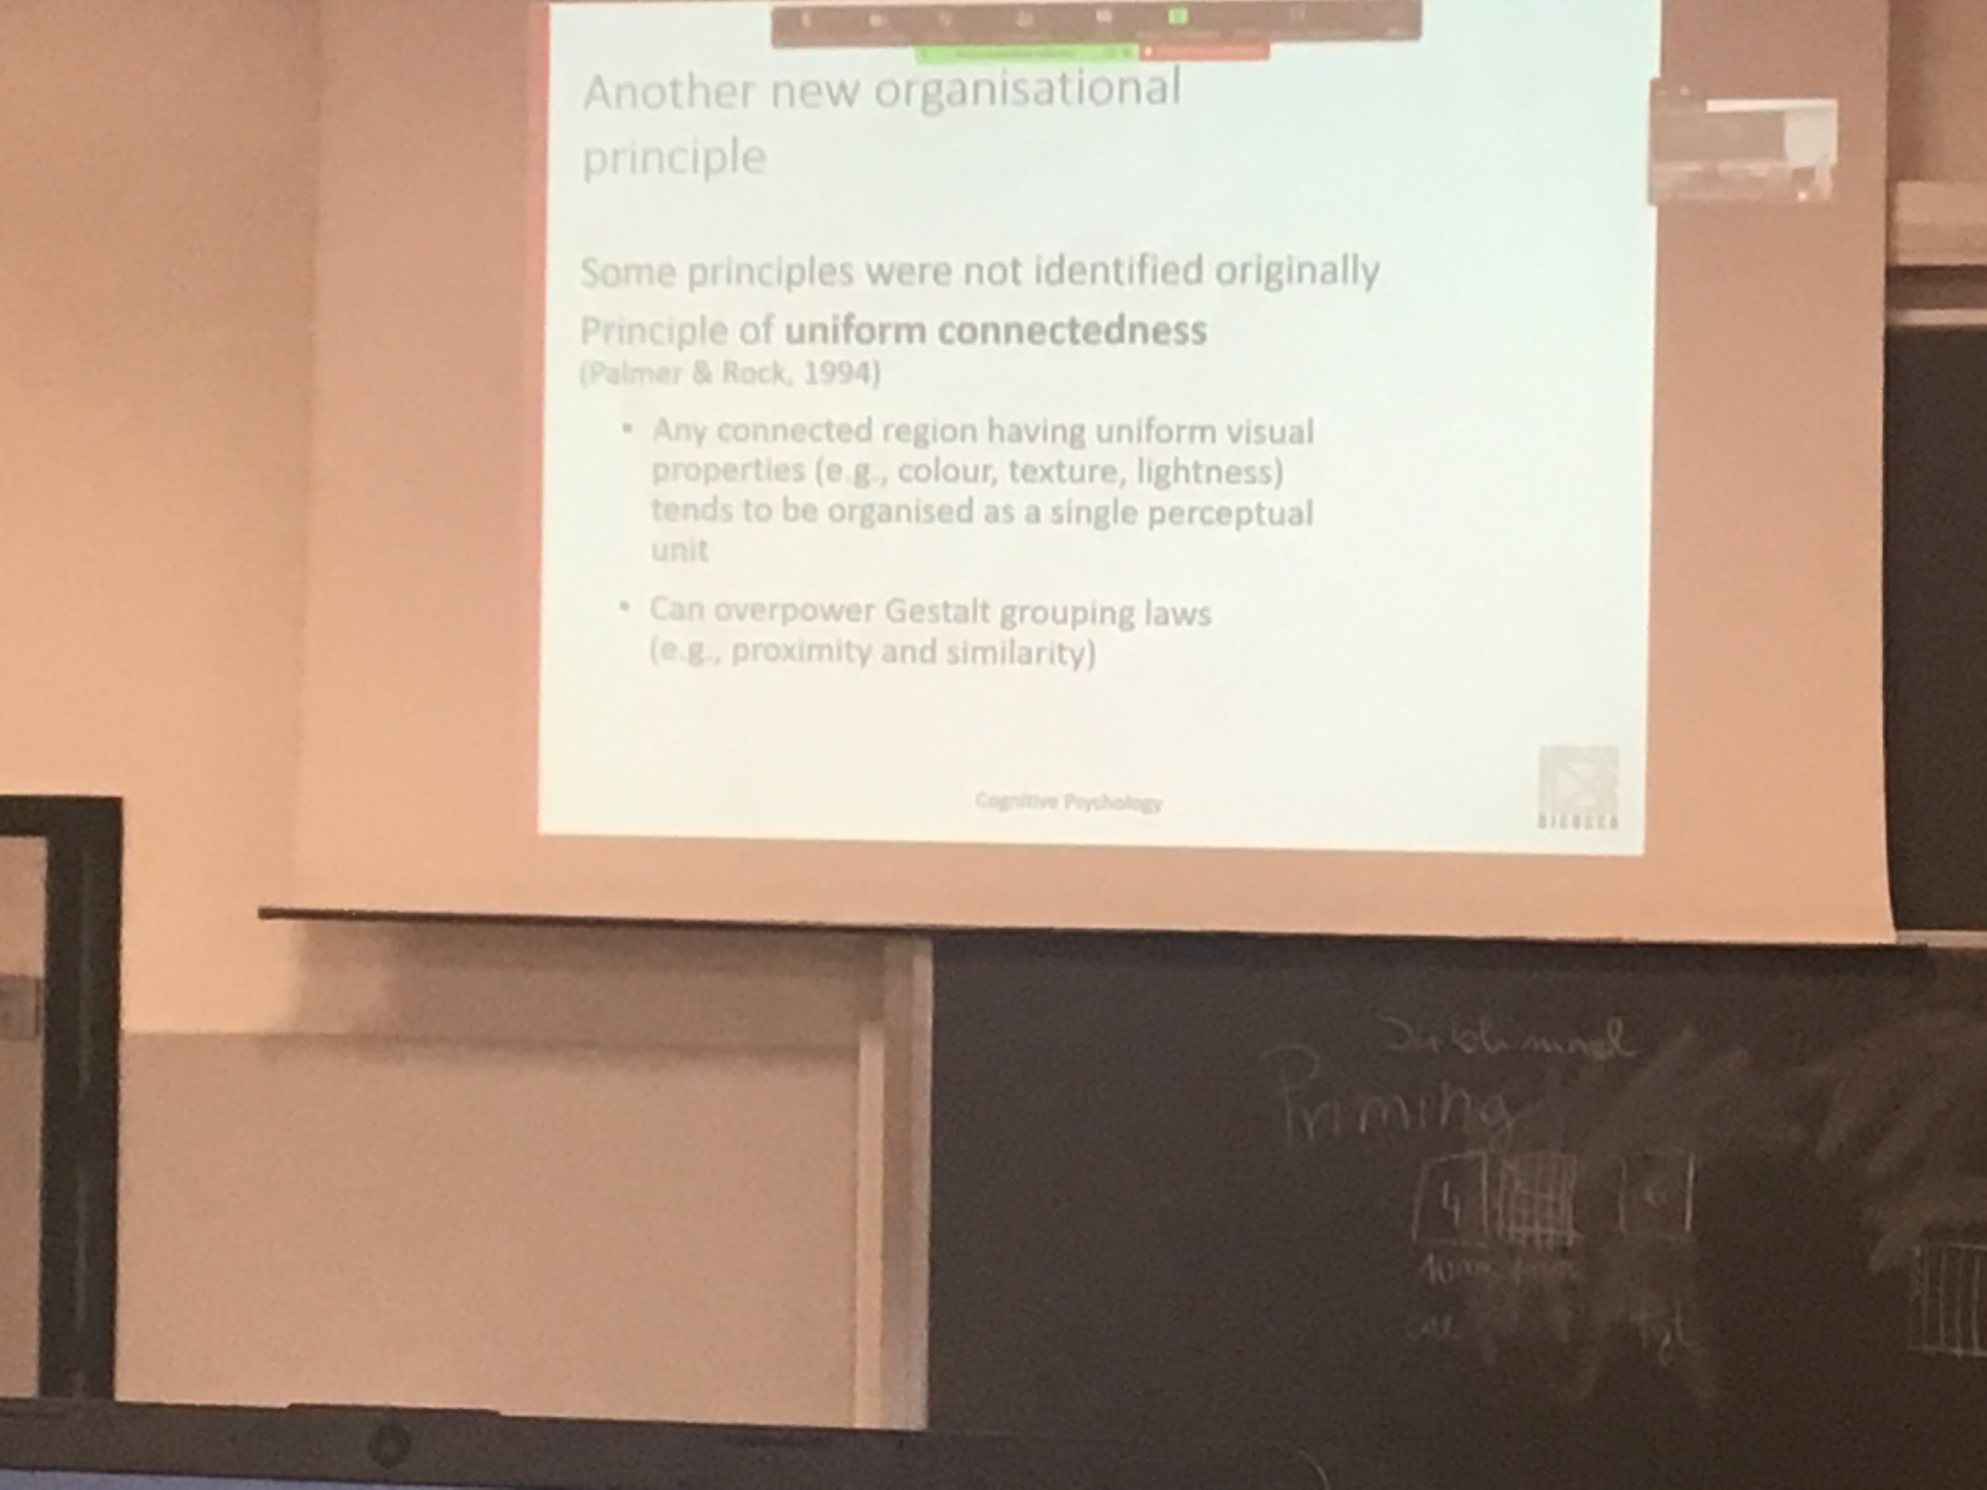

Some principles were not identified like *uniform connectedness*

Any coonnect region having uniform visual properties (same colour, same texture, same lightness…) are organised as single perception unit

Strong than proximity and similarity

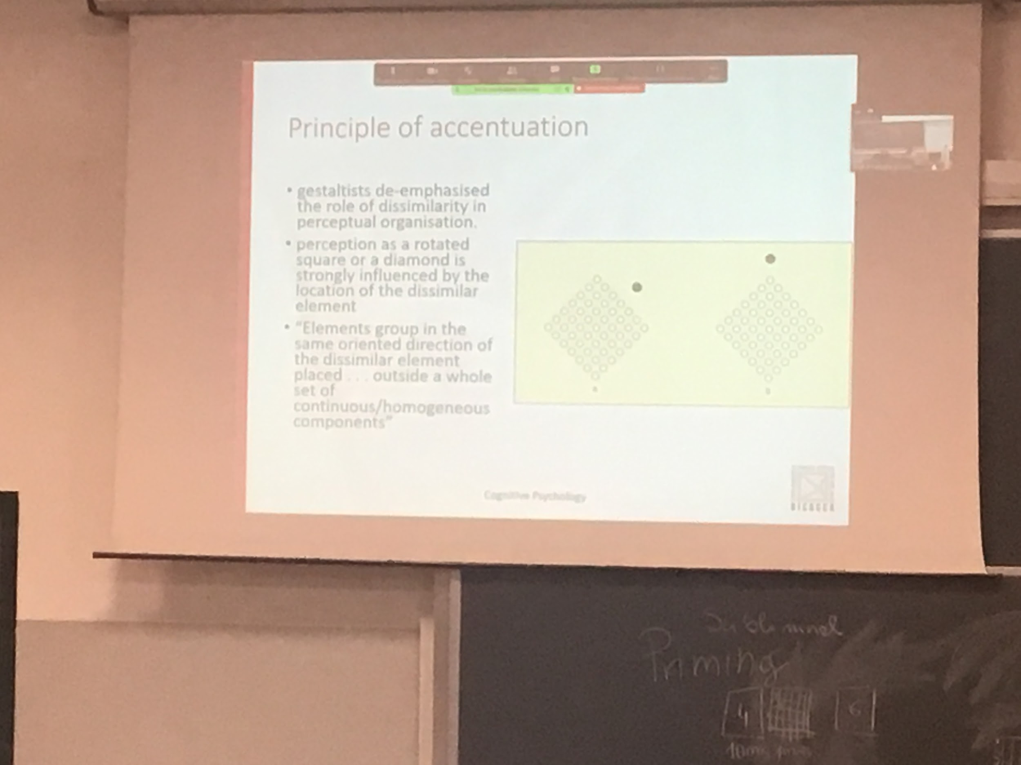

First image: people see a diamond

Second image: people see a tilted square

But the image is identity changes only where I put the black dot, this changes my perception

Figure ground segregation occurs very rapidly in the system. In V1 we have orientation detection.

If we look at the kanizsa square we perceive a square in front of a white background. In V2 there are cells that are 17ms decided what is background and what is the object

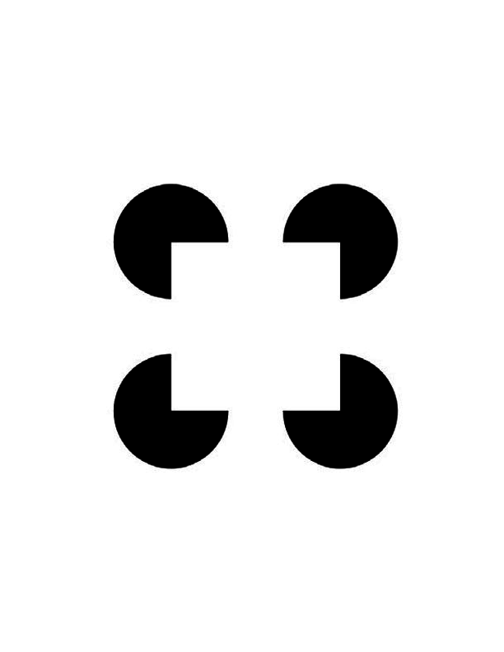

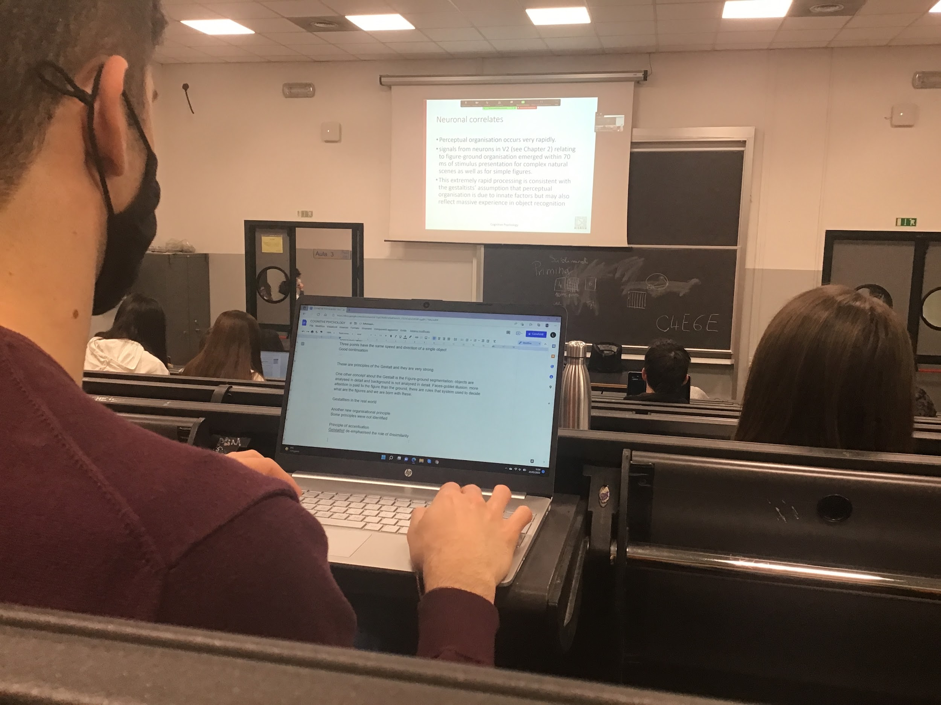

Everything is innate, born with the ability of use these rules

There are some grouping principles that develop with age (continuation, proximity, connectnes… works with newborns)

Test a newborn with preferential looking (1 month or even 3 days old)

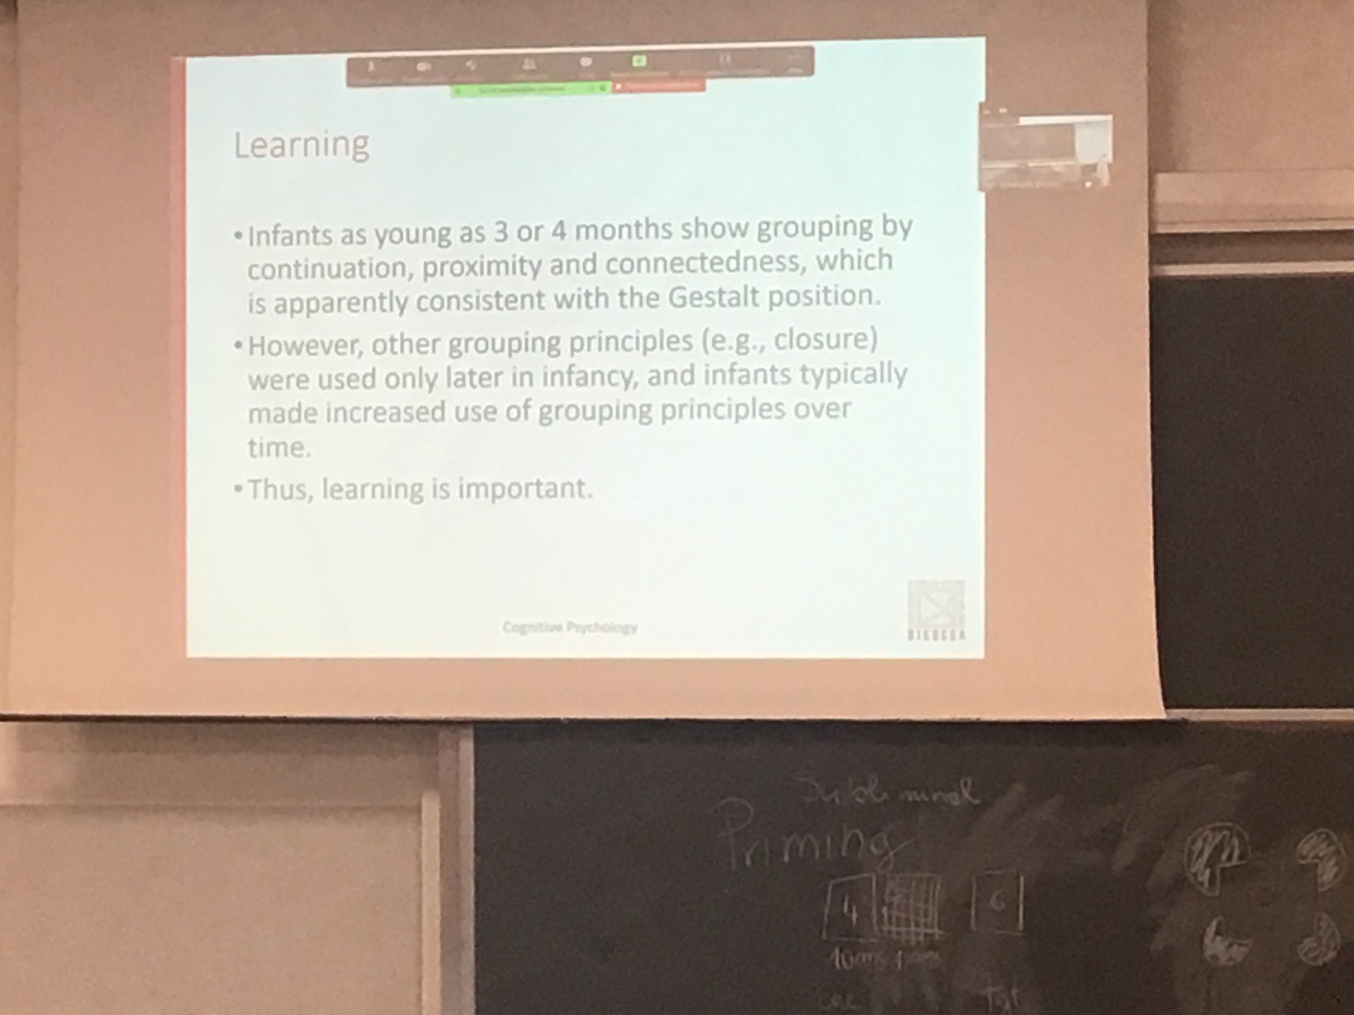

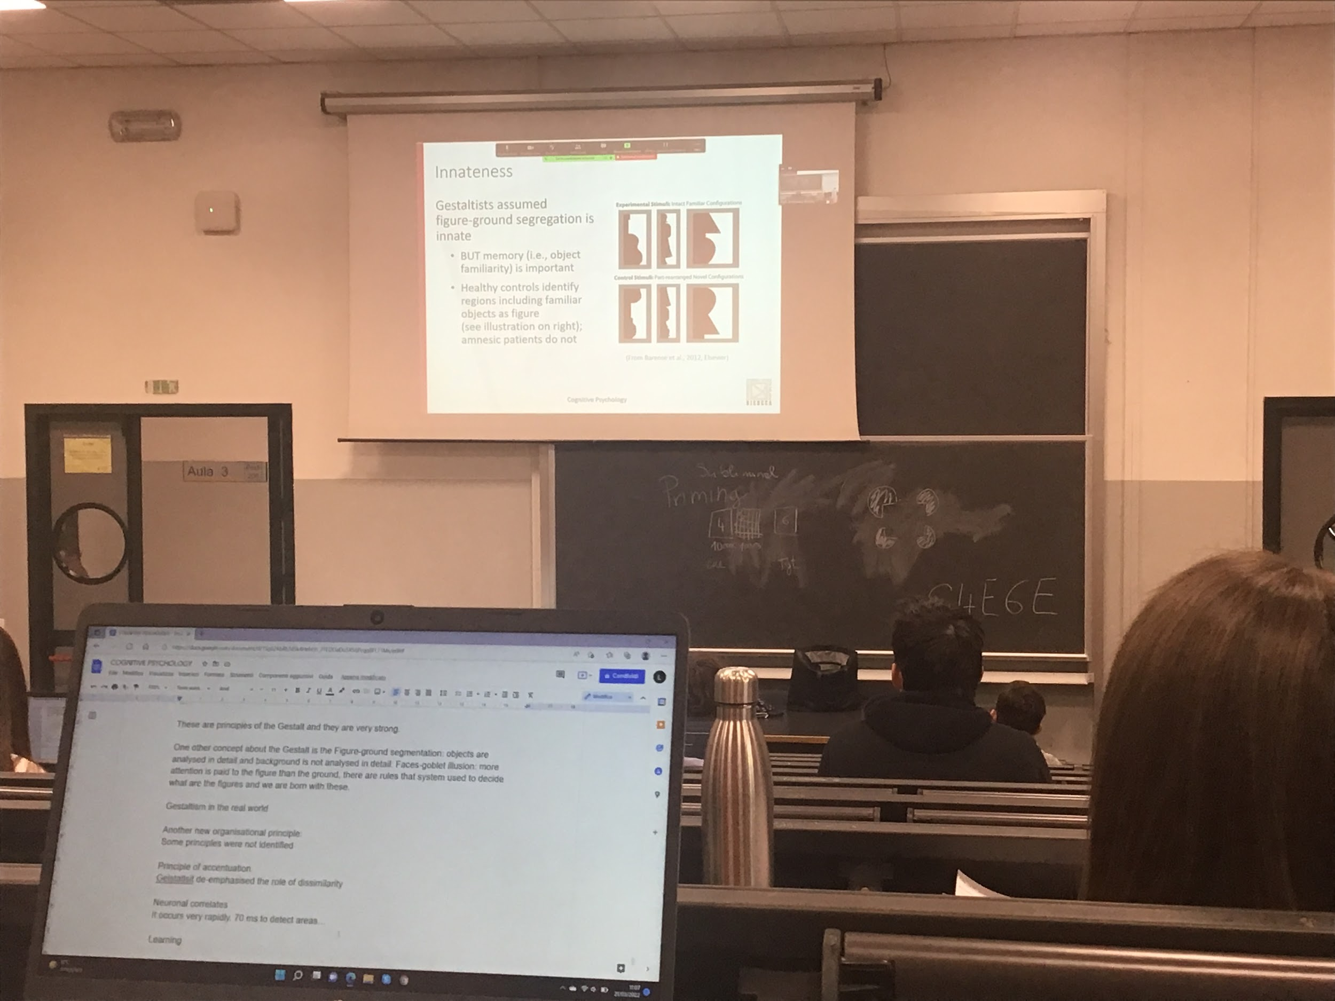

Figure ground segregation

Is modulated by memory

Black is the figure, remains of real object

People with amnesia (people that do not remember object shapes) choose randomly in both conditions

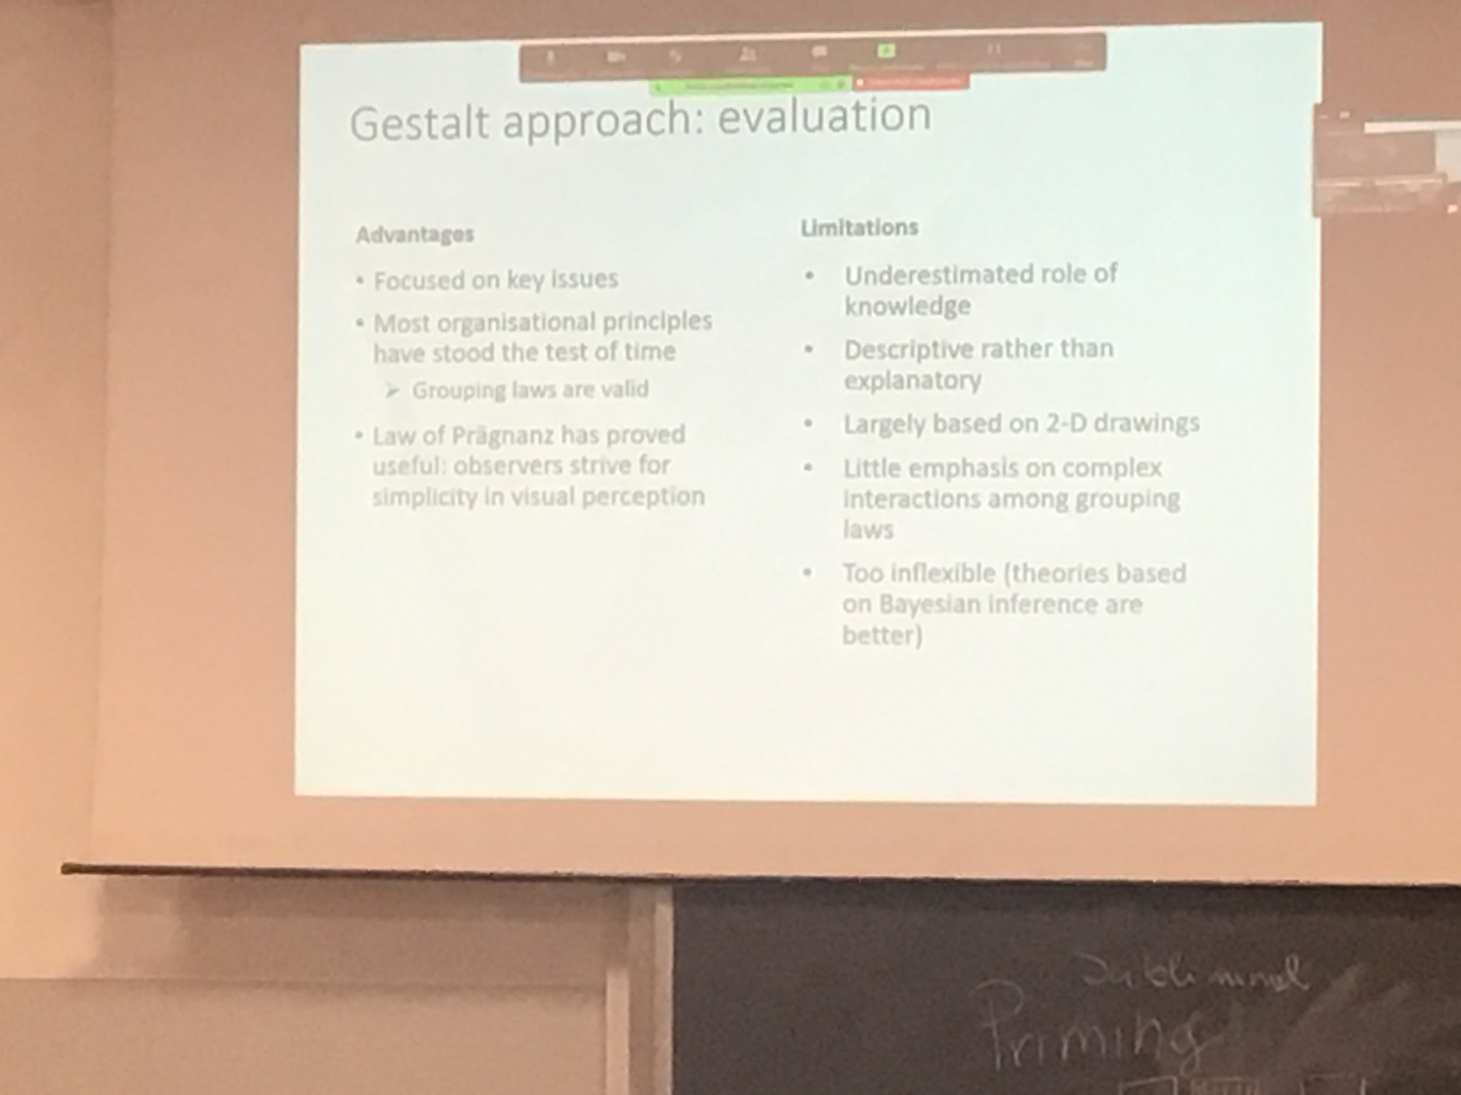

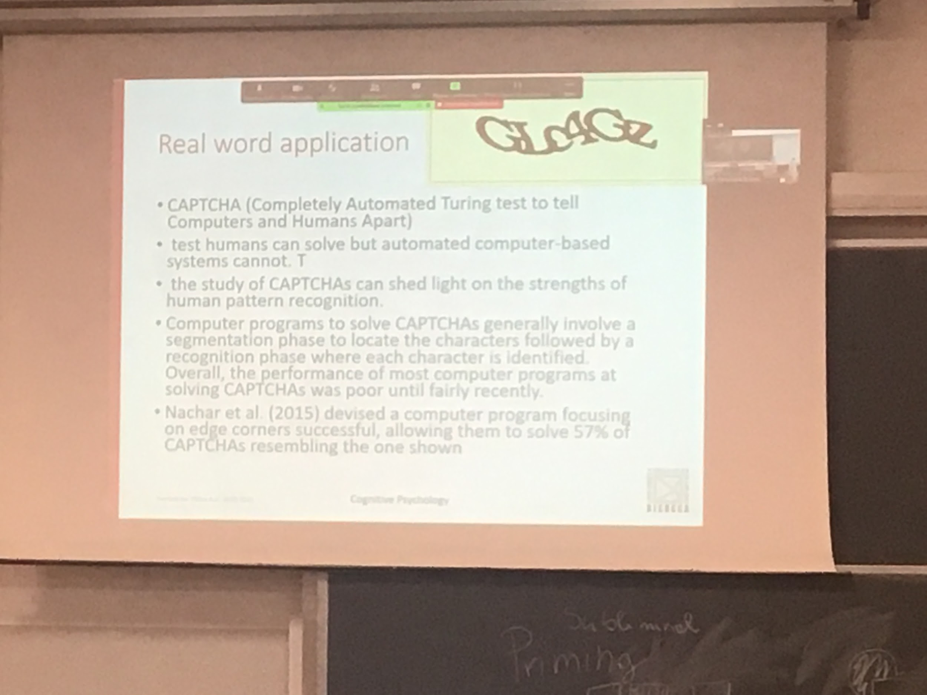

Ability to segregate object from the ground, in some website CAPTCHA

Before 2015, no program could interpret this type of stimulus

For us is easy to tell the letters, pc can not segregate the different objects

Human vision is very good and flexible

**APPROACHES TO OBJECT RECOGNITION**

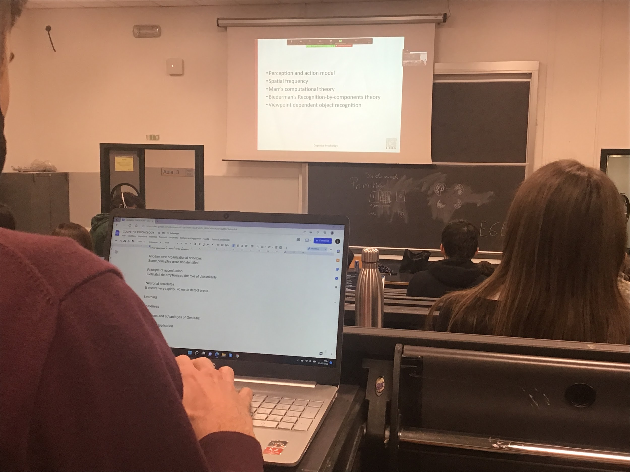

There is a root for object recognition

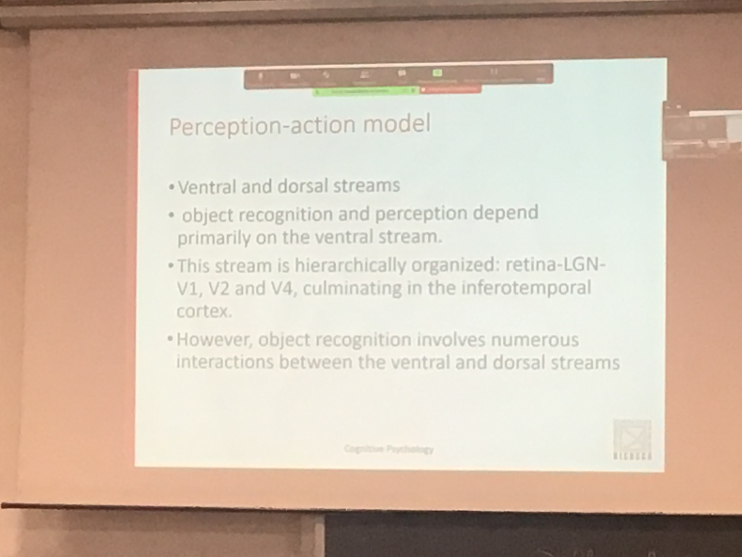

Object recognition and perception depends on the ventral system

The stream is organised gerachicly LGN V1 V2 V4 IT inferotemporal cortex

There are a lot of interaction with the other roots

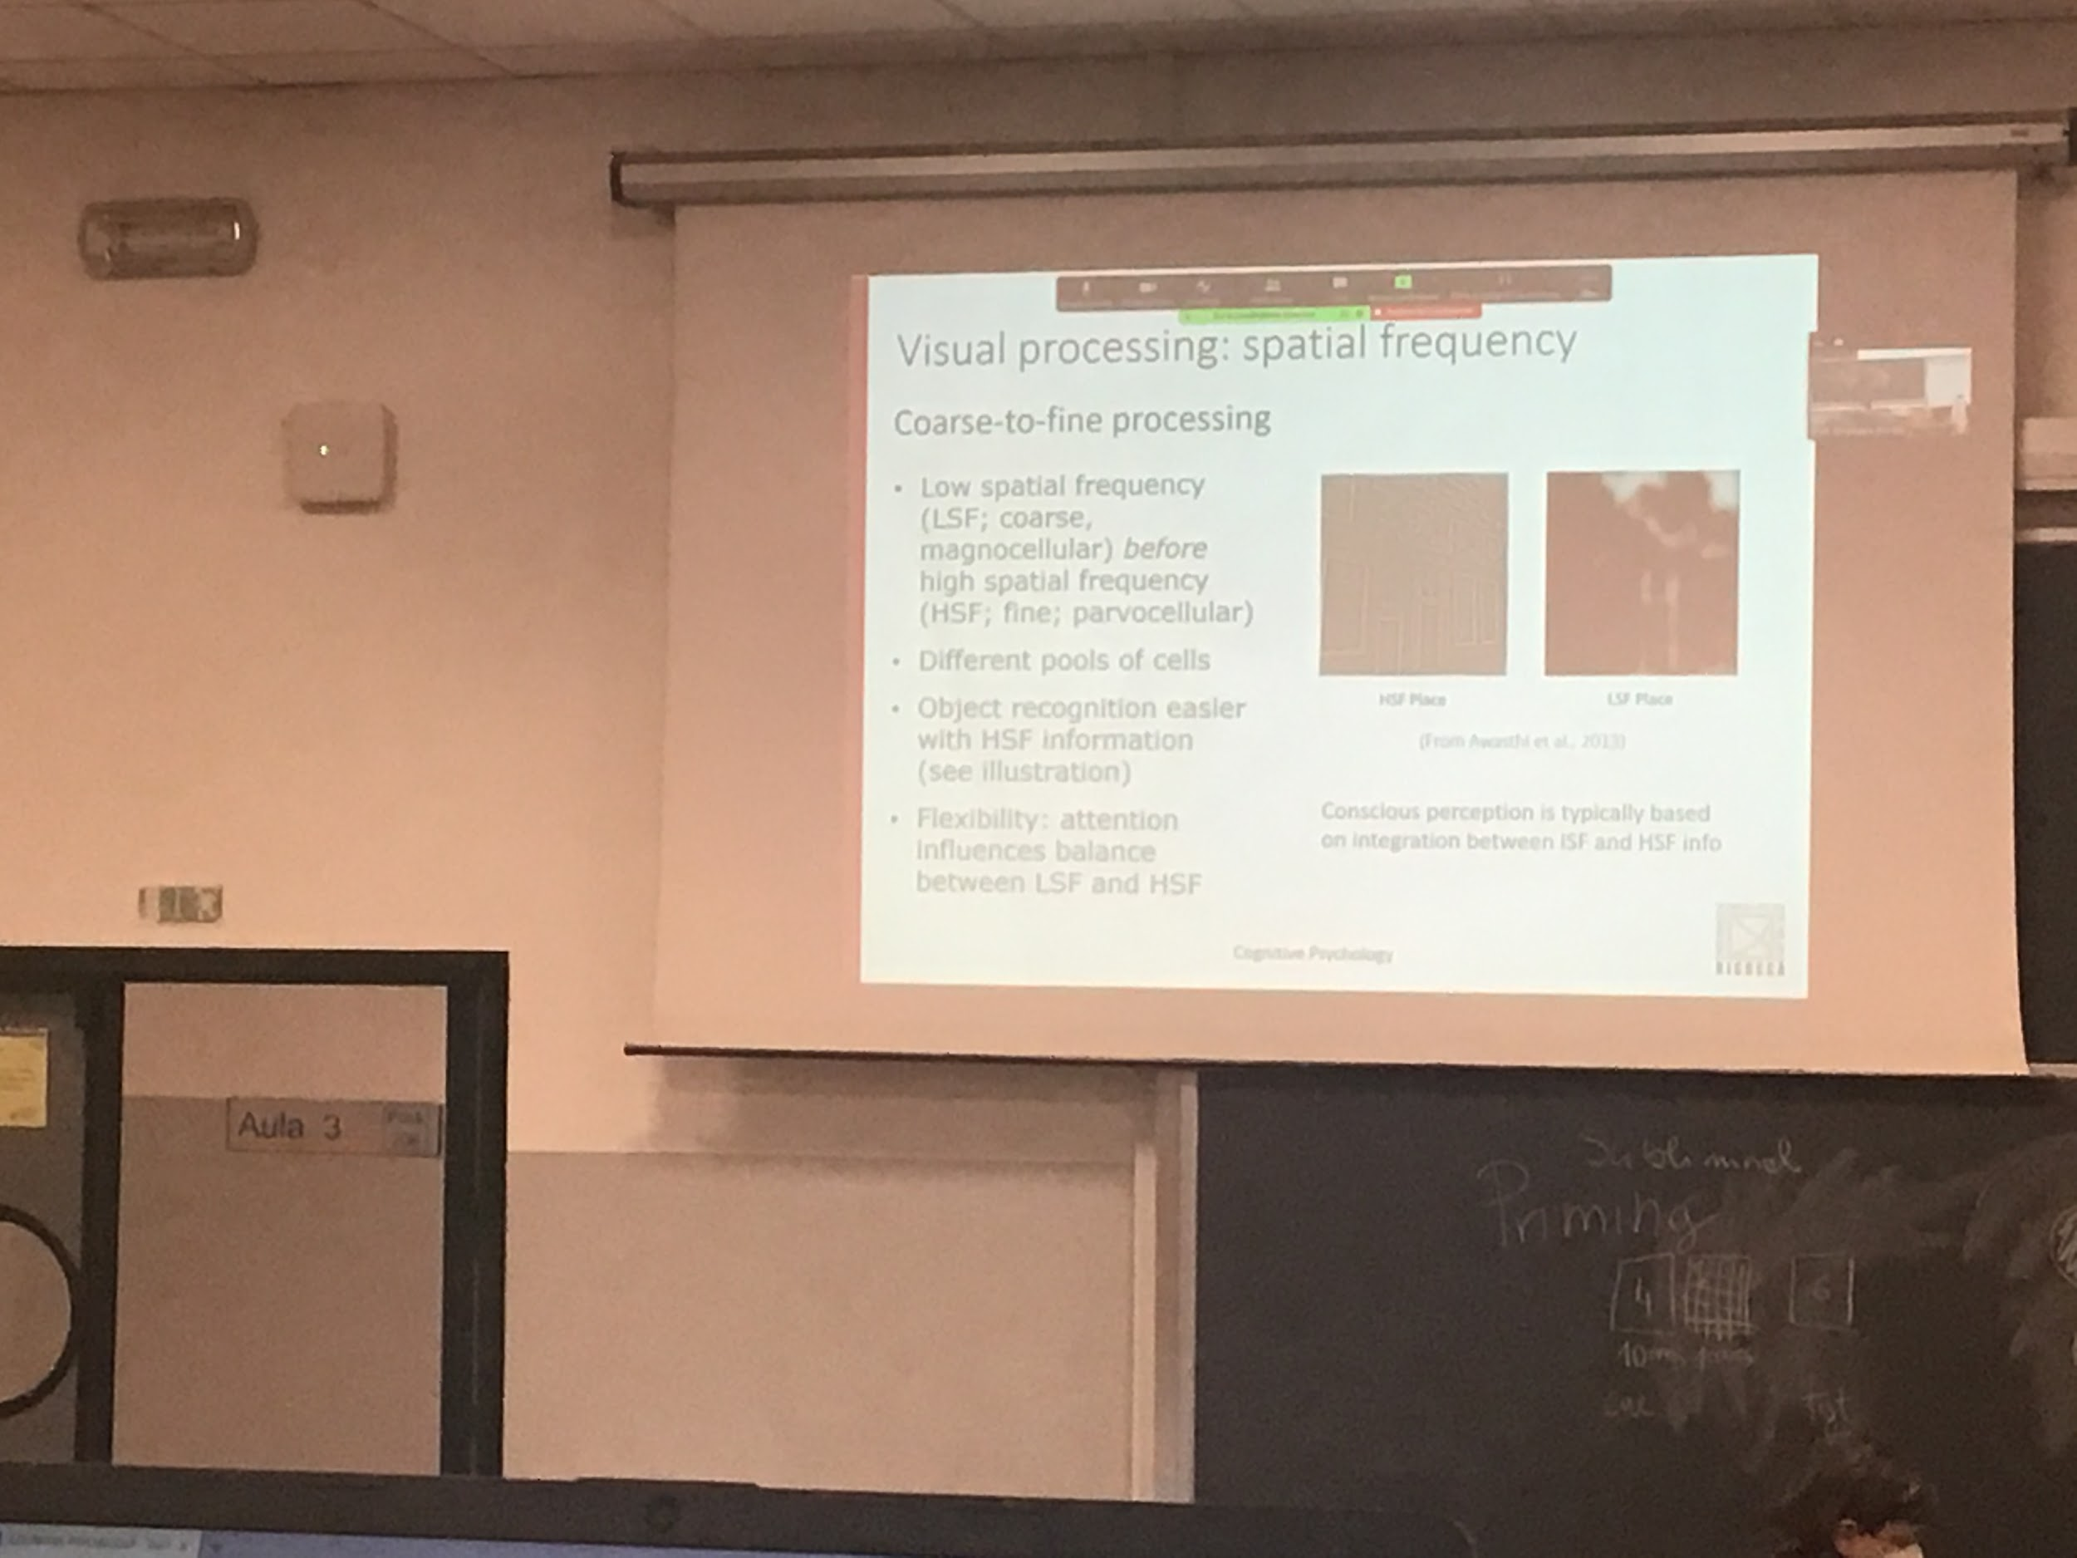

Idea that visual object recognition happens building up a complex form starting from simple elements. In V1 we detect borders, going further up we do more complex representation of parts

If I take an image, I compute the visual frequencies I see there is a large distribution

Recreate the image only with the low spatial frequencies

Takes out part of image that changes very rapidly

With the low spatial frequencies we lose the details

Looking in the brain we see that we have different groups of cells

The analysis elaboration is done in different channels (one for low spatial frequencies, the other on the high)

The low spatial frequencies (no information about details) information rounds along the magnumcellural root. More general changes, as like we defocus the picture

The high spatial frequencies code details go in the parvocellular root

If we look in the brain we have different groups of cells

* More sensitive to low spatial frequencies
* More sensitive to high spatial frequencies

If we use this filtered picture to test recognition we see that the high frequency information is more useful for recognition than the low frequencies information

The system is flexible, able to weight more the low level or the high level recognition. Conscious perception is done by the integration of both channels

Sound can be made up using different frequencies. You can find with different processes what kind of vacation of illumination there are

This idea is very strong, first do some kind of classification

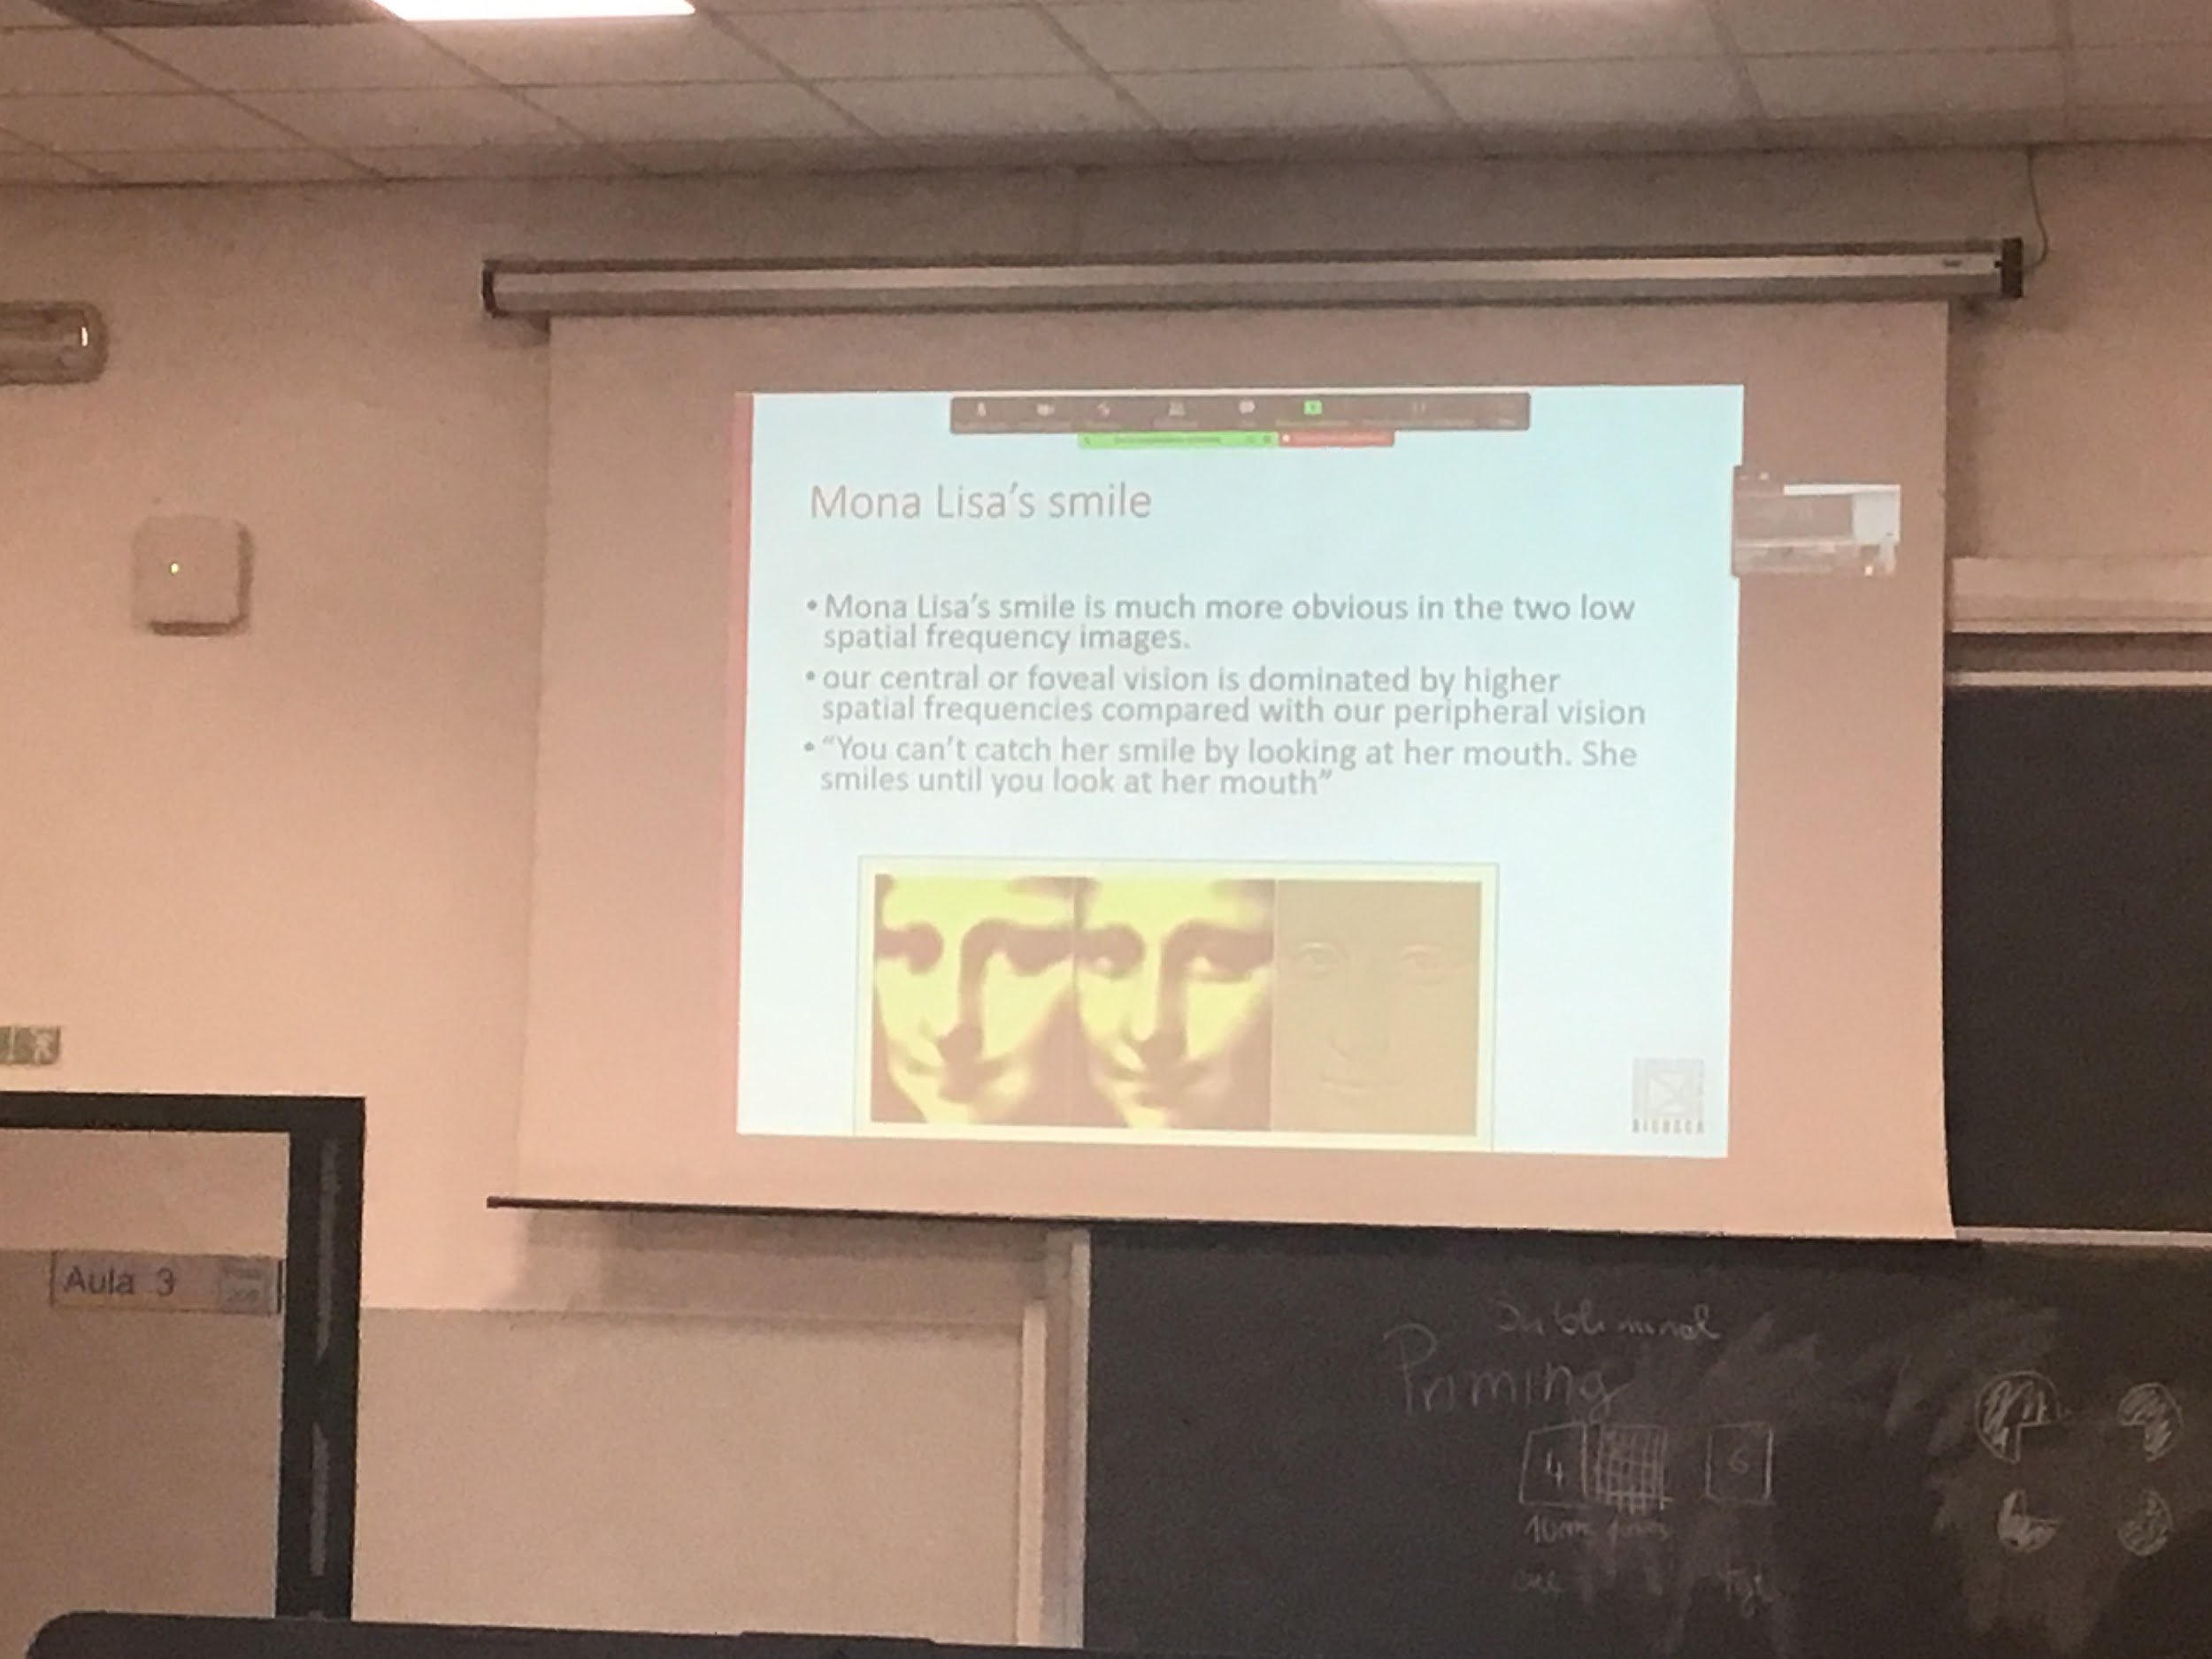

On the right there is the high spatial frequencies, the left and low are low spatial frequencies

Strange smile that we do not understand

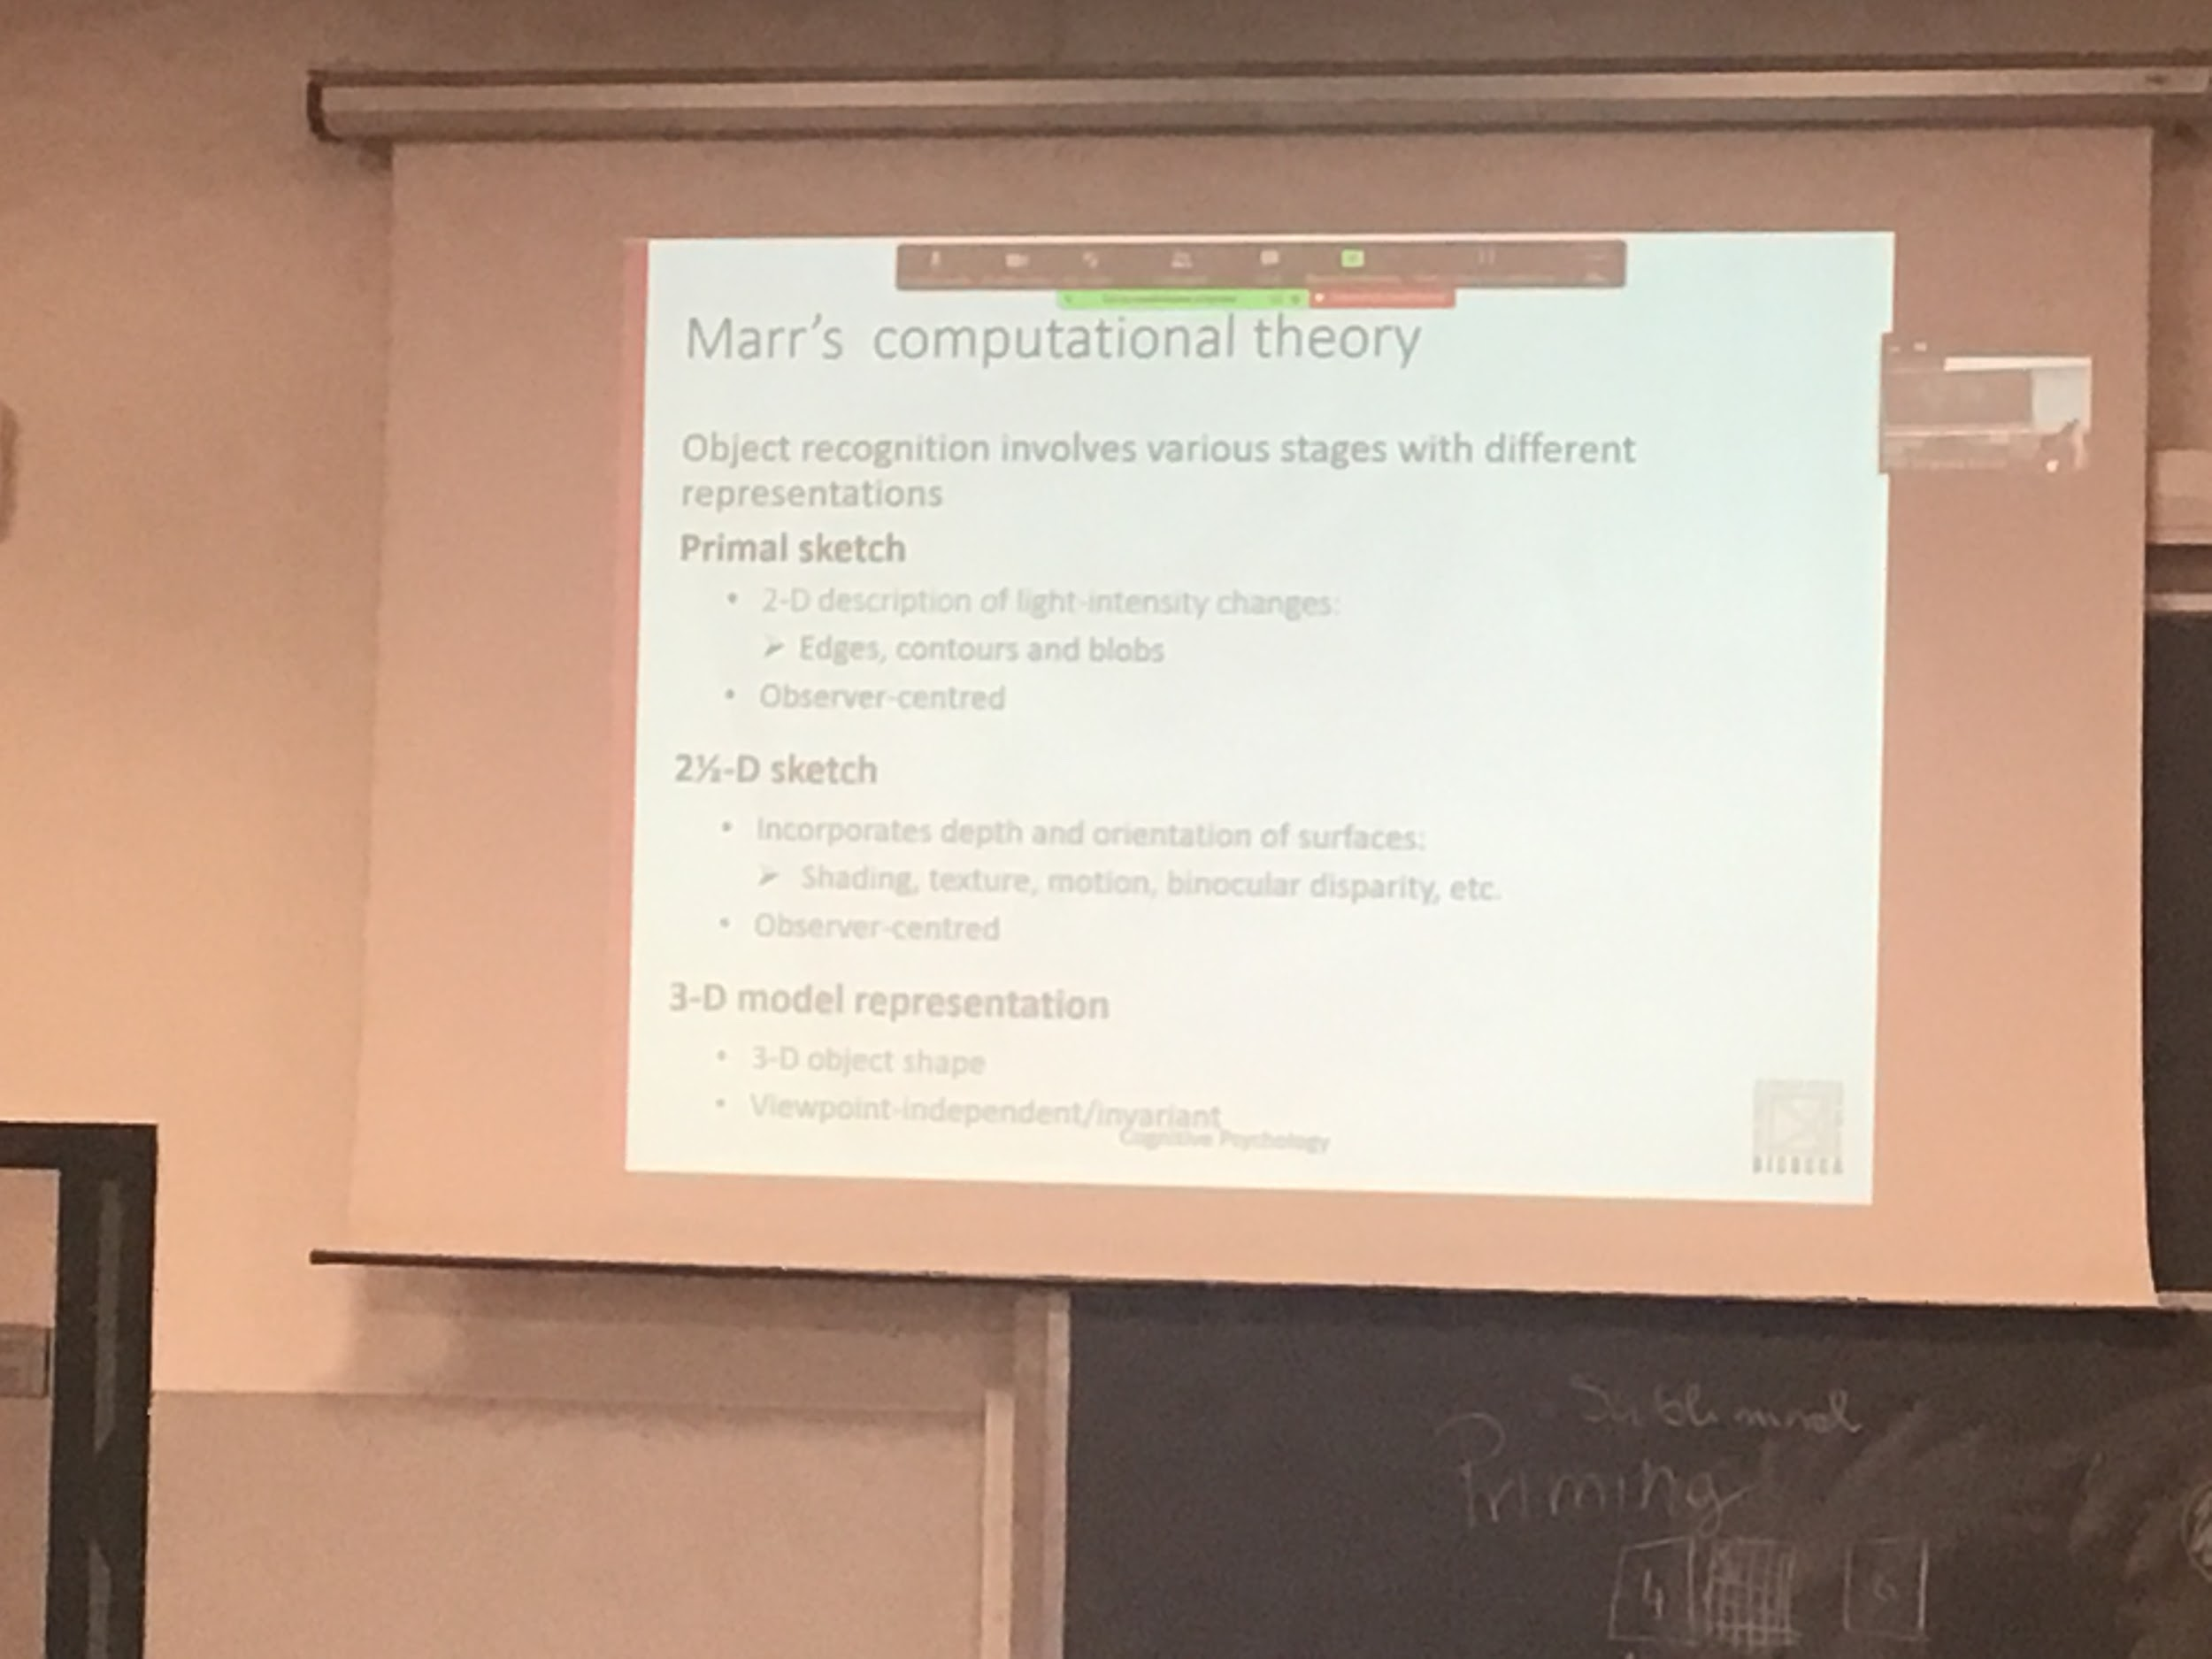

AI born around 1980

The way the brain builds representation is using different steps.

First step taking from an image, has to compute 2D representation of how life changes on the image

The representation is local and observer centre

Since the aim is to build a 3D representation of the object we have in front of us,

* The second step is to create the 2 1/2 D sketch. Representation in which we are adding depth. For each surface compute the orientation wrt to the observer. We still an observed centre point of view, see the object from my point of view
* Represent the full 3D structure of the object, now is object center. We have the representation of the object. Now we obtain a view variant representation. Represent the full tridimensional structure of the object

Even if I see the object from another point of view the representation is independent

One I create the 3D model I compared to the other 3D models

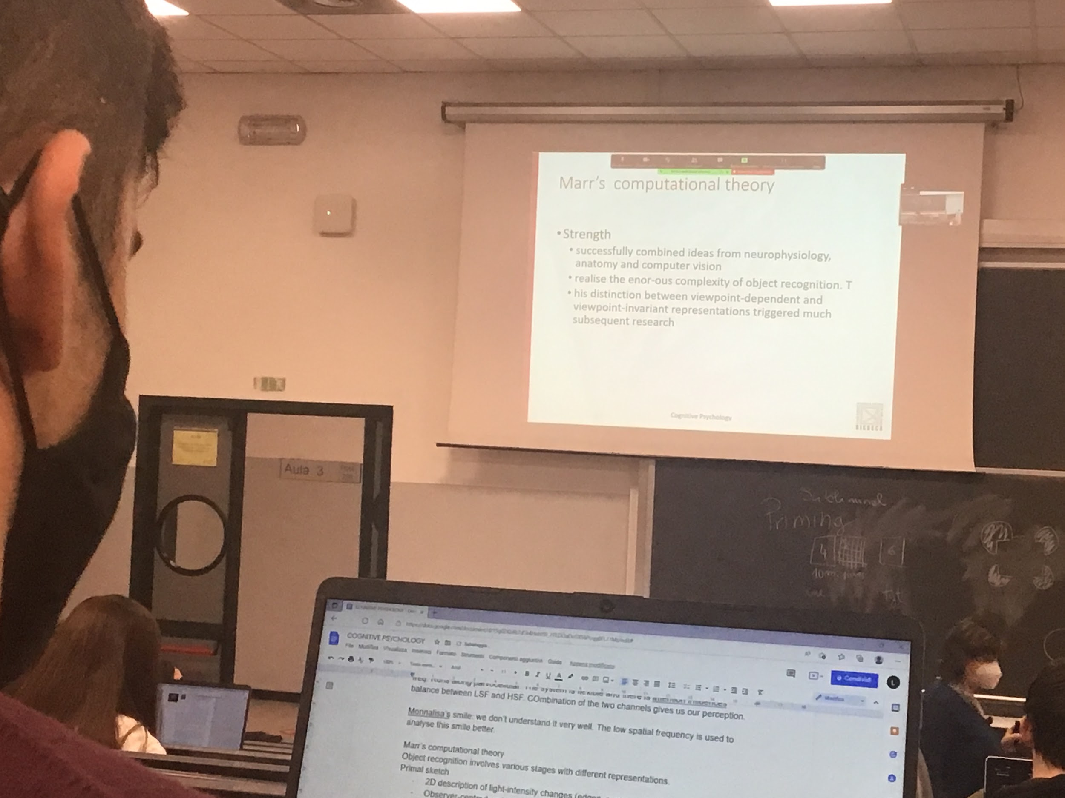

He was in contact with many people

They tried to implement programs that recognise objects

Marr proposed the reconstruction of a perfect 3D model is very difficult to obtain

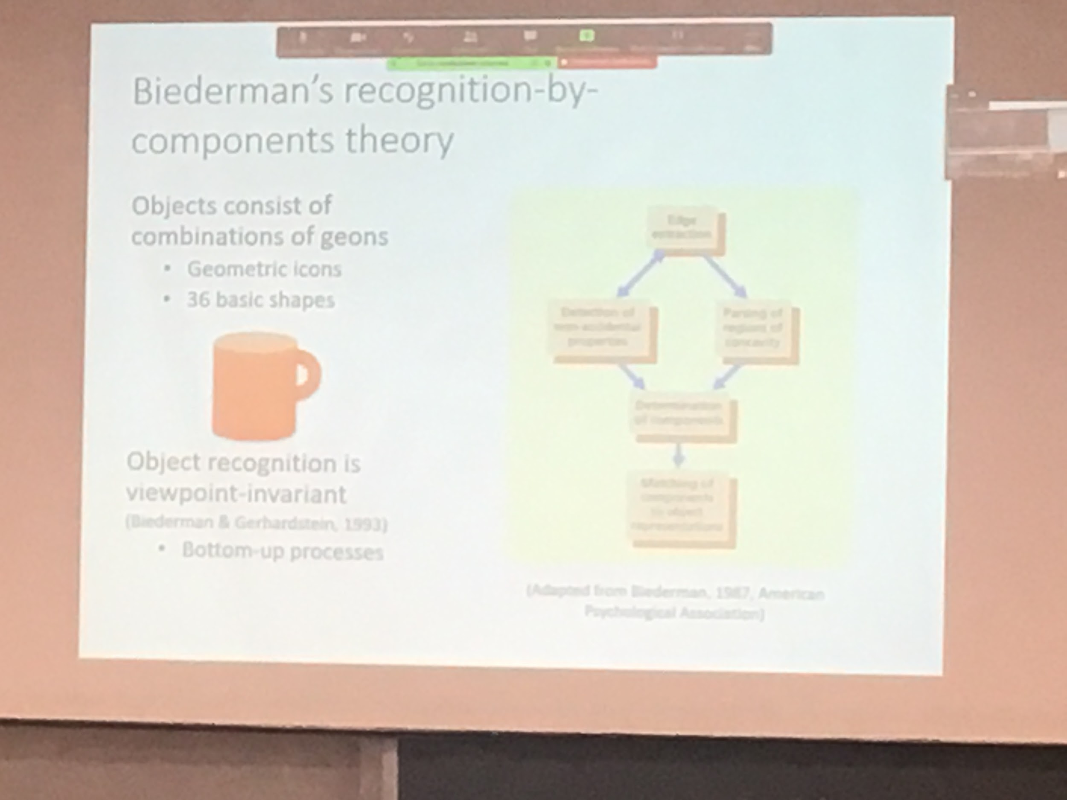

Biedermann student of marr

Changed the marr theory of vision in a specific way, married the idea that object recognition is bepointing variant, we build a 3D representation of the object in our brain

First step is extraction

Build a 3D representation of the object in our brain

He says that when we present visitino with one image

Accidental point of view: don’t see specific characteristics of an object in a specific inclination

There are 36 basic components (GEOMS)

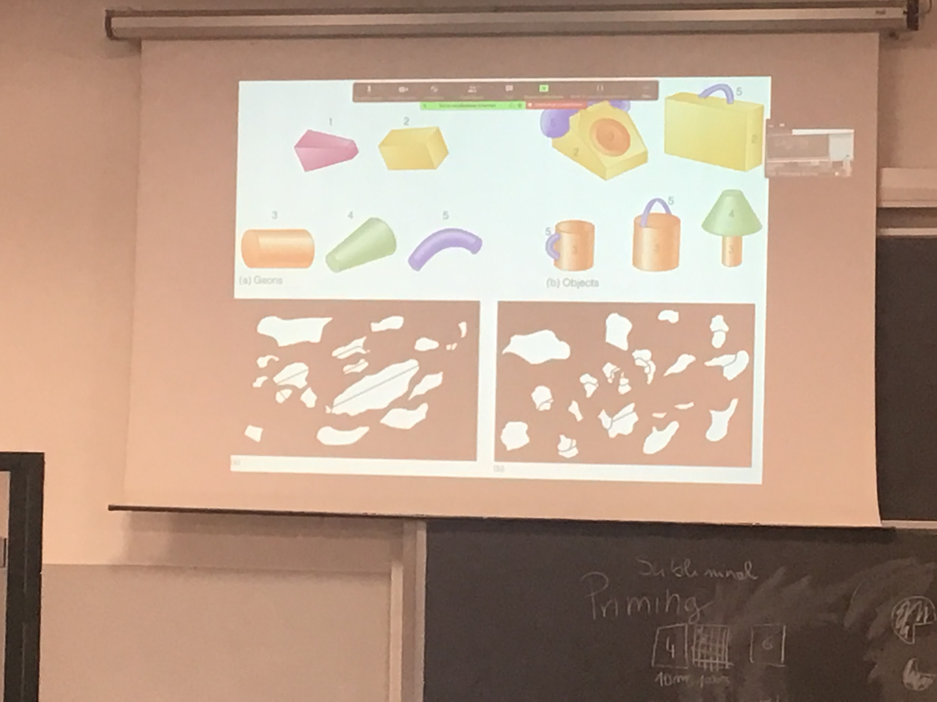

Aggiungere foto

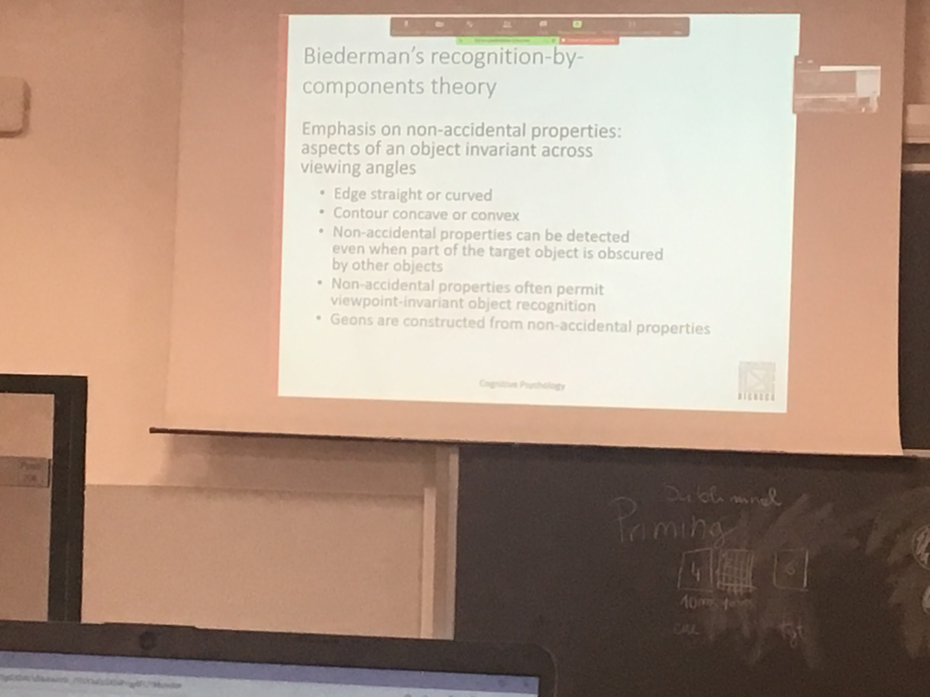

Non-accidental properties

Can not discriminate between different items belonging to the same category

Most or recognition is viewpoint dependent, to test it I have to build object that I am not used to

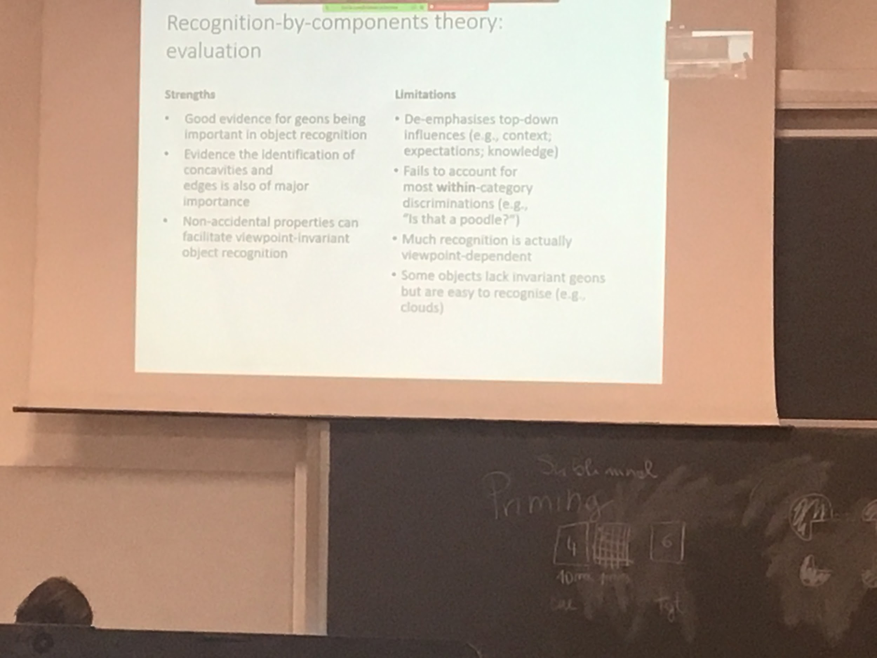

We are able to identify the geoms